

Apogee Enterprises, Inc.

UNITED STATES

SECURITIES AND EXCHANGE COMMISSION

WASHINGTON, D.C. 20549

FORM 10-K

- ANNUAL REPORT PURSUANT TO SECTION 13 or 15(d) OF THE SECURITIES EXCHANGE ACT OF 1934

For the fiscal year ended February 28, 2026

- TRANSITION REPORT PURSUANT TO SECTION 13 or 15(d) OF THE SECURITIES EXCHANGE ACT OF 1934

For the transition period from to

Commission File Number: 0-6365

_________________________________

APOGEE ENTERPRISES, INC.

(Exact name of registrant as specified in its charter)
 | _________________________________
Minnesota |  | 41-0919654
(State or other jurisdiction of incorporation or organization) |  | (I.R.S. Employer
 |  | Identification No.)
4400 West 78th Street, Suite 520 | Minneapolis Minnesota | 55435
(Address of principal executive offices) |  | (Zip Code)

Registrant’s telephone number, including area code: (952) 835-1874

Securities registered pursuant to Section 12(b) of the Act:

Title of each class

Trading Symbol(s)

Name of each exchange on which registered

Common Stock, $0.33 1/3 Par Value

APOG

The Nasdaq Stock Market

Securities registered pursuant to Section 12(g) of the Act: None

________________________________

Indicate by check mark if the registrant is a well-known seasoned issuer, as defined in Rule 405 of the Securities Act.

- Yes ☐ No

Indicate by check mark if the registrant is not required to file reports pursuant to Section 13 or Section 15(d) of the Act.

- Yes ☒ No

Indicate by check mark whether the registrant (1) has filed all reports required to be filed by Section 13 or 15(d) of the Securities Exchange Act of 1934 during the preceding 12 months (or for such shorter period that the registrant was required to file such reports), and (2) has been subject to such filing requirements for the past 90 days. ☒ Yes ☐ No

Indicate by check mark whether the registrant has submitted electronically every Interactive Data File required to be submitted pursuant to Rule 405 of Regulation S-T during the preceding 12 months (or for such shorter period that the registrant was required to submit such files). ☒ Yes ☐ No

Indicate by check mark whether the registrant is a large accelerated filer, an accelerated filer, a non-accelerated filer, smaller reporting company or an emerging growth company. See the definitions of “large accelerated filer,” “accelerated filer,” “smaller reporting company” and “emerging growth company” in Rule 12b-2 of the Exchange Act.

Large Accelerated Filer | ☒ | Accelerated Filer | ☐
Non-accelerated Filer | ☐ | Smaller Reporting Company | ☐
Emerging Growth Company | ☐
If an emerging growth company, indicate by check mark if the registrant has elected not to use the extended

transition period for complying with any new or revised financial accounting standards provided pursuant to ☐ Section 13(a) of the Exchange Act.

Indicate by check mark whether the registrant has filed a report on and attestation to its management's assessment of the effectiveness of its internal control over financial reporting under Section 404(b) of the Sarbanes-Oxley Act (15 U.S.C.
7262(b)) by the registered public accounting firm that prepared or issued its audit report. ☒

If securities are registered pursuant to Section 12(b) of the Act, indicate by check mark whether the financial statements of the

registrant included in the filing reflect the correction of an error to previously issued financial statements. ☐

Indicate by check mark whether any of those error corrections are restatements that required a recovery analysis of incentive-based compensation received by any of the registrant's executive officers during the relevant recovery period pursuant to

§240.10D-1(b). ☐

Indicate by check mark whether the registrant is a shell company (as defined in Rule 12b-2 of the Exchange Act).

- Yes ☒ No

As of August 29, 2025, the last business day of the registrant's most recently completed second fiscal quarter, the approximate aggregate market value of voting and non-voting common equity held by non-affiliates of the registrant was $915,200,000 (based on the closing price of $43.98 per share as reported on The Nasdaq Stock Market as of that date).

As of April 17, 2026, 21,220,737 shares of the registrant’s common stock, par value $0.33 1/3 per share, were outstanding.

DOCUMENTS INCORPORATED BY REFERENCE:

In accordance with General Instruction G(3) of Form 10-K, certain information required by Part III hereof will either be incorporated into this Annual Report on Form 10-K by reference to our Definitive Proxy Statement for our Annual Meeting of Shareholders filed within 120 days of our fiscal year ended February 28, 2026 or will be included in an amendment to this Annual Report on Form 10-K filed within 120 days of February 28, 2026.

Table of Contents

 |  |  |  |  |  |  |  |  |  |  |  |  |  |  | APOGEE ENTERPRISES, INC.
 |  |  |  |  |  |  |  |  |  |  |  |  |  |  |  | Annual Report on Form 10-K
 |  |  |  |  |  |  |  |  |  |  |  |  |  | For the fiscal year ended February 28, 2026
 |  |  |  |  |  |  |  |  |  |  |  |  |  |  |  | TABLE OF CONTENTS
 |  |  |  |  |  |  |  |  |  |  |  |  |  |  |  |  |  |  |  |  |  |  |  |  |  |  |  |  |  |  |  |  |  | Page
 |  |  |  |  |  |  |  |  |  |  |  |  |  |  |  |  |  |  |  |  |  | PART I
Item 1. |  |  |  |  | Business |  |  |  |  |  |  |  |  |  |  |  |  |  |  |  |  |  |  |  |  |  |  |  |  |  |  |  |  | 5
Item 1A. |  |  |  |  | Risk Factors |  |  |  |  |  |  |  |  |  |  |  |  |  |  |  |  |  |  |  |  |  |  |  |  |  |  |  |  | 11
Item 1B. |  |  |  |  | Unresolved Staff Comments |  |  |  |  |  |  |  |  |  |  |  |  |  |  |  |  |  |  |  |  |  |  |  |  |  |  |  |  | 16
Item 1C. |  |  |  |  | Cybersecurity |  |  |  |  |  |  |  |  |  |  |  |  |  |  |  |  |  |  |  |  |  |  |  |  |  |  |  |  | 16
Item 2. |  |  |  |  | Properties |  |  |  |  |  |  |  |  |  |  |  |  |  |  |  |  |  |  |  |  |  |  |  |  |  |  |  |  | 17
Item 3. |  |  |  |  | Legal Proceedings |  |  |  |  |  |  |  |  |  |  |  |  |  |  |  |  |  |  |  |  |  |  |  |  |  |  |  |  | 18
Item 4. |  |  |  |  | Mine Safety Disclosures |  |  |  |  |  |  |  |  |  |  |  |  |  |  |  |  |  |  |  |  |  |  |  |  |  |  |  |  | 18
 |  |  |  |  |  |  |  |  |  |  |  |  |  |  |  |  |  |  |  |  | PART II
Item 5. |  |  |  |  | Market for Registrant’s Common Equity, Related Stockholder Matters and Issuer Purchases of Equity Securities |  |  |  |  |  |  |  |  |  |  |  |  |  |  |  |  |  |  |  |  |  |  |  |  |  |  |  |  | 19
Item 6. |  |  |  |  | Reserved |  |  |  |  |  |  |  |  |  |  |  |  |  |  |  |  |  |  |  |  |  |  |  |  |  |  |  |  | 20
Item 7. |  |  |  |  | Management’s Discussion and Analysis of Financial Condition and Results of Operations |  |  |  |  |  |  |  |  |  |  |  |  |  |  |  |  |  |  |  |  |  |  |  |  |  |  |  |  | 21
Item 7A. |  |  |  |  | Quantitative and Qualitative Disclosures About Market Risk |  |  |  |  |  |  |  |  |  |  |  |  |  |  |  |  |  |  |  |  |  |  |  |  |  |  |  |  | 32
Item 8. |  |  |  |  | Financial Statements and Supplementary Data |  |  |  |  |  |  |  |  |  |  |  |  |  |  |  |  |  |  |  |  |  |  |  |  |  |  |  |  | 33
Item 9. |  |  |  |  | Changes in and Disagreements with Accountants on Accounting and Financial Disclosure |  |  |  |  |  |  |  |  |  |  |  |  |  |  |  |  |  |  |  |  |  |  |  |  |  |  |  |  | 71
Item 9A. |  |  |  |  | Controls and Procedures |  |  |  |  |  |  |  |  |  |  |  |  |  |  |  |  |  |  |  |  |  |  |  |  |  |  |  |  | 72
Item 9B. |  |  |  |  | Other Information |  |  |  |  |  |  |  |  |  |  |  |  |  |  |  |  |  |  |  |  |  |  |  |  |  |  |  |  | 72
Item 9C. |  |  |  |  | Disclosure Regarding Foreign Jurisdictions that Prevent Inspections |  |  |  |  |  |  |  |  |  |  |  |  |  |  |  |  |  |  |  |  |  |  |  |  |  |  |  |  | 72
 |  |  |  |  |  |  |  |  |  |  |  |  |  |  |  |  |  |  | PART III
Item 10. |  |  |  |  | Directors, Executive Officers, Code of Ethics and Corporate Governance |  |  |  |  |  |  |  |  |  |  |  |  |  |  |  |  |  |  |  |  |  |  |  |  |  |  |  |  | 73
Item 11. |  |  |  |  | Executive and Director Compensation |  |  |  |  |  |  |  |  |  |  |  |  |  |  |  |  |  |  |  |  |  |  |  |  |  |  |  |  | 73
Item 12. |  |  |  |  | Security Ownership of Certain Beneficial Owners and Management and Related Stockholder Matters |  |  |  |  |  |  |  |  |  |  |  |  |  |  |  |  |  |  |  |  |  |  |  |  |  |  |  |  | 73
Item 13. |  |  |  |  | Certain Relationships and Related Transactions, and Director Independence |  |  |  |  |  |  |  |  |  |  |  |  |  |  |  |  |  |  |  |  |  |  |  |  |  |  |  |  | 74
Item 14. |  |  |  |  | Principal Accountant Fees and Services |  |  |  |  |  |  |  |  |  |  |  |  |  |  |  |  |  |  |  |  |  |  |  |  |  |  |  |  | 74
 |  |  |  |  |  |  |  |  |  |  |  |  |  |  |  |  |  |  |  | PART IV
Item 15. |  |  |  |  | Exhibits and Financial Statement Schedules |  |  |  |  |  |  |  |  |  |  |  |  |  |  |  |  |  |  |  |  |  |  |  |  |  |  |  |  | 75
Item 16. |  |  |  |  | Form 10-K Summary |  |  |  |  |  |  |  |  |  |  |  |  |  |  |  |  |  |  |  |  |  |  |  |  |  |  |  |  | 77
 |  |  |  |  | Signatures |  |  |  |  |  |  |  |  |  |  |  |  |  |  |  |  |  |  |  |  |  |  |  |  |  |  |  |  | 78

3

Table of Contents

Forward-Looking Statements

This Annual Report on Form 10-K, including “Management's Discussion and Analysis of Financial Condition and Results of Operations” in Part II, Item 7, contains certain statements that are considered “forward-looking statements” within the meaning of the Private Securities Litigation Reform Act of 1995. These statements reflect our current views with respect to future events and financial performance. Forward-looking statements generally can be identified by the use of forward-looking terminology such as “may,” “believe,” “expect,” “anticipate,” “intend,” “estimate,” “forecast,” “project,” “should,” "will," "continue" or similar words or expressions. All forecasts and projections in this document are “forward-looking statements,” and are based on management's current expectations or beliefs of the Company's near-term results, based on current information available pertaining to the Company, including the risk factors noted under Item 1A in this Form 10-K. From time to time, we also may provide oral and written forward-looking statements in other materials we release to the public, such as press releases, presentations to securities analysts or investors, or other communications by the Company. Any or all of our forward-looking statements in this report and in any public statements we make could be materially different from actual results.

Accordingly, we wish to caution investors that any forward-looking statements made by or on behalf of the Company are subject to uncertainties and other factors that could cause actual results to differ materially from such statements. These uncertainties and other risk factors include, but are not limited to, the risks and uncertainties set forth under Item 1A in this Form 10-K, all of which are incorporated by reference into Item 7.

We wish to caution investors that other factors might in the future prove to be important in affecting the Company's results of operations. New factors emerge from time to time; it is not possible for management to predict all such factors, nor can it assess the impact of each such factor on the business or the extent to which any factor, or a combination of factors, may cause actual results to differ materially from those contained in any forward-looking statements. We undertake no obligation to update publicly or revise any forward-looking statements, whether as a result of new information, future events or otherwise.

4

Table of Contents

PART I

ITEM 1. BUSINESS

The Company

Apogee Enterprises, Inc. (Apogee, we, us, our or the Company) was incorporated under the laws of the State of Minnesota in 1949. We are a leading provider of architectural building products and services, as well as high-performance coated materials used in a variety of applications.

Segment Information

We have four reporting segments:

- The Architectural Metals Segment designs, engineers, fabricates and finishes aluminum window, curtainwall, storefront and entrance systems used primarily in non-residential construction. In fiscal 2026, this segment accounted for approximately 36% of our net sales.

- The Architectural Services Segment integrates technical services, project management, and field installation services to design, engineer, fabricate, and install architectural curtainwall and other façade-related systems used primarily in non-residential construction. In fiscal 2026, this segment accounted for approximately 31% of our net sales.

- The Architectural Glass Segment cuts, treats, coats and fabricates high-performance glass used in custom window and wall systems used primarily in non-residential buildings. In fiscal 2026, this segment accounted for approximately 19% of our net sales.

- The Performance Surfaces Segment develops and manufactures high-performance coated materials for a variety of applications, including wall decor, museums, graphic design, digital displays, architectural interiors, and industrial flooring. In fiscal 2026, this segment accounted for approximately 14% of our net sales.

Strategy

Throughout fiscal 2026, we executed the strategy introduced in November 2021, which strengthened our organization through the implementation of the Apogee Management System, drove improvements to our cost structure and manufacturing footprint, and increased leverage of administrative functions across the enterprise. This strategy also contributed to meaningful safety improvements and a more focused product and service portfolio, leading to margin and profitability improvement. Building on this foundation, we are refining our strategic framework to further enhance execution and position Apogee as a more growth-oriented organization with an increased focus on delivering customer value.

- Accelerate Leadership in Target Markets. We intend to enhance our position in targeted end markets by differentiating through deep customer focus and insight, using an informed understanding of customer needs to shape our offerings and delivery models. By aligning our capabilities, investments, and operating approach around this customer-focused strategy, we believe we will be better positioned to differentiate, compete effectively, and strengthen our position in the markets we serve.

- Grow and Strengthen the Portfolio. We seek to grow and strengthen our portfolio through disciplined organic and inorganic investments in differentiated solutions that align with evolving customer needs. By prioritizing opportunities that enhance our competitive positioning and directly address customer challenges, we will reinforce our disciplined approach to portfolio growth and improvement.

- Advance Core Capabilities. We expect to advance core capabilities by fostering a culture of continuous improvement grounded in operational excellence, talent development, and disciplined process execution. Through targeted investments in people, systems, and technology, we will strengthen our ability to deliver consistent performance and enhance the customer experience across the organization.

We continually analyze our portfolio of products, services, and capabilities to identify the best areas for future profitable growth. We also evaluate inorganic investment opportunities where we can deploy capital to acquire businesses that will be accretive to our long-term growth rate and operating margins.

5

Table of Contents

Fiscal 2026 Highlights

Fiscal 2026 was a year of disciplined execution for Apogee as we navigated a difficult economic environment while continuing to strengthen our operating foundation. We executed our priorities for the year including:

- The Performance Surfaces Segment successfully integrated the UW Interco, LLC (UW Solutions), acquired in late fiscal 2025, and the business delivered upon the first-year financial targets of $100 million in revenue and adjusted EBITDA margin of at least 20%.

- Apogee Management System (AMS) continued to drive improvements across our manufacturing footprint including enabling progress improving outcomes for customers in the Architectural Metals Segment through full value-stream redesign, supported by a new product and manufacturing site. These enhancements drove higher service levels and shorter lead times while reducing cost of quality.

- We actively managed our cost structure and manufacturing footprint through Project Fortify 2 ("Project Fortify Phase 2" or "Phase 2") to mitigate portions of direct and indirect tariffs while driving efficiencies across the organization. While these decisions were challenging and disruptive, we are confident that the actions will further position Apogee to successfully navigate the market headwinds into the future.

We also delivered meaningful gains in safety, service, and productivity, and generated solid cash flow.

Products and Services

Architectural Metals Segment

Our Architectural Metals Segment designs, engineers and fabricates aluminum windows, curtainwall, storefront and entrance systems. We also extrude aluminum and provide finishing services for metal components used in a variety of building materials applications. We sell our products and services under the Tubelite®, EFCO, Wausau and Linetec® brands in the U.S. and under Alumicor™ in Canada.

Architectural Services Segment

Our Architectural Services Segment integrates technical services, project management, and field installation services to design, engineer, fabricate, and install architectural curtainwall and other facade-related systems used primarily in non-residential construction. Our ability to efficiently design high-quality window and curtainwall systems and effectively manage the installation of building façades enables our customers to meet performance, schedule and cost requirements of their projects. We sell our products and services under the Harmon® brand.

Architectural Glass Segment

Our Architectural Glass Segment fabricates a wide range of high-performance glass products, offering customized solutions that enable architects and building owners to meet their design, aesthetic, and performance goals. We fabricate insulating, laminated, and monolithic glass units that are used in windows, curtainwall, storefront, and entrance systems. Our premium glass solutions include proprietary, high-performance coatings, digital and silkscreen printing, heat-soaking of tempered glass, and thermal spacers to meet our customers’ design and energy-performance requirements. We sell our products primarily under the Viracon® and GlassecViracon® brands.

Performance Surfaces Segment

The Performance Surfaces Segment develops and manufactures high-performance coated materials for a variety of applications, including wall decor, museums, graphic design, digital displays, architectural interiors, and industrial flooring. We are a vertically integrated manufacturer, differentiated by our proprietary formulations and coating application processes. We sell our products under the Tru Vue®, ResinDEK®, ChromaLuxe®, RDC Coatings™, and Unisub® brands.

6

Table of Contents

Product Demand and Distribution Channels

Architectural Metals, Architectural Services and Architectural Glass Segments

Demand for the products and services offered by our architectural segments is not only impacted by general economic conditions but has historically been affected by changes in the North American non-residential construction industry, which is cyclical in nature.

We look to several external indicators to analyze potential short-term and long-term demand for our products and services, such as U.S. and Canadian job growth, office vacancy rates, credit and interest rates, architectural billing indices, and material costs. We also rely on internal indicators to analyze demand, including our sales pipeline, which is made up of contracts in review, projects awarded or committed, and bidding activity. Our sales pipeline, together with ongoing feedback, analysis and data from our customers, architects and building owners, provides information related to near- and mid-term demand.

Our architectural products and services are used in subsets of the non-residential construction industry differentiated by the following factors:

- Building type - Our products and services are primarily used in commercial buildings (office buildings, hotels and retail centers), institutional buildings (education facilities, health care facilities and government buildings), transportation facilities (airports and transit terminals), and multi-family residential buildings (a subset of residential construction).

- Level of customization - Many of our projects involve a high degree of customization, as the product or service is designed or fabricated to meet customer-specified requirements for aesthetics, performance and size, and local building codes.

- Customers and distribution channels - Our customers are mainly glazing subcontractors and general contractors, with project design being influenced by architects and building owners. Our windows, curtainwall, storefront and entrance systems are sold using a combination of direct sales forces, independent sales representatives, and distributors. Our installation services are sold by a direct sales force in certain metropolitan areas in the U.S. and Canada. Our high-performance architectural glass is sold using both a direct sales force and independent sales representatives.

- Geographic location - We primarily supply architectural glass products and aluminum framing systems, including window, curtainwall, storefront and entrance systems, to customers in North America. We are one of only a few architectural glass installation service companies in the U.S. to have a national presence and we have the ability to provide installation project management throughout the country.

Performance Surfaces Segment

Demand for products in the Performance Surfaces Segment is influenced by general economic conditions and activity levels across commercial, institutional, and specialty end markets, as well as broader construction, renovation, and capital spending trends. Customer purchasing decisions may be affected by budget constraints, timing of projects, and broader market uncertainty, and demand may vary by end market, application, and geographic region.

Products in the Performance Surfaces Segment are sold through a combination of direct sales and third-party distribution channels, including national and regional retailers, specialty dealers and distributors, independent representatives, and other intermediaries, depending on the product and end market served.

The segment also provides custom-engineered coating solutions for a variety of applications, including flooring, furniture, cabinetry, and other industrial and architectural end uses. These coating products are distributed through a global network, with sales outside of North America occurring primarily in Europe and Asia.

Competitive Conditions

The North American non-residential construction market is highly fragmented. Competitive factors include price, product quality, product attributes and performance, reliable service, on-time delivery, lead-time, warranties, and the ability to provide project management, technical engineering and design services. To protect and improve our competitive position, we maintain strong relationships with building owners, architects, and other stakeholders who influence the selection of products and services on a project, and with general contractors, who initiate projects and develop specifications.

Architectural Metals Segment

Our Architectural Metals Segment competes against several national, regional, and local aluminum window and storefront manufacturers, as well as regional finishing companies. Businesses within the segment compete by providing a broad portfolio of high-quality products, robust engineering capabilities, a vertically integrated manufacturing model, and dependable, short lead-time service.

7

Table of Contents

Architectural Services Segment

Our Architectural Services Segment competes against international, national and regional glass installation companies. We compete by offering a robust set of capabilities at a competitive cost. Our capabilities include engineering and design services, project management, manufacturing, and field installation. We deliver these services using an operating model that is designed to reduce costs and risk for our customers.

Architectural Glass Segment

In our Architectural Glass Segment, we compete with regional glass fabricators and international competitors who can provide certain products with attributes similar to ours. We differentiate by providing a wider range of high-quality products, including several proprietary offerings, that we can bundle together into customized solutions. We work to maintain strong relationships with architects, developers, and other industry stakeholders, and provide strong customer service and reliable delivery.

Performance Surfaces Segment

Our Performance Surfaces Segment competes primarily with European, U.S., and Asia Pacific providers of both basic and value-added glass and acrylic, and other high-performance coated substrates. Our competitive strengths include innovative proprietary products, domain expertise in coating processes and technologies, a highly automated manufacturing model, strong customer relationships, an established distribution network, and a portfolio of well-known brands.

Warranties

We offer product and service warranties that we believe are competitive for the markets in which our products and services are sold. The nature and extent of these warranties depend upon the product or service, the market and, in some cases, the customer being served. Our standard warranties are generally from two to 12 years for our curtainwall, window system, and architectural glass and certain coated products, while we generally offer warranties of two years or less on our other products and services.

Sources and Availability of Raw Materials

Materials used in the Architectural Metals Segment include aluminum billet and extrusions, fabricated glass, plastic extrusions, hardware, paint and chemicals. Within the Architectural Services Segment, materials used include fabricated glass, finished aluminum extrusions, fabricated metal panels and hardware. Raw materials used within the Architectural Glass Segment include float glass, vinyl, silicone sealants and lumber for packaging. Materials used in the Performance Surfaces Segment are float glass, acrylic, aluminum sheets, medium-density fiberboard (MDF), and certain chemicals. Most of our raw materials are readily available from a variety of domestic and international sources.

Intellectual Property

We have several patents, trademarks, trade names, trade secrets and proprietary technologies and customer relationships that we believe constitute valuable assets, but we do not regard our business as being materially dependent on any single item or category of intellectual property. We take measures to protect our intellectual property to the extent such intellectual property can be protected.

Seasonality

Activity in the non-residential construction industry is impacted by the seasonal impact of weather and weather events in our operating locations, with activity in some markets reduced in winter due to inclement weather.

Working Capital Requirements

Trade and contract-related receivables and other contract assets are the largest components of our working capital. Inventory requirements, mainly related to raw materials, are most significant in our Architectural Metals, Architectural Glass, and Performance Surfaces Segments.

Compliance with Government Regulations

We are subject to various environmental and occupational safety and health laws and regulations in the U.S. and in other countries in which we operate. These laws and regulations relate to, among other things, our use and storage of hazardous materials in our manufacturing operations and associated air emissions and discharges to surface and underground waters. We have several continuing programs designed to ensure compliance with foreign, federal, state and local environmental and occupational safety and health laws and regulations. We contract with outside vendors to collect and dispose of waste at our production facilities in compliance with applicable environmental laws. In addition, we have procedures in place that enable us to properly manage the regulated materials used in and wastes created by our manufacturing processes. We believe we are currently in compliance with all such laws and regulations.

8

Table of Contents

Supporting Sustainability

We are committed to integrating sustainable business practices and environmental stewardship throughout our business. Our company-wide commitment to sustainable business practices is focused on delivering long-term profitable growth while carefully stewarding the resources entrusted to us, and delivering products and services that address our customers’ increased focus on energy efficiency, greenhouse gas reductions, and other performance requirements.

Our architectural products and services are key enablers of green building and sustainable design. We have long been at the forefront of developing innovative products and services that conserve resources and help architects and building owners achieve their sustainability goals, such as attaining Leadership in Energy and Environmental Design (LEED) certifications. Our high-performance thermal framing systems, energy-efficient architectural glass, and other products are designed to help improve building energy efficiency, reduce greenhouse gas emissions, and increase security and comfort for building occupants. Our products are made primarily with glass and aluminum components, which are recyclable at the end of their useful lives. In addition, many of our framing products can be specified with recycled aluminum content.

Our commitment to sustainable business practices and environmental stewardship also extends to our own operations, including incorporating environmentally sustainable manufacturing processes, reducing waste, and minimizing our resource consumption.

Human Capital Resources

We had approximately 4,100 employees on February 28, 2026, down from 4,500 employees on March 1, 2025, of which 77% are male and 23% are female. As of February 28, 2026, approximately 400, or 10%, of our employees are covered by collective bargaining agreements.

Based on the most recent information available from our latest filing with the U.S. Equal Employment Opportunity Commission, our U.S. employees had the following race and ethnicity demographics:

Employee Demographic |  | Percent of Total
White | 63%
Hispanic / Latinx | 23%
Black / African American | 7%
Asian | 5%
Multiracial, Native American, Native Hawaiian, and Pacific Islander | 2%
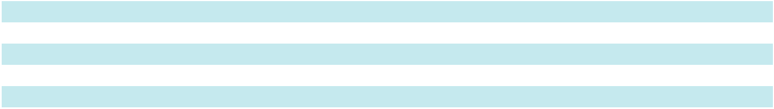

Competition for qualified employees in the markets and industries in which we operate is significant, and our success depends on the ability to attract, select, develop and retain a productive and engaged workforce. Investing in our employees and their well-being, offering competitive compensation and benefits, promoting diversity and inclusion, and adopting positive human capital management practices are critical components of our corporate strategy.

Health, Wellness and Safety

The safety of our employees is integral to our Company. Providing a safe and secure work environment is one of our highest priorities and we devote significant time and resources to workplace safety. Our safety programs are designed to comply with stringent regulatory requirements and to meet or exceed best practices in our industry. This commitment requires focus and dedication to fundamental aspects of our business to minimize the risk of accidents, injury, and exposure to health hazards.

In fiscal 2026, we continued to improve our enterprise-wide health and safety program, which centralizes oversight of workplace safety and actively shares best practices across our business. Our Apogee Safety Council meets regularly to review facility-level performance, maintain our policies, and implement short and long-term plans to lower safety-related incidents.

We utilize a safety culture assessment process along with safety compliance audits to monitor safety programs within our businesses and regularly share best practices. These annual assessments and audits provide suggestions for continuous improvement in safety programs and measure employee engagement. In addition, the programs encourage the development of a proactive, inter-dependent safety culture in which leadership and employees interact to ensure safety is viewed as everyone’s responsibility. Our leadership team and Board of Directors (the Board) are briefed regularly on our health and safety performance metrics.

We offer comprehensive health and wellness programs for our employees. In addition to standard health programs, including medical insurance and preventive care, we have a variety of resources available to employees relating to physical and mental wellness. We also conduct employee engagement surveys at the site level annually to hear directly from our employees with respect to what we are doing well, in addition to areas where they may need additional support.

9

Table of Contents

Diversity and Equal Opportunity

We strive to promote a workplace where each employee’s abilities are recognized, respected, and utilized to further our goals. Our aim is to create an environment where people feel included as a part of a team because of their diversity of outlooks, perspectives, and characteristics, and have an equal opportunity to add value to our Company. We work to create a culture of inclusion, reduce bias in our talent practices, and invest in and engage with our communities. We conduct diversity and Code of Business Ethics and Conduct trainings with employees and managers annually to define our expectations on creating an inclusive and diverse workplace, where all individuals feel respected and part of a team regardless of their race, national origin, ethnicity, gender, age, religion, disability, sexual orientation or gender identity.

Talent Management and Development

Our talent management program is focused on developing employees and leaders to meet our evolving needs. Employees are able to track and manage their growth through a performance management system and managers actively engage with their employees to provide coaching and feedback, identify training and development opportunities to improve performance in the employee’s current role, and to position the employee for future growth. Training and development opportunities include new-hire training, job specific training, stretch assignments, and safety training. We also offer leadership development opportunities, along with technical training for engineers, designers and sales staff. In addition, we offer an education assistance program in which certain eligible employees receive tuition reimbursement to help defray the costs associated with their continuing education. Our executive leadership and Human Resources teams regularly conduct talent reviews and succession planning to assist with meeting critical talent and leadership needs.

International Sales

Information regarding export and international sales is included in Item 8, Financial Statements and Supplementary Data, within Note 16 of our Consolidated Financial Statements.

Available Information

Our internet address is www.apog.com. Through a link to a third-party content provider, our website provides free access to our Annual Reports on Form 10-K, Quarterly Reports on Form 10-Q, Current Reports on Form 8-K and, if applicable, amendments to those reports filed or furnished pursuant to Section 13(a) or 15(d) of the Securities Exchange Act of 1934, as amended (the Exchange Act), as soon as reasonably practicable after electronic filing such material with, or furnishing it to, the Securities and Exchange Commission (SEC). These reports are also available on the SEC's website at www.sec.gov. Also available on our website are various corporate governance documents, including our Code of Business Ethics and Conduct, Corporate Governance Guidelines, and charters for the Audit, Compensation, and Nominating and Corporate Governance Committees of the Board.

10

Table of Contents

INFORMATION ABOUT OUR EXECUTIVE OFFICERS

Name | Age | Positions with Apogee Enterprises and Past Experience
Donald A. Nolan | 65 | Chief Executive Officer (CEO) and Executive Chair of the Board of Directors of the Company since
 |  | October 2025. Mr. Nolan has served on the Board since 2013 and served as Chair since 2020. Prior to
 |  | this role, Mr. Nolan served as President and Chief Executive Officer of Kennametal Inc., President of
 |  | the Materials Group for Avery Dennison Corporation, and as Senior Vice President of Global
 |  | Packaging and Refinish Coatings at Valspar, a developer, manufacturer and distributor of paints and
 |  | coatings. Before joining Valspar, he held leadership positions of increasing responsibility with Loctite,
 |  | General Electric and Ashland Chemical.
Mark R. Augdahl | 60 | Executive Vice President and Chief Financial Officer of the Company since January 2026. Prior to his
 |  | current role, Mr. Augdahl held several senior finance leadership positions within the Company over
 |  | the past 20 years, including Chief Accounting Officer from 2023 to 2025, Interim Chief Financial
 |  | Officer from 2022 to 2023, Vice President of Finance for two of the Company’s segments from 2012
 |  | to 2022, and Corporate Controller from 2004 to 2012.
Bryan A. Welp | 50 | Vice President, General Counsel since February 2026. Prior to this role, Mr. Welp served as Assistant
 |  | General Counsel for Apogee's Architectural Metals Segment. Prior to joining the Company, Mr. Welp
 |  | was a litigator with Lindquist & Vennum, PLLP (n/k/a Ballard Spahr LLP).
Troy R. Johnson | 52 | President of Apogee's Architectural Metals Segment since August 2025. Prior to this role, Mr.
 |  | Johnson served in several leadership roles in the Architectural Services Segment, including Segment
 |  | President beginning in March 2020.
Matthew Christian | 44 | President of Apogee’s Architectural Services Segment since August 2025. Prior to this role, Mr.
 |  | Christian served as the Vice President, Products in the Architectural Metals Segment. Prior to that, he
 |  | spent more than 19 years in the Architectural Services Segment.
Brent C. Jewell | 52 | President of Apogee's Architectural Glass Segment since October 2023. Prior to this role, Mr. Jewell
 |  | held several leadership positions within the Company including, President of the Architectural Metals
 |  | Segment from 2019 to 2023 and Senior Vice President, Business Development and Strategy from
 |  | 2018 to 2019. Prior to joining the Company, Mr. Jewell served in multiple senior leadership positions
 |  | at Valspar from 2010 to 2017.
Veena Lakkundi | 57 | President of Apogee’s Performance Surfaces Segment since January 2025. Prior to joining the
 |  | Company, Ms. Lakkundi served as Senior Vice President, Strategy and Corporate Development at

Rockwell Automation, a global leader in industrial automation and digital transformation. Previously, Ms. Lakkundi served in key leadership positions across 3M Company including Senior Vice President and Chief Strategy Officer at 3M Company.

ITEM 1A. RISK FACTORS

Our businesses face many risks. Any of the risks discussed below, or elsewhere in this Form 10-K or our other filings with the Securities and Exchange Commission, could have a material adverse impact on our business, financial condition or operating results.

Market and Industry Risks

North American and global economic and industry-related business conditions materially adversely affect our sales and results of operations

Our Architectural Metals, Architectural Services, Architectural Glass Segments, and a portion of our Performance Surfaces Segment are influenced by North American economic conditions and the cyclical nature of the North American non-residential construction industry. The non-residential construction industry is impacted by macroeconomic trends, such as availability of credit, employment levels, consumer confidence, interest rates and commodity prices. In addition, changes in architectural design trends, demographic trends, and/or remote work trends could impact demand for our products and services. To the extent changes in these factors negatively impact the overall non-residential construction industry, our business, operating results and financial condition could be significantly adversely impacted.

A significant portion of our Performance Surfaces Segment primarily depends on the strength of the U.S. retail custom picture framing industry. This industry is heavily influenced by consumer confidence and the conditions of the U.S. economy. A decline in consumer confidence, whether as a result of an economic slowdown, uncertainty regarding the future or other factors, could materially and adversely reflect the operating results of the segment.

11

Table of Contents

Global instability and uncertainty arising from events outside of our control, such as significant natural disasters, political crises, public health crises, and/or other catastrophic events could materially adversely affect our results of operations

Natural disasters, political crises, public health crises, and other catastrophic events or other events outside of our control, may negatively impact our facilities or the facilities of third parties on which we depend, have broader adverse impacts on the non-residential construction market, consumer confidence and spending, and/or impact both the well-being of our employees and our ability to operate our facilities. These types of disruptions or other events outside of our control could affect our business negatively, cause delays or cancellation of non-residential construction projects or cause us to temporarily close our facilities, harming our operating results. In addition, if any of our facilities, including our manufacturing, finishing or distribution facilities, or the facilities of our suppliers, third-party service providers, or customers, is affected by natural disasters, political crises, public health crises, or other catastrophic events or events outside of our control, our business and operating results could be materially impacted.

New competitors or specific actions of our existing competitors could materially harm our business

We operate in competitive industries in which the actions of our existing competitors or new competitors could result in loss of customers and/or market share. Changes in our competitors' products, prices or services could negatively impact our share of demand and our operating results.

Strategic Risks

We could be unable to effectively manage and implement our enterprise strategy, which could have a material adverse effect on our business, financial condition, and results of operations

Our strategy includes accelerating leadership in targeted markets by deepening customer insight, aligning capabilities and investments around customer needs, and strengthening competitive differentiation for disciplined portfolio growth and to drive consistent execution, enhance customer value, and position the Company for sustainable, growth-oriented performance. Execution of this strategy requires additional investments of time and resources and could fail to achieve the desired results. For example, we may be unable to increase our sales and earnings by strengthening competitive differentiation of our product and service offerings. We may fail to accurately predict future customer needs and preferences, and thus focus on the wrong core capabilities.

Risks related to acquisitions, divestitures and restructuring programs could adversely affect our operating results

We continue to look for strategic business opportunities to drive long-term growth and operating efficiencies, which may include acquisitions, divestitures and/or restructuring plans. We frequently evaluate our brand and product portfolios and may consider acquisitions that complement our business or divestitures of businesses that we no longer believe to be an appropriate strategic fit.

As we consider and execute acquisitions, we may incur the following risks, among others: difficulties with integrating operations, technologies, products, and employees; failing to realize expected revenue growth and cost synergies from integration initiatives; increasing debt levels to finance an acquisition; failing to fully anticipate changes in cash flows or other market-based assumptions or conditions that cause the value of acquired assets to fall below book value, requiring impairment of intangible assets including goodwill; identifying contingent liabilities subsequent to closing an acquisition; and entering markets in which we have no or limited experience.

As we consider and execute future divestitures, we may be exposed to the following risks, among others: inability to find appropriate buyers; difficulties in executing transactions on favorable terms; separating divested business operations with minimal impact to our remaining operations; incur write-offs and impairment charges; and challenges effectively managing any transition service arrangements.

As we consider and execute restructuring plans, we may be exposed to the following risks, among others: failure to successfully complete the initiative in a timely manner, or at all; not advancing our business strategy as expected; not accurately predicting costs; not realizing anticipated cost savings, efficiencies, synergies, financial targets and other benefits; and the loss of key employees and/or reduced employee morale and productivity.

Any acquisition, divestiture or restructuring plan, if not favorably executed by management, could have a material adverse effect on our operating results and/or financial condition.

Operational Risks

Loss of key personnel and inability to source sufficient labor could adversely affect our operating results

An important aspect of our success depends on the skills of Company leadership, construction project managers and other key technical personnel, and our ability to secure sufficient manufacturing and installation labor. In recent years, low U.S. unemployment has caused increased competition for experienced construction project managers and other labor. If we are

12

Table of Contents

unable to retain existing employees and/or recruit and train additional employees with the requisite skills and experience, our operating results could be adversely impacted.

If we are unable to manage our supply and distribution chains effectively our results of operations will be negatively affected

Our Architectural Metal and Architectural Services Segments use aluminum as a significant input to their products. Our operating results in those two segments could continue to be negatively impacted by supply chain disruptions and adverse price movements in the market for raw aluminum. In recent years, we have seen increased volatility in the price of aluminum that we purchase from both domestic and international sources. Due to our Architectural Metals and presence in Canada, we have cross-border activity, as our Canadian businesses purchase inputs from U.S.-based suppliers and sell to U.S.-based customers. Continued significant changes in U.S. trade policy with Canada could, therefore, have an adverse impact on our operating results.

Our Architectural Glass and Performance Surfaces Segments use float glass as a significant input to their products. Increases in demand for float glass may lead to lower supply or higher costs to acquire. Failure to acquire a sufficient supply of float glass on terms as favorable as current terms could negatively impact our operating results.

Our suppliers are subject to the fluctuations in general economic cycles. Global economic conditions and trade policies may impact their ability to operate their businesses. They may also be impacted by the increasing costs or availability of raw materials, labor and distribution, resulting in demands for less attractive contract terms or an inability for them to meet our requirements or conduct their own businesses. The performance and financial condition of one or more suppliers may cause us to alter our business terms or to cease doing business with a particular supplier or suppliers, or change our sourcing practices generally, which could in turn adversely affect our business and financial condition. If we encounter problems with distribution, our ability to deliver our products to market could be adversely affected. Our operations are vulnerable to interruptions in the event of work stoppages, whether due to public health concerns, labor disputes or shortages, and natural disasters that may affect our distribution and transportation to job sites. Moreover, our distribution system includes computer-controlled and automated equipment, which may be subject to a number of risks related to data and system security or computer viruses, the proper operation of software and hardware, power interruptions or other system failures. If we encounter problems with our distribution systems, our ability to meet customer and consumer expectations, manage inventory, manage transportation-related costs, complete sales and achieve operating efficiencies could be adversely affected.

Project management and installation issues could adversely affect our operating results

Some of our segments are occasionally awarded fixed-price contracts that do not include escalation clauses on material and labor costs. These bids are required before all aspects of a construction project are known. An underestimate in the amount of labor required and/or cost of materials for a project; a change in the timing of the delivery of product; system design errors; difficulties or errors in execution; or significant project delays, caused by us or other trades, could result in failure to achieve the expected results. Any one or more of such issues could result in losses on individual contracts that could negatively impact our operating results.

Information technology failures and cybersecurity threats could adversely affect our operations and/or our reputation

We rely on information technology systems, some of which are managed by third parties, to process, transmit, and store electronic information and to support critical business processes, including our manufacturing operations, financial systems, and data availability across the enterprise. The reliability and availability of these systems are essential to maintaining efficient operations and timely, accurate financial reporting. Disruptions to these systems—whether caused by cyber-attacks, unauthorized access, system failures, human error, or third-party service provider issues—could result in operational downtime, production disruptions, loss or unavailability of critical data, and increased costs, which could adversely affect our business and results of operations.

Our systems have in the past been, and may in the future be, subject to cyber-attacks and other attempts to breach, damage, disrupt, or otherwise compromise our information technology infrastructure, none of which have been material to us in the last three fiscal years. Cyber threats continue to evolve in frequency and sophistication, including through the use of emerging technologies such as advanced forms of artificial intelligence. In addition, employee error, social engineering, and the use of non-company-managed networks in connection with remote or flexible work arrangements may increase the risk of unauthorized access to our systems or data.

A significant cybersecurity incident could lead to the compromise or loss of confidential business information, intellectual property, or personal data, disruption of manufacturing or financial operations, misstatement or unavailability of financial data, reputational harm, regulatory investigations, litigation, and the imposition of fines or penalties under applicable data privacy and security laws. We are subject to numerous cybersecurity, data protection, and privacy requirements imposed by law, regulation, and contract, and changes in these requirements—including regulations governing artificial intelligence and machine learning—could increase our compliance costs or otherwise adversely affect our business.

13

Table of Contents

While we maintain security measures and controls designed to reduce cybersecurity risks, including certain preventative and recovery measures and reliance on third-party safeguards, these measures may not be effective in preventing all incidents. Any failure to maintain the confidentiality, integrity, security, and availability of our information technology systems or the data they process could materially adversely affect our business, operating results, and financial condition.

Legislative, Regulatory and Tax Risks

Changes in trade policies may result in increased costs and could adversely affect our operating results

The impact of geopolitical tensions, including the effects of changing trade policies and tariffs in the U.S. or countries where we sell our products and services or procure products, could have a material adverse effect on our business. In particular, political or trade disputes, or future phases of trade negotiations with Canada that could lead to the imposition of tariffs or other trade actions could require us to take further action to mitigate those effects. We may be unable to pass through additional tariff costs to our customers through price increases, and may be unable to secure adequate alternative sources of supply. Our inability to offset higher tariff costs could have a material adverse effect on our operating results, profitability, customer relationships and future cash flow.

Violations of legal and regulatory compliance requirements, including environmental laws, and changes in existing legal and regulatory requirements, may have a negative impact on our business and results of operations

We are subject to a legal and regulatory framework imposed under federal and state laws and regulatory agencies, including laws and regulations that apply specifically to U.S. public companies and laws and regulations applicable to our manufacturing and construction site operations. Our efforts to comply with evolving laws, regulations, and reporting standards, including climate-related regulations, may increase our general and administrative expenses, divert management time and attention, or limit our operational flexibility, all of which could have a material adverse effect on our business, financial position, and results of operations. Additionally, new laws, rules, and regulations, or changes to existing laws or their interpretations, could create added legal and compliance costs and uncertainty for us.

We use hazardous materials in our manufacturing operations, and have air and water emissions that require controls. Accordingly, we are also subject to federal, state, local and foreign environmental laws and regulations, including those governing the storage and use of hazardous materials and disposal of wastes. A violation of such laws and regulations, or a release of such substances, may expose us to various claims, including claims by third parties, as well as remediation costs and fines.

Product quality issues and product liability claims could adversely affect our operating results

We manufacture and/or install a significant portion of our products based on the specific requirements of each customer. We believe that future orders of our products or services will depend on our ability to maintain the performance, reliability, quality and timely delivery standards required by our customers. We have in the past, and are currently, subject to product liability and warranty claims, including certain legal claims related to a commercial sealant product formerly incorporated into our products, and there is no certainty we will prevail on these claims. If our products have performance, reliability or quality problems, or products are installed using incompatible glazing materials or installed improperly (by us or a customer), we may experience additional warranty and other expenses; reduced or canceled orders; higher manufacturing or installation costs; or delays in the collection of accounts receivable. Additionally, product liability and warranty claims, including relating to the performance, reliability or quality of our products and services, could result in costly and time-consuming litigation that could require significant time and attention of management and involve significant monetary damages that could negatively impact our operating results. There is also no assurance that the number and value of product liability and warranty claims will not increase as compared to historical claim rates, or that our warranty reserve at any particular time is sufficient. No assurance can be given that coverage under insurance policies, if applicable, will be adequate to cover future product liability claims against us. If we are unable to recover on insurance claims including through self insurance coverages, in whole or in part, or if we exhaust our available insurance coverage at some point in the future, then we might be forced to expend our own funds on legal fees and settlement or judgment costs, which could negatively impact our profitability, results of operations, cash flows and financial condition.

Our judgments regarding the accounting for tax positions and the resolution of tax disputes, as well as any changes in tax legislation may impact our net earnings and cash flow

Significant judgment is required to determine our effective tax rate and evaluate our tax positions. We provide for uncertain tax positions when such tax positions do not meet the recognition thresholds or measurement criteria prescribed by applicable accounting standards. Fluctuations in federal, state, local and foreign taxes or a change to uncertain tax positions, including related interest and penalties, may impact our effective tax rate and financial results. Additionally, we are subject to audits in the various taxing jurisdictions in which we conduct business. In cases where audits are conducted and issues are raised, a number of years may elapse before such issues are finally resolved. Unfavorable resolution of any tax matter could increase the

14

Table of Contents

effective tax rate, which could have an adverse effect on our operating results and cash flow. The impact of future tax legislation in the U.S. or abroad is always uncertain. Changes in such laws could adversely impact our effective income tax rate.

Financial Risks

Results can differ significantly from our expectations and the expectations of analysts, which could have an adverse effect on the market price of our common stock

From time to time, we may provide financial projections to our shareholders, lenders, investment community, and other stakeholders. Our projections are based on management’s best estimate utilizing prevailing business and economic conditions as well as other relevant information available at the time. These projections are highly subjective and are based upon a variety of factors that could change materially over time. As a result, our future actual results could vary materially from our projections which could have an adverse impact on the market price of our common stock.

Changes in macroeconomic factors may negatively impact our profitability

Rising interest rates, inflation, and higher input costs, could reduce the demand for our products and services and impact our profitability. Higher interest rates make it more expensive for our customers to finance construction projects, and as a result, may reduce the number of projects available to us and the demand for our products and services, and also increase the interest expenses associated with our borrowings. Cost inflation, including significant cost increases for freight, aluminum, glass, paint, wood-based and other materials used in our operations, has impacted, and could continue to impact, our profitability. Furthermore, in some of our segments, we operate on contracts wherein we bear part or all of the risk of inflation on materials costs and the cost of installation services. Our ability to mitigate these costs, or recover the cost increases through price increases, may lag the cost increases, which could negatively impact our margins.

We may experience further impairment of our goodwill, indefinite- and definite-lived intangible assets and long-lived assets, in the future, which could adversely impact our financial condition and results of operations

Our assets include a significant amount of goodwill, indefinite- and definite-lived intangible assets and long-lived assets. We evaluate goodwill and indefinite-lived intangible assets for impairment annually in our fiscal fourth quarter, or more frequently if events or changes in circumstances indicate that the carrying value of a reporting unit may not be recoverable. We evaluate definite-lived intangible assets and long-lived assets for impairment if events or changes in circumstances indicate that the carrying value of the long-lived asset may not be recoverable. The assessment of impairment involves significant judgment and projections about future performance.

The revenue and cash flow projections used in our annual impairment valuation analysis are dependent upon achieving forecasted levels of revenue and profitability. If revenue or profitability were to fall below forecasted levels, or if market conditions were to decline in a material or sustained manner, impairment could be indicated and we could incur a non-cash impairment expense that would negatively impact our financial condition and results of operations.

Failure to maintain effective internal controls over financial reporting could adversely impact our ability to timely and accurately report financial results and comply with our reporting obligations, which could materially affect our business

Regardless of how internal financial reporting control systems are designed, implemented, and enforced, they cannot ensure with absolute certainty that our internal control objectives will be met in every instance. Because of the inherent limitations of all such systems, our internal controls over financial reporting may not always prevent or detect misstatements. Failure to maintain effective internal control over financial reporting could adversely affect our ability to accurately and timely report financial results, to prevent or detect fraud, or to comply with the requirements of the SEC or the Sarbanes-Oxley Act of 2002, which could necessitate a restatement of our financial statements, and/or result in an investigation, or the imposition of sanctions, by regulators. Such failure could additionally expose us to litigation and/or reputational harm, impair our ability to obtain financing, or increase the cost of any financing we obtain. All of these impacts could adversely affect the price of our common stock and our business overall.

Our liquidity or cost of capital may be materially adversely affected by constraints or changes in the capital and credit markets, interest rates and limitations under our financing arrangements

We need sufficient sources of liquidity to fund our working capital requirements, service our outstanding indebtedness and finance business opportunities. Without sufficient liquidity, we could be forced to curtail our operations, or we may not be able to pursue business opportunities. The principal sources of our liquidity are funds generated from operating activities, available cash, credit facilities, and other debt arrangements. If our sources of liquidity do not satisfy our requirements, we may need to seek additional financing. The future availability of financing will depend on a variety of factors, such as economic and market conditions, the regulatory environment for banks and other financial institutions, the availability of credit and our reputation with potential lenders. These factors could materially adversely affect our liquidity, costs of borrowing and our ability to pursue business opportunities or grow our business.

15

Table of Contents

ITEM 1B. UNRESOLVED STAFF COMMENTS

None.

ITEM 1C. CYBERSECURITY

Risk Management and Strategy

We recognize the critical importance of maintaining the confidentiality, integrity and availability of our information systems and data, and of effectively assessing, identifying and managing cybersecurity and related risks. Our cybersecurity risk management program is integrated into our Enterprise Risk Management framework and utilizes a holistic approach to addressing cybersecurity risk. It is supported by our employees, cybersecurity team, senior management, the Enterprise Risk Management committee, and our Board. The underlying controls for the cybersecurity risk management program are based on recognized best practices and standards for cybersecurity and information technology, including the National Institute of Standards and Technology and the Center for Internet Security Benchmark.

Our cybersecurity risk management program includes an incident response plan for evaluation, response and reporting of cybersecurity incidents, including notification of the Board and third parties, as appropriate. Under the plan, a Cybersecurity Intake Team, which is comprised of the Chief Information Officer (CIO), Vice President of Infrastructure, Security, and Operations (VP of ISO), Senior Director of Information Security (SDIS) and other executive management, is responsible for a materiality assessment of cybersecurity incidents, taking into consideration both quantitative and qualitative factors, and subject to ongoing monitoring and escalation based on materiality.

Third party vendors and suppliers also play a role in our cybersecurity risk management program. In circumstances where such third parties will access our systems and data, our SDIS participates in the vendor management process, including the review of contractual requirements and contractually imposing obligations on the vendor to report cybersecurity incidents to us so that we can assess the impact.

In addition to the incident response plan and vendor management process, our cybersecurity risk management program includes:

- an information technology and cybersecurity training program, and ongoing employee testing to evaluate the effectiveness of quarterly internal training and awareness communications;

- external advisors to assist with cybersecurity risk assessment, including third-party monitoring of the Company's systems, external network penetration testing, and yearly cyber event preparedness exercises;

- development of strategies to mitigate cyber risks; and,

- crisis management, business continuity, and disaster recovery plans.

We have not encountered cybersecurity incidents or identified risks from cybersecurity threats that have had a material adverse effect or are reasonably likely to have a material effect on our business strategy, operations or financial condition.

Notwithstanding the efforts we take to manage our cybersecurity risk, we may not be successful in preventing or mitigating a cybersecurity incident that could have a material adverse effect on us. While the Company maintains cybersecurity insurance, the costs related to cybersecurity threats or disruptions may not be fully insured. See Item 1A. “Risk Factors” for a discussion of cybersecurity risks.

Governance

Management's Role in Managing Risk

Within our organization, our CIO, who reports to our CEO, oversees cybersecurity. The VP of ISO and the SDIS, reporting to the CIO, are generally responsible for management of cybersecurity risk and the protection and defense of our network and systems, including the development and management of policies and processes to identify, contain, and investigate potential incidents and ensure recovery therefrom. Our SDIS has over 15 years of experience managing information technology and cybersecurity matters in multiple industries. The SDIS maintains Certified Information Systems Security Professional and Certified Information Security Manager certifications and holds a degree in information technology management.

Board's Role in Oversight

Our Board oversees our cybersecurity risk management program, and includes cybersecurity as part of the assessment of the Company's overall Enterprise Risk Management program. At least annually, our CIO updates our Board on the Company's cyber risk profile and the steps taken by management to mitigate those risks. In the event of a material cybersecurity incident, the reporting system is designed to provide the Board with prompt and timely information regarding the incident, as well as ongoing updates regarding such incident until it has been addressed. Cybersecurity-related risks are included in the Enterprise

16

Table of Contents

Risk Management Committee’s evaluation of top risks to the enterprise, which are also presented to the Board and executive management twice per year.

ITEM 2. PROPERTIES

The following table lists, by segment, the Company's principal physical properties as of February 28, 2026. We believe these properties are generally in good operating condition, suitable for their respective uses and adequate for our current needs as our business is presently conducted.

 |  | Property Location |  |  |  |  | Owned/ Leased |  | Function
 | Architectural Metals Segment
 | Wausau, WI |  |  |  |  |  | Owned |  | Manufacturing/Administrative
 | Reed City, MI |  |  |  |  |  | Owned |  | Manufacturing
 | Monett, MO |  |  |  |  |  | Owned |  | Manufacturing/Warehouse/Administrative
 | Toronto, ON Canada |  |  |  |  |  | Leased |  | Manufacturing/Warehouse/Administrative
 | Architectural Services Segment
 | Minneapolis, MN |  |  |  |  |  | Leased |  | Administrative
 | West Chester, OH |  |  |  |  |  | Leased |  | Manufacturing
 | Mesquite, TX |  |  |  |  |  | Leased |  | Manufacturing
 | Architectural Glass Segment
 | Owatonna, MN |  |  |  |  |  | Owned |  | Manufacturing/Administrative
 | Performance Surfaces Segment
 | McCook, IL |  |  |  |  |  | Leased |  | Manufacturing/Warehouse/Administrative
 | Faribault, MN |  |  |  |  |  | Owned |  | Manufacturing/Administrative
 | Louisville, KY |  |  |  |  |  | Leased |  | Manufacturing/Administrative
 | Other
 | Minneapolis, MN |  |  |  |  |  | Leased |  | Administrative
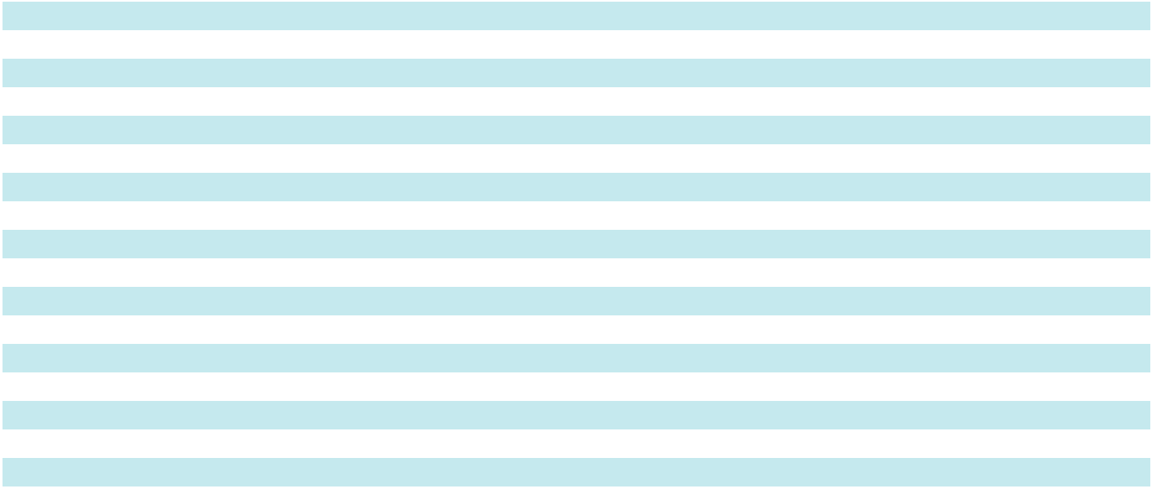

17

Table of Contents

ITEM 3. LEGAL PROCEEDINGS

The Company is a party to various legal proceedings incidental to its normal operating activities. In particular, like others in the construction supply and services industry, the Company is routinely involved in various disputes and claims arising out of construction projects, sometimes involving significant monetary damages or product replacement. We have in the past and are currently subject to product liability and warranty claims, including certain legal claims related to a commercial sealant product formerly incorporated into our products.

In December 2022, the claimant in an arbitration of one such claim was awarded $20 million by an arbitration panel. The claimant then sought to confirm this award in Los Angeles Superior Court in March 2023. In response, the Company moved to vacate the award. Later in March 2023, the Superior Court confirmed the award, which the Company appealed in June 2023. The appeal was argued before the California Court of Appeals, Second Appellate District, Division Seven, on March 7, 2025. The California Court of Appeals confirmed the judgment of the Superior Court on March 25, 2025. The Company paid the final arbitration award, including accrued post-judgment interest, in the amount of $24.7 million, on April 7, 2025. As a result of the judgment by the Superior Court, the Company recorded expense of $9.4 million, which represents the impact of the award amount net of existing reserves and estimated insurance proceeds. This impact was recorded in cost of goods sold in the fourth quarter of fiscal 2025.

The Company is also subject to litigation arising out of areas such as employment practices, workers compensation and general liability matters. Although it is very difficult to accurately predict the outcome of any such proceedings, facts currently available indicate that no matters will result in losses that would have a material adverse effect on the results of operations, cash flows or financial condition of the Company.

ITEM 4. MINE SAFETY DISCLOSURES

Not applicable.

18

Table of Contents

PART II

ITEM 5. MARKET FOR REGISTRANT'S COMMON EQUITY, RELATED STOCKHOLDER MATTERS AND ISSUER PURCHASES OF EQUITY SECURITIES

Market Information

Our common stock is traded on The Nasdaq Stock Market under the ticker symbol "APOG". As of April 4, 2025, there were 1,018 shareholders of record and 18,512 shareholders for whom securities firms acted as nominees.

Dividends

Quarterly, the Board of Directors evaluates declaring dividends based on operating results, available funds and the Company's financial condition. Cash dividends have been paid each quarter since 1974. The chart below shows quarterly and annual cumulative cash dividends per share for the past two fiscal years.

Fiscal Year |  |  | First |  |  | Second |  |  | Third |  |  | Fourth |  |  | Total
2026 | $ |  | 0.2600 | $ |  | 0.2600 | $ |  | 0.2600 | $ |  | 0.2700 | $ |  | 1.0500
2025 |  |  | 0.2500 |  |  | 0.2500 |  |  | 0.2500 |  |  | 0.2600 |  |  | 1.0100

Purchases of Equity Securities by the Company

The following table provides information with respect to purchases made by the Company of its own stock during the fourth quarter of fiscal 2026:

 |  |  |  |  |  |  | Total Number of |  | Maximum
 |  |  |  |  |  |  | Shares Purchased |  | Number of
 |  | Total Number of |  |  |  |  | as Part of |  | Shares that May
 |  | Total Number of |  |  | Average Price |  | Publicly |  | Yet Be Purchased
Period |  | Shares Purchased |  |  | Average Price |  | Announced Plans |  | under the Plans
Period |  | (a) |  |  | Paid per Share |  | or Programs (b) |  | or Programs (b)
November 30, 2025 to December 27, 2025 |  | — | $ |  | — |  | — | 2,186,793
December 28, 2025 to January 24, 2026 | 250,455 |  |  |  | 38.53 | 250,455 |  | 1,936,338
January 25, 2026 to February 28, 2026 |  | 138,127 |  |  | 38.74 |  | 138,127 |  | 1,798,211
Total | 388,582 |  | $ |  | 38.70 | 388,582 |  | 1,798,211
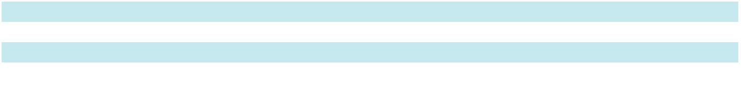

- This column includes shares repurchased pursuant to our publicly announced repurchase program and, to the extent applicable, shares that were surrendered by plan participants to satisfy withholding tax obligations related to share-based compensation.

- In fiscal 2004, announced on April 10, 2003, the Board of Directors authorized the repurchase of 1,500,000 shares of Company stock. The Board increased the authorization by 750,000 shares, announced on January 24, 2008; by 1,000,000 shares on each of the announcement dates of October 8, 2008, January 13, 2016, January 9, 2018, January 14, 2020, October 7, 2021 and June 22, 2022; and by 2,000,000 shares, announced on October 3, 2018, January 14, 2022 and October 6, 2023. The repurchase program does not have an expiration date.

19

Table of Contents

Comparative Stock Performance

The graph below compares the cumulative total shareholder return on a $100 investment in our common stock for the last five fiscal years with the cumulative total return on a $100 investment in the Russell 2000 Index, a broad equity market index, and the S&P 600 Industrials Index. Effective as of February 26, 2023, the Company changed industry indexes, from the S&P Small Cap 600 Growth Index to the S&P 600 Industrials Index. We believe that the S&P 600 Industrials Index is the best available published industry index, composed of companies with similar market capitalization and a mix of GICS classifications that reasonably reflect our diverse business activities, although most of our direct competitors in our various business units are either privately owned or are divisions of larger, publicly owned companies. The graph assumes an investment at the close of trading on February 27, 2021, and also assumes the reinvestment of all dividends.

Index Value

Comparative Stock Performance

Five-Year Cumulative Total Return

February 27, 2021 to February 28, 2026

220
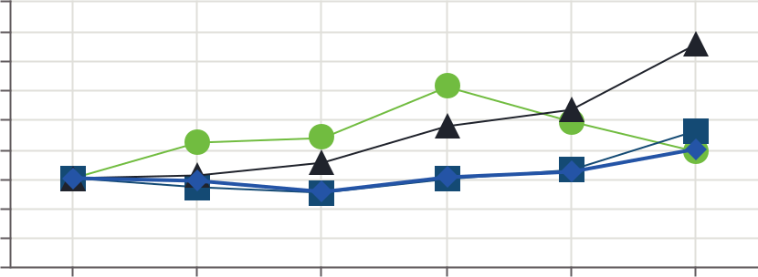

200

180

160

140

120

100

80

60

40

2021 2022 2023 2024 2025 2026

Fiscal Year

Apogee
S&P 600 Industrials
Russell 2000
S&P SmallCap 600 Growth Index

 |  |  | 2021 |  |  | 2022 |  |  | 2023 |  |  | 2024 |  |  | 2025 |  |  | 2026
Apogee |  | $ | 100.00 |  | $ | 124.12 |  | $ | 127.68 |  | $ | 162.31 |  | $ | 138.53 |  | $ | 118.17
S&P 600 Industrials |  |  | 100.00 |  |  | 93.70 |  |  | 90.05 |  |  | 99.43 |  |  | 106.08 |  |  | 132.29
Russell 2000 Index |  |  | 100.00 |  |  | 101.76 |  |  | 110.48 |  |  | 135.72 |  |  | 146.59 |  |  | 191.65
S&P SmallCap 600 Growth Index |  |  | 100.00 |  |  | 98.40 |  |  | 90.71 |  |  | 100.70 |  |  | 104.36 |  |  | 119.87
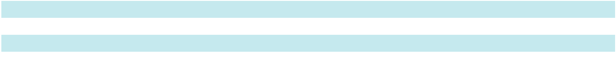

ITEM 6. [RESERVED]

20

Table of Contents

ITEM 7. MANAGEMENT'S DISCUSSION AND ANALYSIS OF FINANCIAL CONDITION AND RESULTS OF OPERATIONS

The following Management’s Discussion and Analysis of Financial Condition and Results of Operations is intended to assist the reader in understanding our financial condition and results of operations, including an evaluation of the amounts and certainty of cash flows from operations and from outside sources, and is provided as a supplement to and should be read in conjunction with the consolidated financial statements and related notes in Item 8. Financial Statements and Supplementary Data in this Form 10-K.

Additional information about results of operations and financial condition for fiscal 2025 and 2024 (including the detailed discussion of the prior fiscal year 2025 to 2024 year-over-year changes) can be found in Management’s Discussion and Analysis of Financial Condition and Results of Operations sections in our Annual Report on Form 10-K for the year ended March 1, 2025.

Overview

We are a leading provider of architectural products and services for enclosing buildings, and high-performance coating products used in applications for preservation, protection and enhanced viewing. Our four reporting segments are: Architectural Metals, Architectural Services, Architectural Glass, and Performance Surfaces.

On October 31, 2025, the Company announced the separation of its Chief Executive Officer. In connection with this separation agreement, the Board of Directors approved the accelerated vesting of certain outstanding unvested restricted stock awards and performance share unit awards previously granted. See Note 13 to our Consolidated Financial Statements for additional information.

In the first quarter of fiscal 2026, we announced Project Fortify Phase 2 to drive cost efficiencies, primarily in the Architectural Metals, Architectural Services and Corporate Segments. An extension of Phase 2 was announced on January 7, 2026 to drive additional cost savings in Architectural Metals and Corporate. Phase 2 focused on further optimizing our operating footprint and aligning resources to enable a more effective operating model. The actions of Phase 2 resulted in $27.4 million of pre-tax charges and are expected to deliver annualized pre-tax cost savings of approximately $26 million. The actions associated with Phase 2 were substantially completed in the fourth quarter of fiscal 2026. See Note 18 to our Consolidated Financial Statements for additional information.

As a result of a March 2025 appellate court decision confirming a December 2022 arbitration award, the Company paid the arbitration award, including accrued post-judgment interest, in the amount of $24.7 million, on April 7, 2025. As a result of the decision, we recorded expense of $9.4 million, which represents the impact of the award amount net of existing reserves and estimated insurance proceeds. This impact was recorded in cost of goods sold in the fourth quarter of fiscal 2025. See Note 10 to our Consolidated Financial Statements for additional information.

During the third quarter of fiscal 2025, we acquired UW Solutions for $240.9 million. UW Solutions is a U.S. based, vertically integrated manufacturer of high-performance coated substrates, differentiated by its proprietary formulations and coating application processes. The business serves a broad range of customers in attractive end markets, including building products for distribution centers and manufacturing facilities, as well as premium products for the graphic arts market. See Note 17 to our Consolidated Financial Statements for additional information.

Non-GAAP Financial Measures

In addition to reporting financial results in accordance with U.S. GAAP, we also provide certain non-GAAP financial measures. These measures are not in accordance with, nor are they a substitute for U.S. GAAP measures, and may not be comparable to similarly titled measures used by other companies. For each of these non-GAAP measures, we provide a reconciliation of the differences between the non-GAAP measure and the most directly comparable GAAP measure, (see "Reconciliation of Non-GAAP Financial Measures" in this Item 7), and an explanation of why we believe the non-GAAP measure provides useful information to management and investors.

Non-GAAP measures include:

- Adjusted net earnings and adjusted earnings per diluted share (adjusted diluted EPS), used by the Company to assess performance on a more comparable basis from period-to-period by excluding amounts that management does not consider part of core operating results.

- Adjusted EBITDA, defined as adjusted net earnings before interest, taxes, depreciation, and amortization, and adjusted EBITDA margin, defined as adjusted EBITDA as a percentage of net sales. We use adjusted EBITDA and adjusted EBITDA margin to assess segment performance and make decisions about the allocation of operating and capital resources by analyzing recent results, trends, and variances of each segment in relation to forecasts and historical performance.

21

Table of Contents

Management uses these measures to evaluate the Company’s historical and prospective financial performance, measure operational profitability on a consistent basis, as a factor in determining executive compensation, and to provide enhanced transparency to the investment community.

Results of Operations

The following tables provide various components of our operations for fiscal years 2026, 2025 and 2024 and percentages reflecting annual changes in such amounts and as a percentage of net sales in each fiscal year.

Our fiscal year ends on the Saturday closest to the last day of February. Fiscal 2026 and fiscal 2025 each consisted of 52 weeks, while fiscal 2024 consisted of 53 weeks.

 |  |  |  |  |  |  |  |  |  |  |  |  |  |  |  | % Change
 |  |  |  | 2026 |  |  | 2025 |  |  |  |  | 2024 |  |  |  | 2026 vs. |  |  |  | 2025 vs.
 | (Dollars in thousands) |  |  | 2026 |  |  | 2025 |  |  |  |  | 2024 |  |  |  | 2025 |  |  |  | 2024
 | Net sales | $ |  | 1,404,733 | $ |  | 1,360,994 |  |  | $ |  | 1,416,942 |  |  |  | 3.2 % |  |  | (3.9)%
 | Cost of sales |  |  | 1,085,259 |  |  | 1,001,101 |  |  |  |  | 1,049,814 |  |  |  | 8.4 % |  |  | (4.6)%
 | Gross profit |  |  | 319,474 |  |  | 359,893 |  |  |  |  | 367,128 |  |  |  | (11.2)% |  |  | (2.0)%
 | Selling, general and administrative expenses |  |  | 235,000 |  |  | 241,783 |  |  |  |  | 233,295 |  |  |  | (2.8)% |  |  | 3.6 %
 | Operating income |  |  | 84,474 |  |  | 118,110 |  |  |  |  | 133,833 |  |  |  | (28.5)% |  |  | (11.7)%
 | Interest expense, net |  |  | 13,976 |  |  | 6,159 |  |  |  |  | 6,669 |  |  |  | 126.9 % |  |  | (7.6)%
 | Other (income) expense, net |  |  | (6,958) |  |  | (623) |  |  |  |  | (2,089) |  |  |  | N/M |  |  |  | N/M
 | Earnings before income taxes |  |  | 77,456 |  |  | 112,574 |  |  |  |  | 129,253 |  |  |  | (31.2)% |  |  | (12.9)%
 | Income tax expense |  |  | 23,325 |  |  | 27,522 |  |  |  |  | 29,640 |  |  |  | (15.2)% |  |  | (7.1)%
 | Net earnings |  | $ | 54,131 |  | $ | 85,052 |  |  |  | $ | 99,613 |  |  |  | (36.4)% |  |  | (14.6)%
 | Diluted earnings per share |  |  |  |  |  |  |  |  |  |  |  |  |  |  | (35.2)% |  |  | (13.7)%
 | Diluted earnings per share |  | $ | 2.52 |  | $ | 3.89 |  |  |  | $ | 4.51
 | N/M - Indicates calculation is not meaningful
 | (Percentage of net sales) |  |  |  |  |  |  |  |  | 2026 |  |  |  |  |  | 2025 |  |  | 2024
 | Net sales |  |  |  |  |  |  |  |  | 100.0 % |  |  |  |  |  | 100.0 % |  |  | 100.0 %
 | Cost of sales |  |  |  |  |  |  |  |  |  |  | 77.3 |  |  |  | 73.6 |  |  | 74.1
 | Gross profit |  |  |  |  |  |  |  |  |  |  | 22.7 |  |  |  | 26.4 |  |  | 25.9
 | Selling, general and administrative expenses |  |  |  |  |  |  |  |  |  |  | 16.7 |  |  |  | 17.8 |  |  | 16.5
 | Operating income |  |  |  |  |  |  |  |  |  |  | 6.0 |  |  |  | 8.7 |  |  | 9.4
 | Interest expense, net |  |  |  |  |  |  |  |  |  |  | 1.0 |  |  |  | 0.5 |  |  | 0.5
 | Other (income) expense, net |  |  |  |  |  |  |  |  |  |  | (0.5) |  |  |  | — |  |  | (0.1)
 | Earnings before income taxes |  |  |  |  |  |  |  |  |  |  | 5.5 |  |  |  | 8.3 |  |  | 9.1
 | Income tax expense |  |  |  |  |  |  |  |  |  |  | 1.7 |  |  |  | 2.0 |  |  | 2.1
 | Net earnings |  |  |  |  |  |  |  |  |  |  | 3.9 % |  |  |  | 6.2 % |  |  | 7.0 %
 | Effective income tax rate
 | Effective income tax rate |  |  |  |  |  |  |  |  |  |  | 30.1 % |  |  |  | 24.4 % |  |  | 22.9 %
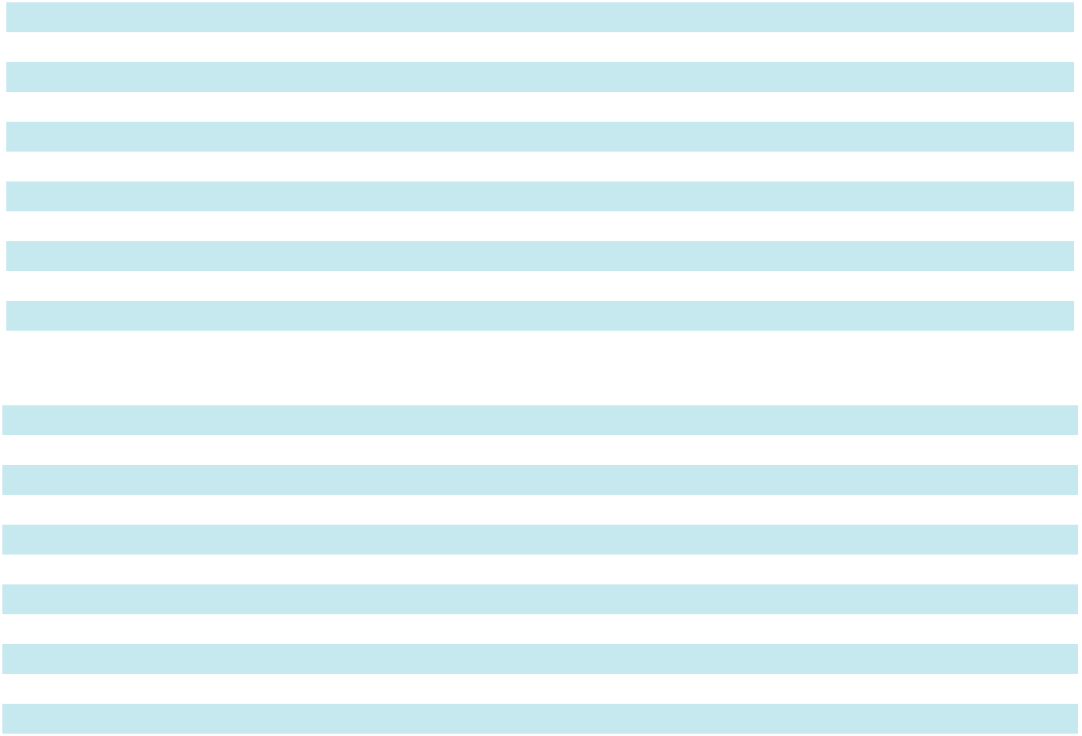

22

Table of Contents

The following table summarizes the changes in net sales from fiscal 2025 to fiscal 2026.

 |  | Architectural |  |  | Architectural |  |  | Architectural |  |  | Performance |  |  | Intersegment |  |  | Consolidated
(In thousands, except percentages) |  |  | Metals |  |  | Services |  |  | Glass |  |  | Surfaces |  | eliminations
Fiscal 2025 net sales |  | $ | 524,709 |  | $ | 419,861 |  | $ | 322,197 |  | $ | 122,131 |  | $ | (27,904) |  | $ | 1,360,994
Organic business ⁽¹⁾ |  |  | (20,681) |  |  | 19,371 |  |  | (38,538) |  |  | 10,564 |  |  | 7,752 |  |  | (21,532)
Acquisition ⁽²⁾ |  |  | — |  |  | — |  |  | — |  |  | 65,271 |  |  | — |  |  | 65,271
Fiscal 2026 net sales |  | $ | 504,028 |  | $ | 439,232 |  | $ | 283,659 |  | $ | 197,966 |  | $ | (20,152) |  | $ | 1,404,733
Total net sales growth (decline) |  |  | (3.9)% |  |  | 4.6 % |  |  | (12.0)% |  |  | 62.1 % |  |  | (27.8)% |  |  | 3.2 %
Organic business ⁽¹⁾ |  |  | (3.9)% |  |  | 4.6 % |  |  | (12.0)% |  |  | 8.6 % |  |  | (27.8)% |  |  | (1.6)%
Acquisition ⁽²⁾ |  |  | — % |  |  | — % |  |  | — % |  |  | 53.4 % |  |  | — % |  |  | 4.8 %
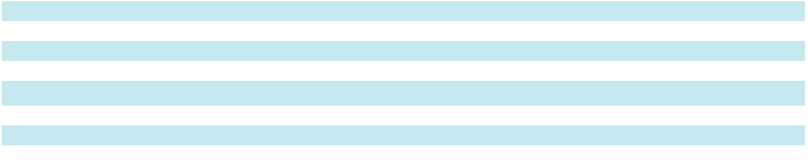

- Organic business is defined as (declines) growth in net sales from legacy businesses and from acquired businesses, twelve months after the acquisition date.

- On November 4, 2024, we completed the acquisition of UW Solutions. For additional information see Note 17 to the accompanying Consolidated Financial Statements.

Comparison of Fiscal 2026 to Fiscal 2025

- Consolidated net sales were $1.40 billion compared to $1.36 billion, an increase of 3.2%, primarily driven by $65.3 million of inorganic sales contribution from the acquisition of UW Solutions in the Performance Surfaces Segment. This was partially offset by lower volume, primarily as a result of lower demand, primarily in the Architectural Glass and Metals Segments.

- Gross margin decreased to 22.7% of net sales, compared to 26.4%, primarily due to higher aluminum costs, impacts from lower volume, and higher health insurance costs, partially offset productivity improvements including savings from Project Fortify 2 and lower risk-based insurance and incentive compensation expense. Additionally, fiscal 2025 gross margin was impacted by a non-recurring $9.4 million arbitration award expense.

- SG&A expense decreased $6.8 million to 16.7% of net sales, compared to 17.8% of net sales. The decrease was primarily due to lower incentive compensation expense, lower acquisition related expenses, and benefits from cost savings of Fortify Phase 2, partially offset by increased amortization associated with the UW Solutions transaction.

- Operating income was $84.5 million and operating margin declined to 6.0%, compared to 8.7% in the prior year.

- Interest expense, net was $14.0 million, compared to $6.2 million, primarily driven by a higher average debt balance resulting from the acquisition of UW Solutions.

- Other income was $7.0 million, compared to $0.6 million, driven by a $6.7 million gain from settling a New Markets Tax Credit transaction.

- Income tax expense as a percentage of earnings before income tax was 30.1%, compared to 24.4% for fiscal 2025. The increase in the effective tax rate was primarily due to an increase in tax expense on discrete items in fiscal year 2026.

- Diluted EPS was $2.52, compared to $3.89.

Segment Analysis

Disclosures related to our business segments are included in Note 16 of our Consolidated Financial Statements. We manage our business in four reportable segments: Architectural Metals, Architectural Services, Architectural Glass and Performance Surfaces.

23

Table of Contents

The following table presents net sales, adjusted EBITDA and adjusted EBITDA margin by segment and the consolidated total.

 |  |  |  |  |  |  |  |  |  |  | % Change
 |  |  | 2026 |  |  | 2025 |  |  | 2024 |  | 2026 vs. |  | 2025 vs.
(Dollars in thousands) |  |  | 2026 |  |  | 2025 |  |  | 2024 |  | 2025 | 2024
Segment net sales
Architectural Metals | $ |  | 504,028 | $ |  | 524,709 | $ |  | 601,736 |  | (3.9)% | (12.8)%
Architectural Services |  |  | 439,232 |  |  | 419,861 |  |  | 378,422 |  | 4.6 % | 11.0 %
Architectural Glass |  |  | 283,659 |  |  | 322,197 |  |  | 378,449 |  | (12.0)% | (14.9)%
Performance Surfaces |  |  | 197,966 |  |  | 122,131 |  |  | 99,223 |  | 62.1 % | 23.1 %
Total segment sales |  |  | 1,424,885 |  |  | 1,388,898 |  |  | 1,457,830 |  | 2.6 % | (4.7)%
Intersegment eliminations |  |  | (20,152) |  |  | (27,904) |  |  | (40,888) |  | (27.8)% | (31.8)%
Net sales | $ |  | 1,404,733 | $ |  | 1,360,994 | $ |  | 1,416,942 |  | 3.2 % | (3.9)%
Segment adjusted EBITDA
Architectural Metals | $ |  | 54,109 | $ |  | 70,591 | $ |  | 90,029 |  | (23.3)% | (21.6)%
Architectural Services |  |  | 30,856 |  |  | 33,533 |  |  | 18,376 |  | (8.0)% | 82.5 %
Architectural Glass |  |  | 45,699 |  |  | 71,664 |  |  | 77,738 |  | (36.2)% | (7.8)%
Performance Surfaces |  |  | 41,643 |  |  | 30,886 |  |  | 27,273 |  | 34.8 % | 13.2 %
Corporate and Other |  |  | (5,004) |  |  | (14,021) |  |  | (35,119) |  | (64.3)% | (60.1)%
Adjusted EBITDA | $ |  | 167,303 | $ |  | 192,653 | $ |  | 178,297 |  | (13.2)% | 8.1 %
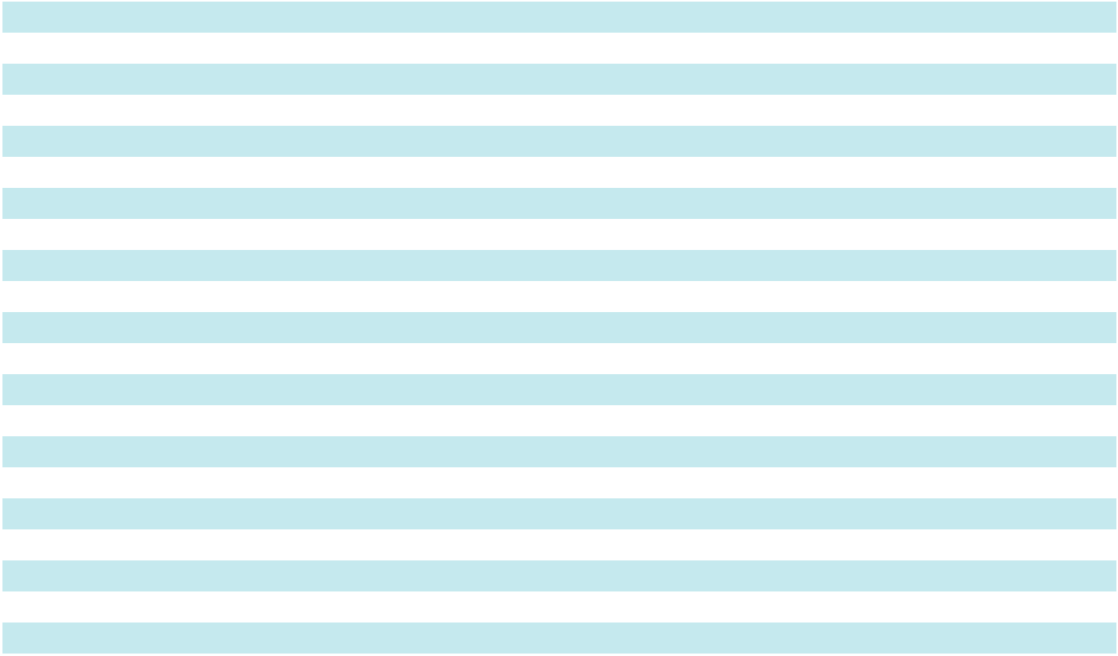
Segment adjusted EBITDA margin
Architectural Metals | 10.7 % | 13.5 % |  | 15.0 %
Architectural Services | 7.0 % | 8.0 % |  | 4.9 %
Architectural Glass | 16.1 % | 22.2 % |  | 20.5 %
Performance Surfaces | 21.0 % | 25.3 % |  | 27.5 %
Adjusted EBITDA margin | 11.9 % | 14.2 % |  | 12.6 %

Architectural Metals

Comparison of Fiscal 2026 to Fiscal 2025

- Net sales were $504.0 million, compared to $524.7 million, due to lower volume, partially offset by favorable price.

- Adjusted EBITDA was $54.1 million, or 10.7% of net sales, compared to $70.6 million, or 13.5% of net sales. The decline in Adjusted EBITDA margin was primarily driven by inflation, including higher aluminum costs, and the impact of lower volume, partially offset by pricing, cost savings from Project Fortify Phase 2 and lower incentive compensation costs.

Architectural Services

Comparison of Fiscal 2026 to Fiscal 2025

- Net sales were $439.2 million, compared to $419.9 million. The increase in net sales was driven by increased volume, partially offset by unfavorable project mix and lower pricing.

- Adjusted EBITDA was $30.9 million, or 7.0% of net sales, compared to $33.5 million, or 8.0% of net sales. The decline in Adjusted EBITDA margin was primarily due to the impact of unfavorable project mix, lower price, and direct tariff expenses, partially offset by the impact of increased volume and lower incentive compensation costs.

- For the years ended February 28, 2026 and March 1, 2025, gross favorable and unfavorable cumulative catch-up adjustments on our longer-term contracts for changes in estimates were as follows:

(in thousands) |  |  | 2026 |  |  | 2025
Gross favorable adjustments | $ |  | 32,810 | $ |  | 28,430
Gross unfavorable adjustments |  |  | (23,978) |  |  | (12,123)
Net adjustments | $ |  | 8,832 | $ |  | 16,307

24

Table of Contents

Architectural Glass

Comparison of Fiscal 2026 to Fiscal 2025

- Net sales were $283.7 million, compared to $322.2 million. The decrease in net sales was primarily driven by lower volume and price due to lower end-market demand.

- Adjusted EBITDA was $45.7 million, or 16.1% of net sales, compared to $71.7 million, or 22.2% of net sales. The decline in Adjusted EBITDA margin was primarily driven by the impact from lower volume and price, and higher manufacturing costs, partially offset by lower incentive compensation costs.

Performance Surfaces

Comparison of Fiscal 2026 to Fiscal 2025

- Net sales were $198.0 million, compared to $122.1 million. The increase was driven by $65.3 million of inorganic sales contribution from the acquisition of UW Solutions, and higher volume and price.

- Adjusted EBITDA was $41.6 million, or 21.0% of net sales, compared to $30.9 million, or 25.3% of net sales. The decline in Adjusted EBITDA margin was primarily driven by higher manufacturing costs and the dilutive effect of lower adjusted EBITDA margin from the UW Solutions acquisition, partially offset by favorable product mix and price.

Corporate and Other

Comparison of Fiscal 2026 to Fiscal 2025

- Corporate and Other Adjusted EBITDA expense was $5.0 million, compared to $14.0 million. The decline in Corporate expense was primarily due to lower incentive compensation and risk-related insurance costs, partially offset by higher health insurance costs.

Backlog

Backlog is defined as the dollar amount of signed contracts or firm orders, generally as a result of a competitive bidding process, which is expected to be recognized as revenue. Backlog is an operating measure used by management to assess future potential sales revenue. Backlog is not a term defined under GAAP and is not a measure of contract profitability. Backlog should not be used as the sole indicator of future revenue because we have a substantial number of projects with short lead times that book-and-bill within the same reporting period that are not included in backlog.

As of fiscal 2026 year-end, backlog in the Architectural Services Segment was $693.8 million, compared to $720.3 million at the end of the prior year.

Reconciliations of Non-GAAP Financial Measures

Adjusted EBITDA and Adjusted EBITDA Margin

 |  |  |  |  |  | Twelve Months Ended February 28, 2026
(In thousands) (Unaudited) |  | Architectural |  |  | Architectural |  |  | Architectural |  |  |  | Performance |  | Corporate and |  |  |  | Consolidated
(In thousands) (Unaudited) |  |  | Metals |  |  | Services |  |  | Glass |  |  | Surfaces |  |  | Other |  |  | Consolidated
Net earnings (loss) |  | $ | 37,775 | $ |  | 12,193 | $ |  | 32,661 | $ |  | 24,659 | $ |  | (53,157) | $ |  | 54,131
Interest expense (income), net |  |  | 1,733 |  |  | (310) |  |  | (699) |  |  | — |  |  | 13,252 |  |  | 13,976
Income tax (benefit) expense |  |  | (43) |  |  | (8) |  |  | 295 |  |  | — |  |  | 23,081 |  |  | 23,325
Depreciation and amortization |  |  | 14,813 |  |  | 3,593 |  |  | 13,442 |  |  | 15,153 |  |  | 2,997 |  |  | 49,998
EBITDA |  |  | 54,278 |  |  | 15,468 |  |  | 45,699 |  |  | 39,812 |  |  | (13,827) |  |  | 141,430
Acquisition-related costs ⁽¹⁾ |  |  | — |  |  | — |  |  | — |  |  | 1,831 |  |  | 313 |  |  | 2,144
Restructuring costs ⁽²⁾ |  |  | 6,571 |  |  | 15,388 |  |  | — |  |  | — |  |  | 5,484 |  |  | 27,443
CEO transition costs ⁽³⁾ |  |  | — |  |  | — |  |  | — |  |  | — |  |  | 3,026 |  |  | 3,026
NMTC settlement gain ⁽⁴⁾ |  |  | (6,740) |  |  | — |  |  | — |  |  | — |  |  | — |  |  | (6,740)
Adjusted EBITDA |  | $ | 54,109 | $ |  | 30,856 | $ |  | 45,699 | $ |  | 41,643 | $ |  | (5,004) | $ |  | 167,303
EBITDA margin |  |  | 10.8 % |  |  | 3.5 % |  |  | 16.1 % |  |  | 20.1 % |  |  | N/M |  |  | 10.1 %
Adjusted EBITDA margin |  |  | 10.7 % |  |  | 7.0 % |  |  | 16.1 % |  |  | 21.0 % |  |  | N/M |  |  | 11.9 %
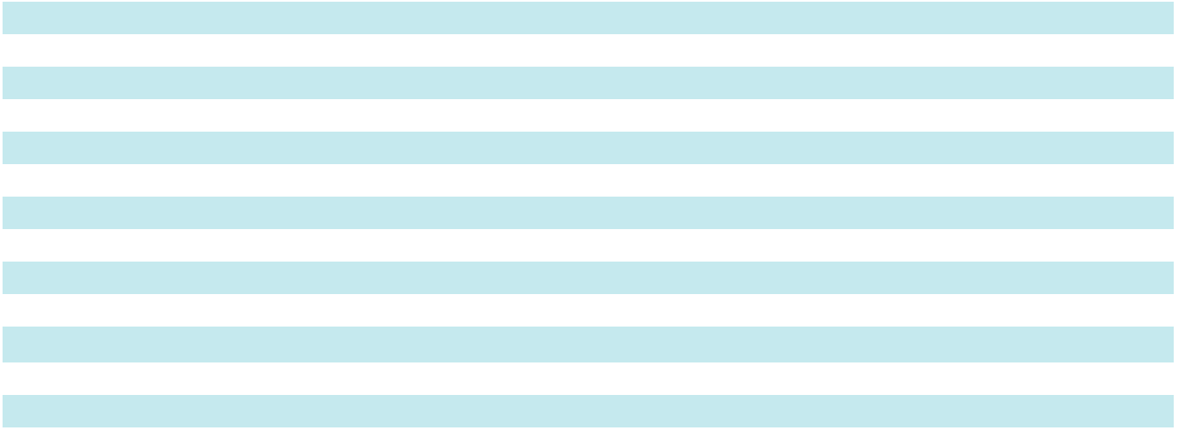

25

Table of Contents

 |  |  |  |  |  | Twelve Months Ended March 01, 2025
(In thousands) (Unaudited) |  | Architectural |  |  | Architectural |  |  | Architectural |  |  |  | Performance |  |  | Corporate and |  |  |  | Consolidated
(In thousands) (Unaudited) |  |  | Metals |  |  | Services |  |  | Glass |  |  | Surfaces |  |  |  | Other |  |  | Consolidated
Net earnings (loss) |  | $ | 40,345 | $ |  | 30,035 | $ |  | 60,451 | $ |  | 19,611 |  |  | $ | (65,390) | $ |  | 85,052
Interest expense (income), net |  |  | 2,113 |  |  | 10 |  |  | (408) |  |  | — |  |  |  | 4,444 |  |  | 6,159
Income tax expense (benefit) |  |  | 7 |  |  | — |  |  | (653) |  |  | — |  |  |  | 28,168 |  |  | 27,522
Depreciation and amortization |  |  | 16,471 |  |  | 3,978 |  |  | 12,274 |  |  | 9,086 |  |  |  | 2,799 |  |  | 44,608
EBITDA |  |  | 58,936 |  |  | 34,023 |  |  | 71,664 |  |  | 28,697 |  |  |  | (29,979) |  |  | 163,341
Acquisition-related costs ⁽¹⁾ |  |  | — |  |  | — |  |  | — |  |  | 2,189 |  |  |  | 5,773 |  |  | 7,962
Restructuring costs ⁽²⁾ |  |  | 4,021 |  |  | (490) |  |  | — |  |  | — |  |  |  | 792 |  |  | 4,323
Impairment expense ⁽⁵⁾ |  |  | 7,634 |  |  | — |  |  | — |  |  | — |  |  |  | — |  |  | 7,634
Arbitration award expense ⁽⁶⁾ |  |  | — |  |  | — |  |  | — |  |  | — |  |  |  | 9,393 |  |  | 9,393
Adjusted EBITDA |  | $ | 70,591 | $ |  | 33,533 | $ |  | 71,664 | $ |  | 30,886 |  |  | $ | (14,021) | $ |  | 192,653
EBITDA margin |  |  | 11.2 % |  |  | 8.1 % |  |  | 22.2 % |  |  | 23.5 % |  |  |  | N/M |  |  | 12.0 %
Adjusted EBITDA margin |  |  | 13.5 % |  |  | 8.0 % |  |  | 22.2 % |  |  | 25.3 % |  |  |  | N/M |  |  | 14.2 %

- Acquisition-related costs include one-time expenses incurred to integrate the UW Solutions acquisition and excludes $2.3 million of backlog amortization added back as part of depreciation and amortization above.

- Restructuring costs related to Project Fortify. Costs incurred in fiscal year 2025 were associated with Phase 1 and costs incurred in fiscal year 2026 are associated with Phase 2, including $11.5 million of asset impairment charges in fiscal 2026.

- Transition costs related to departure of Chief Executive Officer during the third quarter of fiscal 2026.

- Gain related to the settlement of a New Markets Tax Credit transaction.

- Impairment expense on intangible assets in the Architectural Metals Segment.

- Expense related to an arbitration award, which represents the impact of the award amount net of existing reserves and estimated insurance proceeds.

Adjusted net earnings and adjusted diluted earnings per share

Twelve Months Ended

(In thousands) (Unaudited) |  | February 28, 2026 |  |  | March 1, 2025
Net earnings | $ | 54,131 | $ |  | 85,052
Acquisition-related costs ⁽¹⁾ |  | 2,144 |  |  | 10,302
Restructuring costs ⁽²⁾ |  | 27,443 |  |  | 4,323
CEO transition costs ⁽³⁾ |  | 3,026 |  |  | —
NMTC settlement gain ⁽⁴⁾ |  | (6,740) |  |  | —
Impairment expense ⁽⁵⁾ |  | — |  |  | 7,634
Arbitration award expense ⁽⁶⁾ |  | — |  |  | 9,393
Income tax impact on above adjustments ⁽⁷⁾ |  | (5,321) |  |  | (7,832)
Adjusted net earnings | $ | 74,683 | $ |  | 108,872
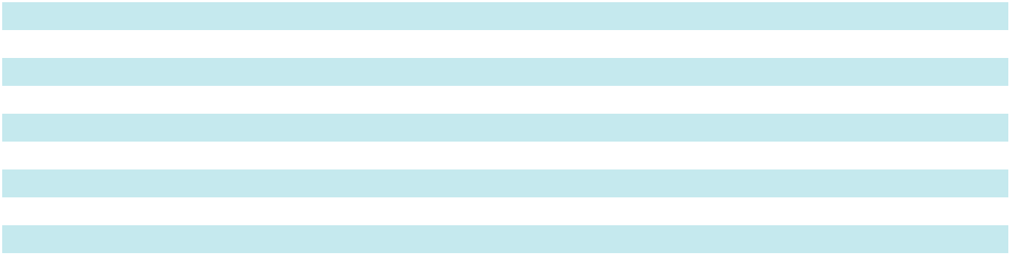

26

Table of Contents

Twelve Months Ended

(Shares in thousands) (Unaudited) February 28, 2026 March 1, 2025
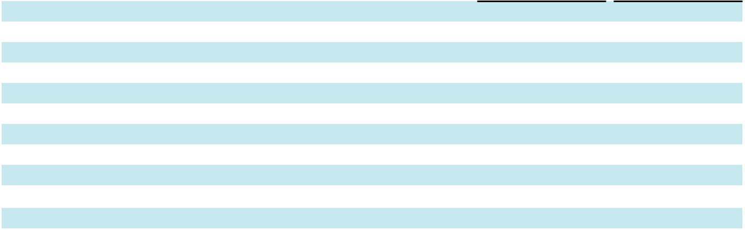

Diluted earnings per share

Acquisition-related costs ⁽¹⁾
Restructuring costs ⁽²⁾
CEO transition costs ⁽³⁾
NMTC settlement gain ⁽⁴⁾
Impairment expense ⁽⁵⁾
Arbitration award expense ⁽⁶⁾
Income tax impact on above adjustments ⁽⁷⁾
Adjusted diluted earnings per share

$ | 2.52 | $ |  | 3.89
 | 0.10 |  |  | 0.47
 | 1.28 |  |  | 0.20
 | 0.14 |  |  | —
 | (0.31) |  |  | —
 | — |  |  | 0.35
 | — |  |  | 0.43
 | (0.25) |  |  | (0.36)
$ | 3.47 | $ |  | 4.97

Weighted average diluted shares outstanding | 21,517 | 21,891

- Acquisition-related costs include one-time expenses incurred to integrate the UW Solutions acquisition.

- Restructuring costs related to Project Fortify. Costs incurred in fiscal year 2025 were associated with Phase 1 and costs incurred in fiscal year 2026 are associated with Phase 2, including $11.5 million of asset impairment charges in fiscal 2026.

- Transition costs related to departure of Chief Executive Officer during the third quarter of fiscal 2026.

- Gain related to the settlement of a New Market Tax Credit transaction.

- Impairment expense on intangible assets in the Architectural Metals Segment.

- Expense related to an arbitration award, which represents the impact of the award amount net of existing reserves and estimated insurance proceeds.

- Income tax impact reflects the estimated blended statutory tax rate for the jurisdictions in which the charge or income occurred.

Liquidity and Capital Resources

We rely on cash provided by operations for our material cash requirements, including working capital needs, capital expenditures, satisfaction of contractual commitments (including principal and interest payments on our outstanding indebtedness) and shareholder return through dividend payments and share repurchases.

Operating Activities. Net cash provided by operating activities was $122.5 million, compared to $125.2 million. . The decline in cash provided by operating activities was driven by reduced net earnings, partially offset by a reduction in cash used for working capital.

Investing Activities. Net cash used by investing activities was $30.5 million, compared to $265.9 million. In fiscal 2026, cash was primarily used to fund capital expenditures of $27.3 million, while in fiscal 2025, cash was primarily used to fund the acquisition of UW Solutions for $232.2 million, in addition to funding capital expenditures of $35.6 million.

Financing Activities. Net cash used by financing activities was $96.2 million in fiscal 2026, compared to $146.0 million of net cash provided by financing activities in fiscal 2025. The use of cash in fiscal 2026 was primarily for net repayment of debt compared to obtaining debt funding in fiscal 2025 to support the acquisition of UW Solutions. Net cash used to repurchase common stock was $15.0 million and $45.4 million for fiscal 2026 and fiscal 2025, respectively.

Additional Liquidity Considerations. We periodically evaluate our liquidity requirements, cash needs and availability of debt resources relative to acquisition plans, significant capital plans, and other working capital needs.

On July 19, 2024, we entered into a Credit Agreement (the Credit Agreement) with Bank of America, N.A., as administrative agent, and other lenders. The Credit Agreement provides for an unsecured senior credit facility in an aggregate principal amount of up to $700.0 million, in which commitments were made through a $450.0 million, five-year revolving credit facility and a committed $250.0 million delayed draw term loan facility. Borrowings under the revolving credit facility can be in Canadian dollars (CAD) limited to $25.0 million USD. The term loan facility may be utilized in up to two draw downs, which are available to be made within one year after the closing date. The senior credit facility has a term of five years with a maturity date of July 19, 2029.

The Credit Agreement replaces the previous revolving credit facility with Wells Fargo Bank, N.A., as administrative agent, and other lenders, with maximum borrowings up to $385.0 million, and the two Canadian credit facilities with Bank of Montreal totaling $25.0 million USD.

The Credit Agreement contains two maintenance financial covenants that require our Consolidated Leverage Ratio (as defined in the Credit Agreement) to be less than 3.50 and our Consolidated Interest Coverage Ratio (as defined in the Credit Agreement) to exceed 3.00. At February 28, 2026, we were in compliance with all covenants as defined under the terms of the Credit Agreement.

27

Table of Contents

The Credit Agreement also contains an acquisition "holiday." In the event we make an acquisition for which the purchase price is greater than $75 million, we can elect to increase the maximum Consolidated Leverage Ratio (as defined in the Credit Agreement) to 4.00 for a period of four consecutive fiscal quarters, commencing with the fiscal quarter in which a qualifying acquisition occurs. No more than two acquisition holidays can occur during the term of the Credit Agreement, and at least two fiscal quarters must separate qualifying acquisitions.

Borrowings under the Credit Agreement bear floating interest at either the Base Rate or Term Secured Overnight Financing Rate (SOFR), or, for CAD borrowings, Canadian Overnight Repo Rate Average (CORRA) plus a margin based on the Consolidated Leverage Ratio (as defined in the Credit Agreement). For Base Rate borrowings, the margin ranges from 0.25% to 0.75%. For Term SOFR and CORRA borrowings, the margin ranges from 1.25% to 1.75%, with an incremental Term SOFR and CORRA adjustment of 0.10% and 0.29547%.

The Credit Agreement also contains an "accordion" provision. Under this provision, we can request that the senior credit facility be increased unlimited additional amounts. Any lender may elect or decline to participate in the requested increase at their sole discretion.

As of February 28, 2026, outstanding borrowings under the term loan facility were $212.3 million and outstanding borrowings under the revolving credit facility were $20.0 million. As of March 1, 2025, outstanding borrowings under the term loan and credit facility were $215.0 million and $70.0 million, respectively. Outstanding borrowings under the previous revolving credit facility were $50.0 million as of March 2, 2024. We had no outstanding borrowings under the Canadian facilities as of March 2, 2024.

At March 2, 2024, debt included $12.0 million of industrial revenue bonds. We had no outstanding industrial revenue bonds as of February 28, 2026, or March 1, 2025, as in the fourth quarter of fiscal 2025 we paid the remaining balance of these bonds, including principal and interest outstanding, without penalty.

At February 28, 2026, we had a total of $2.6 million of ongoing letters of credit that expire in fiscal year 2027 and reduce borrowing capacity under the revolving credit facility. As of February 28, 2026, the amount available for revolving borrowings was $427.4 million.

We acquire the use of certain assets through operating leases, such as property, manufacturing equipment, vehicles and other equipment. Future payments for such leases, excluding leases with initial terms of one year or less, were $60.8 million at February 28, 2026, with $15.8 million payable within the next 12 months. See Note 8 to our Consolidated Financial Statements for further detail surrounding our lease obligations and the timing of expected future payments.

As of February 28, 2026, we had $15.1 million of open purchase obligations, primarily related to raw material commitments, of which payments totaling $9.3 million are expected to become due within the next 12 months.

As of February 28, 2026, we had reserves of $4.1 million for long-term unrecognized tax benefits. We are unable to reasonably estimate in which future periods the remaining unrecognized tax benefits will ultimately be settled.

We are required, in the ordinary course of business, to provide surety or performance bonds that commit payments to our customers for any non-performance. At February 28, 2026, $267.5 million of our backlog was bonded by performance bonds with a face value of $1.3 billion. These bonds have expiration dates that align with completion of the purchase order or contract. We have never been required to make payments under surety or performance bonds with respect to our existing businesses.

Due to our ability to generate strong cash from operations and our borrowing capability under our committed revolving credit facilities, we believe that our sources of liquidity will be adequate to meet our short-term and long-term liquidity and capital expenditure needs. In addition, we believe we have the ability to obtain both short-term and long-term debt to meet our financing needs, including additional sources of debt to finance potential material acquisitions for the foreseeable future. We also believe we will be able to operate our business so as to continue to be in compliance with our existing debt covenants over the next fiscal year.

We continually review our portfolio of businesses and their assets and how they support our business strategy and performance objectives. As part of this review, we may acquire other businesses, pursue geographic expansion, take actions to manage capacity and further invest in, divest and/or sell parts of our current businesses.

Recently Issued Accounting Pronouncements

See Note 1 to our Consolidated Financial Statements in Item 8 of this Form 10-K for information pertaining to recently issued accounting pronouncements, incorporated herein by reference.

28

Table of Contents

Critical Accounting Policies and Estimates

Our analysis of operations and financial condition is based on our consolidated financial statements prepared in accordance with GAAP. Preparation of these consolidated financial statements requires us to make estimates and assumptions affecting the reported amounts of assets and liabilities at the date of the consolidated financial statements, reported amounts of revenues and expenses during the reporting period and related disclosures of contingent assets and liabilities. Our estimates are evaluated on an ongoing basis and are drawn from historical experience and other assumptions that we believe to be reasonable under the circumstances. Actual results could differ under other assumptions or circumstances.

We consider the following items in our consolidated financial statements to require significant estimation or judgment. Revenue recognition

We generate revenue from the design, engineering and fabrication of architectural glass, curtainwall, window, storefront and entrance systems, and from installing those products on non-residential buildings. We also manufacture value-added glass, acrylic, and industrial flooring products. Due to the diverse nature of our operations and various types of contracts with customers, we have businesses that recognize revenue over time and businesses that recognize revenue at a point in time. We believe the most significant areas of estimation and judgment are related to our businesses that recognize revenue using the over-time input method.

Approximately 35% of our total revenue in fiscal 2026 was from longer-term, fixed-price contracts, which are primarily in our Architectural Services Segment. The contracts in this segment have a single, bundled performance obligation, as this business generally provides interrelated products and services and integrates these products and services into a combined output specified by the customer. The customer obtains control of this combined output over time. We measure progress on these contracts following an input method, by comparing total costs incurred to-date to the total estimated costs for the contract, and record that proportion of the total contract price as revenue in the period. Contract costs include materials, labor and other direct costs related to contract performance. We believe this method of recognizing revenue is consistent with our progress in satisfying our contract obligations.

Due to the nature of the work required under these long-term contracts, the estimation of total costs remaining to complete on a project is subject to many variables and requires significant judgment. It is common for these contracts to contain potential bonuses or penalties which are generally awarded or charged upon certain project milestones or cost or timing targets, and can be based on customer discretion. We estimate variable consideration at the most likely amount to which we expect to be entitled. We include estimated amounts in the transaction price to the extent that it is probable that a significant reversal of cumulative revenue recognized will not occur when the uncertainty associated with the variable consideration is resolved. Our estimates of variable consideration and determination of whether to include estimated amounts in the transaction price are based largely on our assessments of anticipated performance and all information (historical, current and forecasted) that is reasonably available to us.

Long-term contracts are often modified to account for changes in contract specifications and requirements of work to be performed. We consider contract modifications to exist when the modification, generally through a change order, either creates new or changes existing enforceable rights and obligations, and we evaluate these types of modifications to determine whether they may be considered distinct performance obligations. In many cases, these contract modifications are for goods or services that are not distinct from the existing contract, due to the significant integration service provided in the context of the contract. Therefore, these modifications are generally accounted for as part of the existing contract. The effect of a contract modification on the transaction price and our measure of progress is recognized as an adjustment to revenue, generally on a cumulative catch-up basis.

Due to the significant judgments utilized in our revenue recognition on long-term contracts, if subsequent actual results and/or updated assumptions, estimates, or projections were to materially change from those utilized at February 28, 2026, our results of operations in the future could be materially impacted.

Goodwill and indefinite-lived intangible asset valuation

Goodwill

We evaluate goodwill for impairment annually on the first day in our fiscal fourth quarter, or more frequently if events or changes in circumstances indicate the carrying value of the goodwill may not be recoverable. Evaluating goodwill for impairment involves the determination of the fair value of each reporting unit in which goodwill is recorded using a qualitative or quantitative analysis. A reporting unit is an operating segment, or a component of an operating segment, for which discrete financial information is available and reviewed by segment management on a regular basis. The reporting units for our fiscal 2026 annual impairment test align with our Architectural Metals, Architectural Services, Architectural Glass, and Performance Surfaces Segments.

29

Table of Contents

For the fiscal 2026 impairment test, we elected to bypass the qualitative assessment process and proceeded directly to comparing the estimated fair value of each of our reporting units to carrying value, including goodwill. If fair value exceeds the carrying value, goodwill impairment is not indicated. If the carrying amount of a reporting unit is higher than its estimated fair value, the excess is recognized as an impairment expense.

We estimate the fair value of a reporting unit using both the income approach and the market approach. The income approach uses a discounted cash flow methodology that involves significant judgment and projections of future performance. Assumptions about future revenues and future operating expenses, capital expenditures and changes in working capital are based on the annual operating plan and other business plans for each reporting unit. These plans take into consideration numerous factors, including historical experience, current and future operational plans, anticipated future economic conditions and growth expectations for the industries and end markets in which we participate. These projections are discounted using a weighted-average cost of capital, which considers the risk inherent in our projections of future cash flows. We determine the weighted-average cost of capital for this analysis by weighting the required returns on interest-bearing debt and common equity capital in proportion to their estimated percentages in an expected capital structure, using published data where possible. We used discount rates that are commensurate with the risks and uncertainties inherent in the respective businesses and in the internally developed forecasts. The market approach uses a multiple of earnings and revenue based on publicly traded companies.

Based on these analyses, estimated fair value exceeded carrying value at all of our reporting units. The discounted cash flow projections used in these analyses are dependent upon achieving forecasted levels of revenue and profitability. If revenue or profitability were to fall below forecasted levels, or if market conditions were to decline in a material or sustained manner, impairment could be indicated at our reporting units and we could incur non-cash impairment expense that would negatively impact our net earnings. For example, keeping all other assumptions constant, a 100 basis point increase in the weighted average cost of capital would cause the estimated fair values of our reporting units to decrease in the range of $9 million to $39 million. In addition, keeping all other assumptions constant, a 100 basis point reduction in the long-term growth rate would cause the estimated fair values of our reporting units to decrease in the range of $11 million to $18 million. Given the amounts by which the fair value exceeds the carrying value for each of our reporting units, the decreases in estimated fair values described above would not have significantly impacted the results of our impairment tests.

Indefinite-lived intangible assets

We have intangible assets for certain acquired trade names and trademarks which we have determined to have indefinite useful lives. We evaluate the reasonableness of the useful lives and test indefinite-lived intangible assets for impairment annually at the same measurement date as goodwill, the first day of our fiscal fourth quarter, or more frequently if events or changes in circumstances indicate that it is more likely than not that the asset is impaired.

For our fiscal 2026 annual impairment test, we bypassed a qualitative assessment and performed a quantitative impairment test to compare the fair value of each indefinite-lived intangible asset with its carrying value. If the carrying value of an indefinite-lived intangible asset exceeds its fair value, an impairment expense is recognized in an amount equal to that excess. If an impairment expense is recognized, the adjusted carrying amount becomes the asset's new accounting basis.

Fair value is measured using the relief-from-royalty method. This method assumes the trade name or trademark has value to the extent that the owner is relieved of the obligation to pay royalties for the benefits received from the asset. This method requires estimation of future revenue from the related asset, the appropriate royalty rate, and the weighted average cost of capital. The assessment of fair value involves significant judgment and projections about future performance. In the fair value analysis, we assumed a discount rate of 13%, a royalty rate of 1.5%, and a long-term growth rate of 1.0%. Based on our annual analysis, the fair value of our indefinite-lived intangible assets exceeded carrying value.

We continue to conclude that the useful lives of our indefinite-lived intangible assets are appropriate. If future revenue were to fall below forecasted levels or if market conditions were to decline in a material or sustained manner, impairment could be indicated on these indefinite-lived intangible assets.

Reserves for disputes and claims regarding product liability, warranties and other project-related contingencies

We are subject to claims associated with our products and services, principally as a result of disputes with our customers involving the performance or aesthetics of our products, some of which may be covered under our warranty policies. We have in the past and are currently subject to product liability and warranty claims, including certain legal claims related to a commercial sealant product formerly incorporated into our products. We also are subject to project management and installation-related contingencies as a result of our fixed-price material supply and installation service contracts, primarily in our Architectural Services Segment. The time period from when a claim is asserted to when it is resolved, either by negotiation, settlement or litigation, can be several years. While we maintain various types of product liability insurance, the insurance policies include significant self-retention of risk in the form of policy deductibles. In addition, certain claims could be

30

Table of Contents

determined to be uninsured. We also actively manage the risk of these exposures through contract negotiations and proactive project management.

We reserve estimated exposures on known claims, as well as on a portion of anticipated claims for product warranty and rework costs, based on similar historical product liability claims, as a ratio of sales. We also reserve for estimated exposures on other claims as they are known and reasonably estimable.

Income taxes

We are required to make judgments regarding the potential tax effects of various financial transactions and ongoing operations to estimate our obligation to taxing authorities. These tax obligations include income, real estate, franchise and sales/use taxes. Judgments related to income taxes require the evaluation and recognition in our financial statements that a tax position is more-likely-than-not to be sustained on audit.

Judgment and estimation is required in developing a provision for income taxes and recognizing tax-related assets and liabilities and, if necessary, any valuation allowances. The interpretation of tax laws can involve uncertainty, since tax authorities may interpret such laws differently. Actual income tax could vary from estimated amounts and may result in favorable or unfavorable impacts to net income, cash flows and tax-related assets and liabilities. In addition, the effective tax rate may be affected by other changes, including the allocation of property, payroll and revenues between states.

We assess deferred tax assets for recoverability taking into consideration historical and anticipated earnings levels; the reversal of other existing temporary differences; available net operating losses and tax carryforwards; and available tax planning strategies that could be implemented to realize the deferred tax assets. Based on this assessment, management must evaluate the need for, and amount of, a valuation allowance against deferred tax assets. As facts and circumstances change, adjustment to the valuation allowance may be required.

31

Table of Contents

ITEM 7A. QUANTITATIVE AND QUALITATIVE DISCLOSURES ABOUT MARKET RISK

We are exposed to ongoing market risk related to changes in interest rates, foreign currency exchange rates and raw material pricing.

Interest Rate Risk

A rise in interest rates could negatively affect the fair value of our fixed income investments, while serving to provide greater long-term return potential on these investments. To manage our direct risk from changes in market interest rates, we actively monitor the interest-sensitive components of our balance sheet, primarily available-for-sale securities, fixed income securities and debt obligations, and maintain a diversified portfolio in order to minimize the impact of changes in interest rates on net earnings and cash flow. We do not hold any financial instruments for trading purposes. We may use interest rate swaps, currency put options, forward purchase contracts, or other instruments to manage risks generally associated with foreign exchange rate, interest rate and commodity price fluctuations.

The primary measure of interest rate risk is the simulation of net income under different interest rate environments. If interest rates were to increase or decrease over the next 12 months by 200 basis points, net earnings would be impacted by approximately $0.6 million. Our debt exceeded investments at February 28, 2026, so as interest rates increase, net earnings decrease; as interest rates decrease, net earnings increase.

In addition to the market risk related to interest rate changes on our financial instruments, the non-residential construction markets in which our businesses operate are highly affected by changes in interest rates. Increases in interest rates could adversely impact activity in the non-residential construction industry and our operating results.

Foreign Currency Exchange Rate Risk

We are subject to market risk due to changes in the value of foreign currencies in relation to our reporting currency, the U.S. dollar.

We have foreign operations in Canada, Brazil, the Netherlands and Belgium which primarily transact business in local currencies. We manage these operating activities locally. Revenues, costs, assets and liabilities of these operations are generally denominated in local currencies, thereby mitigating some of the risk associated with changes in foreign exchange rates. However, our consolidated financial results are reported in U.S. dollars. Thus, changes in exchange rates between the Canadian dollar, Brazilian Real and Euro versus the U.S. dollar, will impact our reported financial results. From time to time, we enter into forward purchase foreign currency contracts, generally with an original maturity date of less than one year, to hedge foreign currency risk (see Note 4 to our Consolidated Financial Statements). Sales from our domestic operations are generally denominated in U.S. dollars.

Raw Material Pricing Risk

We are subject to market risk exposure related to volatility in the prices of aluminum and lumber, among other raw materials and supplies used in our end products. A significant amount of our cost of sales relates to material costs. The commodities markets, which include aluminum, are highly cyclical in nature. As a result, commodity costs can be volatile. Commodity costs are influenced by numerous factors beyond our control, including general economic conditions, the availability of raw materials, competition, labor costs, freight and transportation costs, production costs, tariffs, import duties and other trade restrictions.

We principally manage our exposures to the market fluctuations in the aluminum industry through forward purchase agreements. Although we have the ability to purchase aluminum from a number of suppliers, a production cutback by one or more of our current suppliers could create challenges in meeting delivery schedules to our customers. The prices we offer to our customers are also impacted by changes in commodity costs. We manage the alignment of the cost of our raw materials and the prices offered to customers, and attempt to pass changes to raw material costs through to our customers. To improve our management of commodity costs, we attempt to maintain inventory levels not in excess of our production requirements.

We cannot accurately calculate the pre-tax impact a one percent change in the commodity costs of aluminum and/or lumber would have on our fiscal 2026 operating results, as the change in commodity costs would both impact the cost to purchase materials and the selling prices we offer our customers. The impact to our operating results would depend on the competitive environment and the costs of other alternative products, which could impact our ability to pass commodities costs to our customers.

32

Table of Contents

ITEM 8. FINANCIAL STATEMENTS AND SUPPLEMENTARY DATA Management's Annual Report on Internal Control over Financial Reporting

Management of Apogee Enterprises, Inc. and its subsidiaries (the Company) is responsible for establishing and maintaining adequate internal control over financial reporting, as such term is defined in Rules 13a-15(f) of the Securities Exchange Act of 1934. The Company's internal control over financial reporting is designed to provide reasonable assurance regarding the reliability of financial reporting and the preparation of financial statements for external purposes in accordance with generally accepted accounting principles. The Company's internal control over financial reporting includes those policies and procedures that (1) pertain to maintenance of records that, in reasonable detail, accurately and fairly reflect the transactions and dispositions of the assets of the Company; (2) provide reasonable assurance that transactions are recorded as necessary to permit preparation of the financial statements in accordance with generally accepted accounting principles, and that receipts and expenditures of the Company are being made only in accordance with authorizations of management and directors of the Company; and (3) provide reasonable assurance regarding prevention or timely detection of unauthorized acquisition, use or disposition of the Company's assets that could have a material effect on the financial statements.

Because of inherent limitations, internal control over financial reporting may not prevent or detect misstatements. Also, projections of any evaluation of the effectiveness of internal control over financial reporting to future periods are subject to the risk that the controls may become inadequate because of changes in conditions, or that the degree of compliance with the policies or procedures may deteriorate.

The Company's management assessed the effectiveness of the Company's internal control over financial reporting as of February 28, 2026, using criteria set forth by the Committee of Sponsoring Organizations of the Treadway Commission (COSO) in Internal Control - Integrated Framework (2013).

Following this report are reports from the Company's independent registered public accounting firm, Deloitte & Touche LLP, on the Company's consolidated financial statements and on the effectiveness of the Company's internal control over financial reporting as of February 28, 2026.

33

Table of Contents

REPORT OF INDEPENDENT REGISTERED PUBLIC ACCOUNTING FIRM To the shareholders and the Board of Directors of Apogee Enterprises, Inc.

Opinion on the Financial Statements

We have audited the accompanying consolidated balance sheets of Apogee Enterprises, Inc. and subsidiaries (the "Company") as of February 28, 2026 and March 1, 2025, the related consolidated results of operations, statements of comprehensive earnings, cash flows, and shareholders' equity, for each of the three years in the period ended February 28, 2026, and the related notes (collectively referred to as the "financial statements"). In our opinion, the financial statements present fairly, in all material respects, the financial position of the Company as of February 28, 2026 and March 1, 2025, and the results of its operations and its cash flows for each of the three years in the period ended February 28, 2026, in conformity with accounting principles generally accepted in the United States of America.

We have also audited, in accordance with the standards of the Public Company Accounting Oversight Board (United States) (PCAOB), the Company's internal control over financial reporting as of February 28, 2026, based on criteria established in Internal Control — Integrated Framework (2013) issued by the Committee of Sponsoring Organizations of the Treadway Commission and our report dated April 24, 2026, expressed an unqualified opinion on the Company's internal control over financial reporting.

Basis for Opinion

These financial statements are the responsibility of the Company's management. Our responsibility is to express an opinion on the Company's financial statements based on our audits. We are a public accounting firm registered with the PCAOB and are required to be independent with respect to the Company in accordance with the U.S. federal securities laws and the applicable rules and regulations of the Securities and Exchange Commission and the PCAOB.

We conducted our audits in accordance with the standards of the PCAOB. Those standards require that we plan and perform the audit to obtain reasonable assurance about whether the financial statements are free of material misstatement, whether due to error or fraud. Our audits included performing procedures to assess the risks of material misstatement of the financial statements, whether due to error or fraud, and performing procedures that respond to those risks. Such procedures included examining, on a test basis, evidence regarding the amounts and disclosures in the financial statements. Our audits also included evaluating the accounting principles used and significant estimates made by management, as well as evaluating the overall presentation of the financial statements. We believe that our audits provide a reasonable basis for our opinion.

Critical Audit Matter

The critical audit matter communicated below is a matter arising from the current-period audit of the financial statements that was communicated or required to be communicated to the audit committee and that (1) relates to accounts or disclosures that are material to the financial statements and (2) involved our especially challenging, subjective, or complex judgments. The communication of critical audit matters does not alter in any way our opinion on the financial statements, taken as a whole, and we are not, by communicating the critical audit matter below, providing a separate opinion on the critical audit matter or on the accounts or disclosures to which it relates.

Net Sales — Revenue Recognition for Long-Term Contracts in the Architectural Services Segment — Refer to Notes 1, 2, and 16 to the consolidated financial statements

The Architectural Services Segment, which provides building glass and curtainwall installation services and operates under long-term, fixed-price contracts, accounted for approximately $439.2 million, or 31 percent of total net sales for the year ended February 28, 2026. The contracts for this business typically have a single, bundled performance obligation, as the business generally provides interrelated products and services and integrates these products and services into a combined output specified by the customer. The customer obtains control of this combined output, generally integrated window systems or installed window and curtainwall systems, over time. The Company measures progress on these contracts following an input method, by comparing total costs incurred to-date to the total estimated costs for the contract and recording that proportion of the total contract price as revenue.

Given the judgments necessary to estimate total costs and profit for the contract performance obligations used to recognize revenue for long-term, fixed-price contracts in the Architectural Services segment, auditing such estimates required extensive audit effort due to the complexity of long-term contracts and a high degree of auditor judgment when performing audit procedures and evaluating the results of those procedures.

34

Table of Contents

How the Critical Audit Matter Was Addressed in the Audit

Our audit procedures related to management’s estimates of total costs and profit for the contract performance obligations used to recognize revenue for certain long-term contracts in the Architectural Services segment included, but were not limited to the following:

- We tested the effectiveness of controls over long-term contract revenue, including those over the estimates of total costs and profit for performance obligations.

- We developed an expectation of the amount of total long-term contract revenue based on prior year margins applied to cost of sales in the current year and compared our expectation to the amount of long-term contract revenue recorded by management.

- We evaluated management’s ability to estimate total costs and profit by comparing actual costs and profit to management’s historical estimates for performance obligations that have been fulfilled.

- We selected a sample of long-term contracts from the contract portfolio and performed the following procedures:

  - Evaluated whether the long-term contracts were properly included in management’s calculation of long-term contract revenue based on the terms and conditions of each contract, including whether continuous transfer of control to the customer occurred as progress was made toward fulfillment of the performance obligations.

  - Compared the transaction prices to the consideration expected to be received based on current rights and obligations under the long-term contracts and any modifications that were agreed upon with the customers.

  - Tested management’s identification of distinct performance obligations by evaluating whether the underlying services are highly interdependent and interrelated.

  - Tested the accuracy and completeness of the costs incurred to date for the performance obligations.

  - Tested the mathematical accuracy of management’s calculation of long-term contract revenue for the performance obligation.

  - Evaluated the estimates of total cost and profit for the performance obligations by:

    - Comparing costs incurred to date to the costs management estimated to be incurred to date.

    - Evaluating management’s ability to achieve the estimates of total cost and profit by performing corroborating inquiries with the Company’s project managers and engineers, and comparing the estimates to management’s work plans, engineering specifications, and supplier contracts.

/s/ Deloitte & Touche LLP

Minneapolis, Minnesota

April 24, 2026

We have served as the Company's auditor since fiscal 2003.

35

Table of Contents

REPORT OF INDEPENDENT REGISTERED PUBLIC ACCOUNTING FIRM To the shareholders and the Board of Directors of Apogee Enterprises, Inc.

Opinion on Internal Control over Financial Reporting

We have audited the internal control over financial reporting of Apogee Enterprises, Inc. and subsidiaries (the "Company") as of February 28, 2026, based on criteria established in Internal Control — Integrated Framework (2013) issued by the Committee of Sponsoring Organizations of the Treadway Commission (COSO). In our opinion, the Company maintained, in all material respects, effective internal control over financial reporting as of February 28, 2026, based on criteria established in Internal Control — Integrated Framework (2013) issued by COSO.

We have also audited, in accordance with the standards of the Public Company Accounting Oversight Board (United States) (PCAOB), the consolidated financial statements as of and for the year ended February 28, 2026, of the Company and our report dated April 24, 2026, expressed an unqualified opinion on those financial statements.

Basis for Opinion

The Company's management is responsible for maintaining effective internal control over financial reporting and for its assessment of the effectiveness of internal control over financial reporting, included in the accompanying Management's Annual Report on Internal Control over Financial Reporting. Our responsibility is to express an opinion on the Company's internal control over financial reporting based on our audit. We are a public accounting firm registered with the PCAOB and are required to be independent with respect to the Company in accordance with the U.S. federal securities laws and the applicable rules and regulations of the Securities and Exchange Commission and the PCAOB.

We conducted our audit in accordance with the standards of the PCAOB. Those standards require that we plan and perform the audit to obtain reasonable assurance about whether effective internal control over financial reporting was maintained in all material respects. Our audit included obtaining an understanding of internal control over financial reporting, assessing the risk that a material weakness exists, testing and evaluating the design and operating effectiveness of internal control based on the assessed risk, and performing such other procedures as we considered necessary in the circumstances. We believe that our audit provides a reasonable basis for our opinion.

Definition and Limitations of Internal Control over Financial Reporting

A company's internal control over financial reporting is a process designed to provide reasonable assurance regarding the reliability of financial reporting and the preparation of financial statements for external purposes in accordance with generally accepted accounting principles. A company's internal control over financial reporting includes those policies and procedures that (1) pertain to the maintenance of records that, in reasonable detail, accurately and fairly reflect the transactions and dispositions of the assets of the company; (2) provide reasonable assurance that transactions are recorded as necessary to permit preparation of financial statements in accordance with generally accepted accounting principles, and that receipts and expenditures of the company are being made only in accordance with authorizations of management and directors of the company; and (3) provide reasonable assurance regarding prevention or timely detection of unauthorized acquisition, use, or disposition of the company's assets that could have a material effect on the financial statements.

Because of its inherent limitations, internal control over financial reporting may not prevent or detect misstatements. Also, projections of any evaluation of effectiveness to future periods are subject to the risk that controls may become inadequate because of changes in conditions, or that the degree of compliance with the policies or procedures may deteriorate.

/s/ Deloitte & Touche LLP

Minneapolis, Minnesota

April 24, 2026

36

Table of Contents

CONSOLIDATED BALANCE SHEETS

(In thousands, except per share data) |  | February 28, 2026 |  |  |  | March 1, 2025
Assets
Current assets
Cash and cash equivalents | $ |  | 39,523 | $ |  | 41,448
Receivables, net |  |  | 198,516 |  |  | 185,590
Inventories, net |  |  | 98,059 |  |  | 92,305
Contract assets |  |  | 59,512 |  |  | 71,842
Other current assets |  |  | 43,823 |  |  | 50,919
Total current assets |  |  | 439,433 |  |  | 442,104
Property, plant and equipment, net |  |  | 255,032 |  |  | 268,139
Operating lease right-of-use assets |  |  | 48,736 |  |  | 62,314
Goodwill |  |  | 236,744 |  |  | 235,775
Intangible assets, net |  |  | 111,261 |  |  | 128,417
Other non-current assets |  |  | 31,139 |  |  | 38,520
Total assets | $ |  | 1,122,345 | $ |  | 1,175,269
Liabilities and Shareholders’ Equity
Current liabilities
Accounts payable | $ |  | 105,478 | $ |  | 98,804
Accrued compensation and benefits |  |  | 39,667 |  |  | 48,510
Contract liabilities |  |  | 60,903 |  |  | 35,193
Operating lease liabilities |  |  | 14,729 |  |  | 15,290
Other current liabilities |  |  | 46,079 |  |  | 87,659
Total current liabilities |  |  | 266,856 |  |  | 285,456
Long-term debt |  |  | 232,279 |  |  | 285,000
Non-current operating lease liabilities |  |  | 39,375 |  |  | 51,632
Non-current self-insurance reserves |  |  | 24,914 |  |  | 30,382
Other non-current liabilities |  |  | 47,127 |  |  | 34,901
Commitments and contingent liabilities (Note 10)
Shareholders’ equity
Common stock of $0.33-1/3 par value; authorized 50,000,000 shares; issued and |  |  | 7,073 |  |  | 7,139
outstanding 21,220,350 and 21,417,631 shares, respectively |  |  | 7,073 |  |  | 7,139
Additional paid-in capital |  |  | 159,085 |  |  | 156,075
Retained earnings |  |  | 376,438 |  |  | 359,976
Accumulated other comprehensive loss |  |  | (30,802) |  |  | (35,292)
Total shareholders’ equity |  |  | 511,794 |  |  | 487,898
Total liabilities and shareholders’ equity | $ |  | 1,122,345 | $ |  | 1,175,269


See accompanying notes to Consolidated Financial Statements.

37

Table of Contents

CONSOLIDATED RESULTS OF OPERATIONS

 |  |  |  |  |  | Year-Ended
 |  | February 28, 2026 |  |  |  | March 1, 2025 |  |  | March 2, 2024
(In thousands, except per share data) |  |  | (52 weeks) |  |  | (52 weeks) |  |  | (53 weeks)
Net sales |  | $ | 1,404,733 | $ |  | 1,360,994 | $ |  | 1,416,942
Cost of sales |  |  | 1,085,259 |  |  | 1,001,101 |  |  | 1,049,814
Gross profit |  |  | 319,474 |  |  | 359,893 |  |  | 367,128
Selling, general and administrative expenses |  |  | 235,000 |  |  | 241,783 |  |  | 233,295
Operating income |  |  | 84,474 |  |  | 118,110 |  |  | 133,833
Interest expense, net |  |  | 13,976 |  |  | 6,159 |  |  | 6,669
Other (income) expense, net |  |  | (6,958) |  |  | (623) |  |  | (2,089)
Earnings before income taxes |  |  | 77,456 |  |  | 112,574 |  |  | 129,253
Income tax expense |  |  | 23,325 |  |  | 27,522 |  |  | 29,640
Net earnings |  | $ | 54,131 |  | $ | 85,052 |  | $ | 99,613
Basic earnings per share
 |  | $ | 2.54 | $ |  | 3.91 | $ |  | 4.55
Diluted earnings per share |  | $ | 2.52 | $ |  | 3.89 | $ |  | 4.51
Weighted average basic shares outstanding |  |  | 21,295 |  |  | 21,726 |  |  | 21,871
Weighted average diluted shares outstanding |  |  | 21,517 |  |  | 21,891 |  |  | 22,091
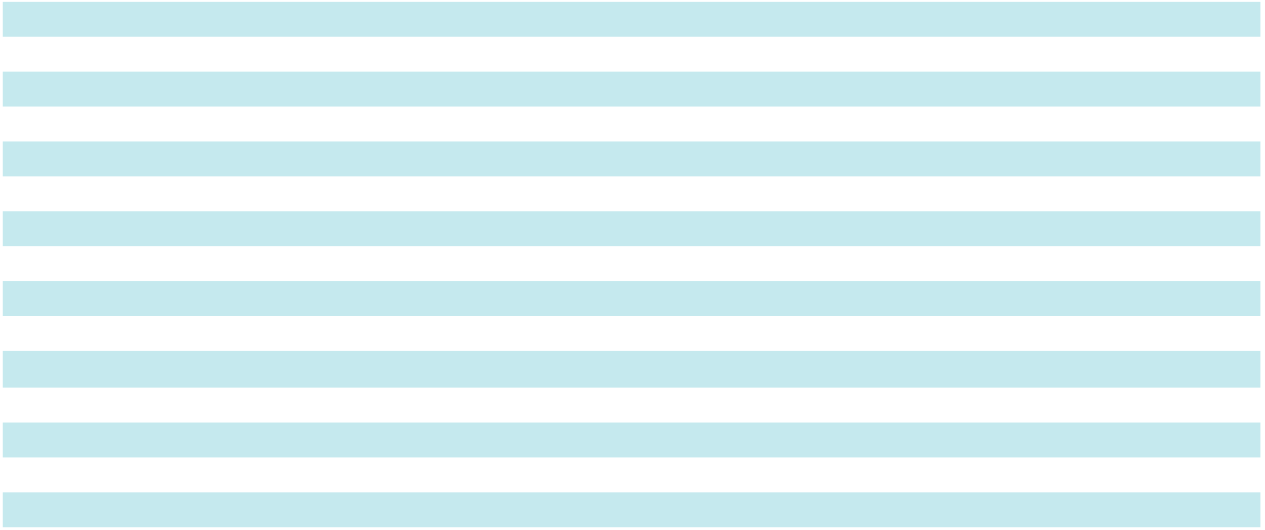

See accompanying notes to Consolidated Financial Statements.

38

Table of Contents

CONSOLIDATED STATEMENTS OF COMPREHENSIVE EARNINGS

 |  |  |  |  |  | Year-Ended
 |  |  | February 28, |  |  | March 1, |  |  | March 2, 2024
 |  |  | 2026 |  |  | 2025 |  |  | March 2, 2024
(In thousands) |  |  | (52 weeks) |  |  | (52 Weeks) |  |  | (53 weeks)
Net earnings |  | $ | 54,131 | $ |  | 85,052 | $ |  | 99,613
Other comprehensive earnings (loss):
Unrealized gain on marketable securities, net of $25, $49 |  |  | 92 |  |  | 184 |  |  | 222
and $59 of tax expense, respectively |  |  | 92 |  |  | 184 |  |  | 222
Unrealized gain (loss) on derivative instruments, net of
$46, $(135) and $(22) of tax expense (benefit),
respectively |  |  | 121 |  |  | (442) |  |  | (72)
Unrealized gain on pension obligation, net of $11, $23 and |  |  | 110 |  |  | 79 |  |  | 857
$261 of tax expense, respectively |  |  | 110 |  |  | 79 |  |  | 857
Foreign currency translation adjustments |  |  | 4,167 |  |  | (5,582) |  |  | 1,018
Other comprehensive earnings (loss) |  |  | 4,490 |  |  | (5,761) |  |  | 2,025
Total comprehensive earnings |  | $ | 58,621 | $ |  | 79,291 | $ |  | 101,638
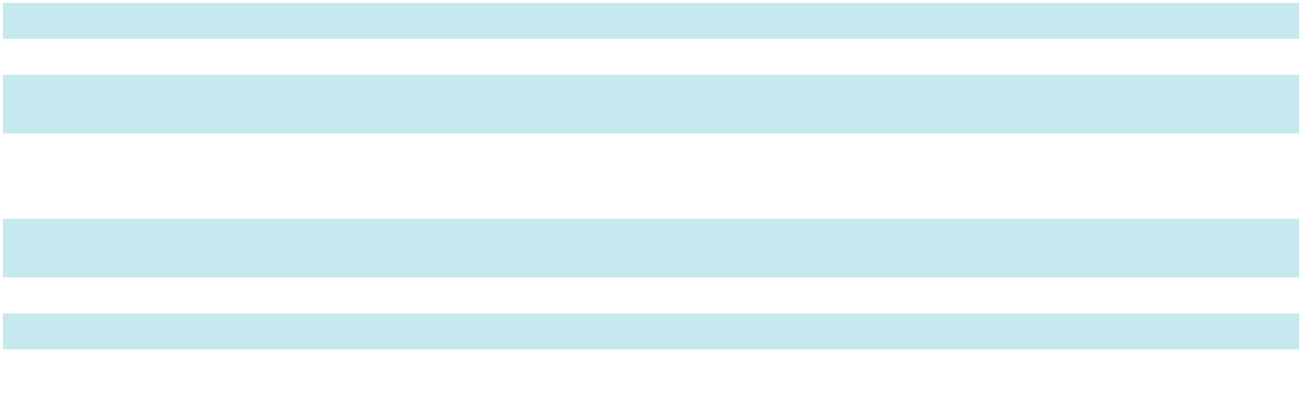

See accompanying notes to Consolidated Financial Statements.

39

Table of Contents

CONSOLIDATED STATEMENTS OF CASH FLOWS

 |  |  |  |  |  | Year-Ended
 |  |  | February 28, |  |  | March 1, |  |  | March 2, 2024
 |  |  | 2026 |  |  | 2025 |  |  | March 2, 2024
(In thousands) |  |  | (52 weeks) |  |  | (52 weeks) |  |  | (53 weeks)
Operating Activities
Net earnings |  | $ | 54,131 | $ |  | 85,052 | $ |  | 99,613
Adjustments to reconcile net earnings to net cash provided by operating
activities:
Depreciation and amortization |  |  | 49,998 |  |  | 44,608 |  |  | 41,588
Share-based compensation |  |  | 8,246 |  |  | 10,725 |  |  | 9,721
Deferred income taxes |  |  | 15,483 |  |  | 3,836 |  |  | (9,748)
Impairment of long-lived assets |  |  | 11,477 |  |  | 7,634 |  |  | 7,021
Settlement of New Markets Tax Credit transaction |  |  | (6,740) |  |  | — |  |  | (4,687)
Non-cash lease expense |  |  | 6,574 |  |  | 13,749 |  |  | 11,721
Other, net |  |  | (1,671) |  |  | (1,247) |  |  | 4,615
Changes in operating assets and liabilities:
Receivables |  |  | (12,409) |  |  | (508) |  |  | 23,993
Inventories |  |  | (5,340) |  |  | (5,810) |  |  | 9,366
Contract assets |  |  | 12,583 |  |  | (22,625) |  |  | 9,880
Accounts payable |  |  | 5,515 |  |  | 9,595 |  |  | (2,655)
Accrued compensation and benefits |  |  | (9,117) |  |  | (11,793) |  |  | 2,102
Contract liabilities |  |  | 25,649 |  |  | 598 |  |  | 6,590
Operating lease liability |  |  | (9,706) |  |  | (12,703) |  |  | (12,632)
Accrued income taxes |  |  | 3,858 |  |  | (5,120) |  |  | 6,523
Other current assets and liabilities |  |  | (26,066) |  |  | 9,171 |  |  | 1,143
Net cash provided by operating activities |  |  | 122,465 |  |  | 125,162 |  |  | 204,154
Investing Activities
Capital expenditures |  |  | (27,308) |  |  | (35,593) |  |  | (43,180)
Proceeds from sales of property, plant and equipment |  |  | 1,632 |  |  | 693 |  |  | 293
Purchases of marketable securities |  |  | (9,670) |  |  | (2,394) |  |  | (2,953)
Sales/maturities of marketable securities |  |  | 4,820 |  |  | 3,570 |  |  | 2,165
Acquisition of business, net of cash acquired |  |  | — |  |  | (232,169) |  |  | —
Net cash used by investing activities |  |  | (30,526) |  |  | (265,893) |  |  | (43,675)
Financing Activities
Proceeds from revolving credit facilities |  |  | 93,000 |  |  | 77,201 |  |  | 196,964
Repayment on revolving credit facilities |  |  | (143,000) |  |  | (57,201) |  |  | (304,817)
Proceeds from term loans |  |  | — |  |  | 250,000 |  |  | —
Repayment of term loans |  |  | (2,722) |  |  | (47,000) |  |  | —
Payments of debt issuance costs |  |  | — |  |  | (3,798) |  |  | —
Repurchase of common stock |  |  | (15,000) |  |  | (45,364) |  |  | (11,821)
Dividends paid |  |  | (22,216) |  |  | (21,737) |  |  | (21,133)
Other, net |  |  | (6,241) |  |  | (6,052) |  |  | (3,800)
Net cash (used by) provided by financing activities |  |  | (96,179) |  |  | 146,049 |  |  | (144,607)
Effect of exchange rates on cash |  |  | 2,315 |  |  | (1,086) |  |  | (129)
(Decrease) increase in cash and cash equivalents |  |  | (1,925) |  |  | 4,232 |  |  | 15,743
Cash and cash equivalents at beginning of period |  |  | 41,448 |  |  | 37,216 |  |  | 21,473
Cash and cash equivalents at end of period |  | $ | 39,523 |  | $ | 41,448 |  | $ | 37,216
Non-cash Activity
Capital expenditures in accounts payable |  | $ | 4,170 | $ |  | 3,313 | $ |  | 3,588


See accompanying notes to Consolidated Financial Statements.

40

Table of Contents

CONSOLIDATED STATEMENTS OF SHAREHOLDERS' EQUITY

 |  | Common |  |  |  |  |  |  |  |  |  |  |  | Accumulated |  |  | Total
 |  | Common |  | Common Stock |  |  |  | Additional |  |  | Retained |  |  | Other |  |  | Total
(In thousands, except per share data) |  | Shares |  |  |  |  |  | Additional |  |  | Retained |  | Comprehensive |  |  | Shareholders'
(In thousands, except per share data) |  | Outstanding |  |  | at Par Value |  | Paid-In Capital |  |  |  | Earnings |  | (Loss) Income |  |  |  | Equity
Balance at February 25, 2023 |  | 22,224 |  | $ | 7,408 |  | $ | 146,816 |  | $ | 273,740 |  | $ | (31,556) |  | $ | 396,408
Net earnings |  | — |  |  | — |  |  | — |  |  | 99,613 |  |  | — |  |  | 99,613
Other comprehensive income, net of tax |  | — |  |  | — |  |  | — |  |  | — |  |  | 2,025 |  |  | 2,025
Issuance of stock, net of cancellations | 171 |  |  |  | 58 |  |  | (150) |  |  | (40) |  |  | — |  |  | (132)
Share-based compensation |  | — |  |  | — |  |  | 9,721 |  |  | — |  |  | — |  |  | 9,721
Exercise of stock options | 25 |  |  |  | 8 |  |  | (840) |  |  | — |  |  | — |  |  | (832)
Share repurchases | (280) |  |  |  | (93) |  |  | (1,989) |  |  | (9,739) |  |  | — |  |  | (11,821)
Other share retirements | (51) |  |  |  | (18) |  |  | (740) |  |  | (2,066) |  |  | — |  |  | (2,824)
Cash dividends ($0.9700 per share) |  | — |  |  | — |  |  | — |  |  | (21,133) |  |  | — |  |  | (21,133)
Balance at March 2, 2024 |  | 22,089 |  | $ | 7,363 |  | $ | 152,818 |  | $ | 340,375 |  | $ | (29,531) |  | $ | 471,025
Net earnings |  | — |  |  | — |  |  | — |  |  | 85,052 |  |  | — |  |  | 85,052
Other comprehensive loss, net of tax |  | — |  |  | — |  |  | — |  |  | — |  |  | (5,761) |  |  | (5,761)
Issuance of stock, net of cancellations | 214 |  |  |  | 71 |  |  | (312) |  |  | 241 |  |  | — |  |  | —
Share-based compensation |  | — |  |  | — |  |  | 10,725 |  |  | — |  |  | — |  |  | 10,725
Share repurchases | (787) |  |  |  | (263) |  |  | (6,415) |  |  | (38,686) |  |  | — |  |  | (45,364)
Other share retirements | (98) |  |  |  | (32) |  |  | (741) |  |  | (5,269) |  |  | — |  |  | (6,042)
Cash dividends ($1.0100 per share) |  | — |  |  | — |  |  | — |  |  | (21,737) |  |  | — |  |  | (21,737)
Balance at March 1, 2025 |  | 21,418 |  | $ | 7,139 |  | $ | 156,075 |  | $ | 359,976 |  | $ | (35,292) |  | $ | 487,898
Net earnings |  | — |  |  | — |  |  | — |  |  | 54,131 |  |  | — |  |  | 54,131
Other comprehensive income, net of tax |  | — |  |  | — |  |  | — |  |  | — |  |  | 4,490 |  |  | 4,490
Issuance of stock, net of cancellations | 303 |  |  |  | 96 |  |  | (1,284) |  |  | (118) |  |  | — |  |  | (1,306)
Share-based compensation |  | — |  |  | — |  |  | 8,246 |  |  | — |  |  | — |  |  | 8,246
Share repurchases | (388) |  |  |  | (129) |  |  | (3,032) |  |  | (11,839) |  |  | — |  |  | (15,000)
Other share retirements | (113) |  |  |  | (33) |  |  | (920) |  |  | (3,496) |  |  | — |  |  | (4,449)
Cash dividends ($1.0500 per share) |  | — |  |  | — |  |  | — |  |  | (22,216) |  |  | — |  |  | (22,216)
Balance at February 28, 2026 |  | 21,220 |  | $ | 7,073 |  | $ | 159,085 |  | $ | 376,438 |  | $ | (30,802) |  | $ | 511,794
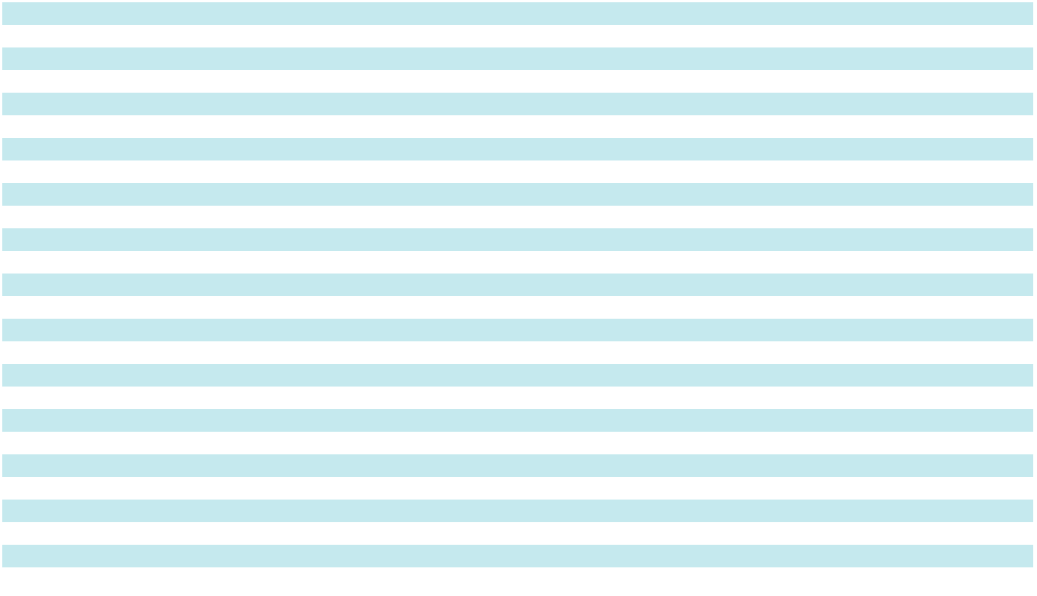

See accompanying notes to Consolidated Financial Statements.

41

Table of Contents

NOTES TO CONSOLIDATED FINANCIAL STATEMENTS

- Summary of Significant Accounting Policies and Related Data

Basis of consolidation

The consolidated financial statements include the balances of Apogee Enterprises, Inc. and its subsidiaries (Apogee, we, us, our or the Company) after elimination of intercompany balances and transactions. We consolidate variable interest entities related to our New Markets Tax Credit transactions as it has been determined that the Company is the primary beneficiary of those entities' operations (refer to Note 10 for more information).

Fiscal year

Our fiscal year ends on the Saturday closest to the last day of February. Fiscal 2026 and fiscal 2025 each consisted of 52 weeks, while fiscal 2024 consisted of 53 weeks.

Accounting estimates

The preparation of the consolidated financial statements in conformity with U.S. generally accepted accounting principles requires management to make estimates and assumptions that affect the reported amounts on the consolidated financial statements and accompanying notes. Actual results could differ significantly from those estimates.

Cash equivalents

Highly liquid investments with an original maturity of three months or less are included in cash equivalents and are stated at cost, which approximates fair value.

Marketable securities

We hold marketable securities consisting of municipal and corporate bonds, which are carried at fair value on the Consolidated Balance Sheets. To the extent the amortized cost basis of the available-for-sale securities exceeds the fair value, we assess the debt securities for credit loss. When assessing the risk of credit loss, we consider factors such as the severity and the reason of the decline in value, including any changes to the rating of the security by a rating agency or other adverse conditions specifically related to the security, and management's intended holding period and time horizon for selling. During fiscal 2026, 2025, and 2024, the Company did not recognize any credit losses related to its available-for-sale securities. Further, as of February 28, 2026 and March 1, 2025, the Company did not record an allowance for credit losses related to its available-for-sale securities. Marketable securities are included in other current and non-current assets on the Consolidated Balance Sheets and gross realized gains and losses are included in other (income) expense, net in our Consolidated Results of Operations.

Inventories

Inventories are valued at lower of cost or net realizable value using the first-in, first-out (FIFO) method.

Property, plant and equipment

Property, plant and equipment (PP&E) is recorded at cost. Significant improvements and renewals that extend the useful life of an asset are capitalized. Repairs and maintenance items are generally charged to expense when incurred. When an asset is retired or otherwise disposed of, the cost and related accumulated depreciation are removed from the balance sheet and any related gains or losses are included in selling, general and administrative expenses.

Depreciation is computed on a straight-line basis, based on estimated useful lives of 10 years to 25 years for buildings and improvements; 3 years to 15 years for machinery and equipment; and 3 years to 7 years for computer and office equipment and furniture.

Goodwill and intangible assets

Goodwill

Goodwill represents the excess of the cost over the net tangible and identified intangible assets of acquired businesses. We evaluate goodwill for impairment annually on the first day in our fiscal fourth quarter, or more frequently if events or changes in circumstances indicate the carrying value of the goodwill may not be recoverable.

Evaluating goodwill for impairment involves the determination of the fair value of each reporting unit in which goodwill is recorded using a qualitative or quantitative analysis. A reporting unit is an operating segment or a component of an operating segment for which discrete financial information is available and reviewed by segment management on a regular basis.

The reporting units for our fiscal 2026 annual impairment test align with our reporting segments of Architectural Metals, Architectural Services, Architectural Glass, and Performance Surfaces.

42

Table of Contents

We estimate the fair value of a reporting unit using both the income approach and the market approach. The income approach uses a discounted cash flow methodology that involves significant judgment and projections of future performance. Assumptions about future revenues and future operating expenses, capital expenditures and changes in working capital are based on the annual operating plan and other business plans for each reporting unit. These plans take into consideration numerous factors, including historical experience, current and future operational plans, anticipated future economic conditions and growth expectations for the industries and end markets in which we participate. These projections are discounted using a weighted-average cost of capital, which considers the risk inherent in our projections of future cash flows. We determine the weighted-average cost of capital for this analysis by weighting the required returns on interest bearing debt and common equity capital in proportion to their estimated percentages in an expected capital structure, using published data where possible. We used discount rates that are commensurate with the risks and uncertainties inherent in the respective businesses and in the internally developed forecasts. The market approach uses a multiple of earnings and revenue based on guidelines for publicly traded companies.

Intangible assets

We have intangible assets for certain acquired trade names and trademarks which are determined to have indefinite useful lives. We test indefinite-lived intangible assets for impairment annually at the same measurement date as goodwill, the first day of our fiscal fourth quarter, or more frequently if events or changes in circumstances indicate that it is more likely than not that the asset is impaired. If the carrying amount of an indefinite-lived intangible asset exceeds its fair value, an impairment expense is recognized in an amount equal to that excess. If an impairment expense is recognized, the adjusted carrying amount becomes the asset's new accounting basis.

Fair value of indefinite-lived intangible assets is measured using the relief-from-royalty method. This method assumes the trade name or trademark has value to the extent that the owner is relieved of the obligation to pay royalties for the benefits received from the asset. This method requires estimation of future revenue from the related asset, the appropriate royalty rate, and the weighted average cost of capital. The assessment of fair value involves significant judgment and projections about future performance.

Definite-lived intangible assets are amortized based on estimated useful lives ranging from 5 years to 20 years and are reviewed for impairment whenever events or changes in circumstances indicate that the carrying amount may not be recoverable. We use undiscounted cash flows to determine whether impairment exists and measure any impairment loss using discounted cash flows.

The estimated useful lives of all intangible assets are reviewed annually, and we have determined that the remaining lives were appropriate. Refer to Note 6 for additional information.

Leases

We have commercially negotiated leases where we recognize a right-of-use asset and lease liability on our Consolidated Balance Sheet at lease commencement for leases with terms greater than twelve months. The initial lease liability is recognized at the present value of remaining lease payments over the lease term. Leases with an initial term of twelve months or less are not recorded on our Consolidated Balance Sheet. We recognize lease expense for operating leases on a straight-line basis over the lease term. Refer to Note 8 for additional information.

Impairment of long-lived assets

Long-lived assets or asset groups, including property, plant, and equipment and definite-lived intangible assets subject to amortization, are reviewed for impairment whenever events or changes in circumstances such as asset utilization, physical change, legal factors or other matters indicate that the carrying value of those assets may not be recoverable. When this review indicates the carrying value of an asset or asset group exceeds the sum of the undiscounted cash flows expected to result from the use and eventual disposition of the asset or asset group, an asset impairment expense is recognized in earnings in the period such a determination is made. The amount of the impairment expense recorded is the amount by which the carrying value of the impaired asset or asset group exceeds its fair value based on discounted cash flows.

The Company recognized impairments of long-lived assets that were directly associated with restructuring initiatives undertaken to streamline operations and align the cost structure with expected future business activity in fiscal years 2026 and 2024. Impairment charges incurred as part of these restructuring plans were $11.5 million in fiscal year 2026, and $6.2 million in fiscal 2024.

Fiscal year 2026 impairment charges were made up of:

- $5.0 million on a customer relationship intangible within the Architectural Services Segment;

- $3.4 million on right-of-use assets within the Architectural Services and Metals Segments; and

43

Table of Contents

- $3.1 million on property, plant, and equipment and internal-use software within Corporate.

During fiscal year 2025, because of our annual impairment analysis and driven by changes to branding strategies within the Architectural Metals segment, an impairment charge of $7.6 million was incurred on certain tradenames.

In fiscal year 2024, we recorded asset impairment on property, plant and equipment and right-of-use assets within the Architectural Metals Segment.

Impairment charges were included within Selling, General and Administrative expenses in our Consolidated Results of Operations for all periods.

Self-Insurance

We obtain commercial insurance to provide coverage for potential losses in areas such as employment practices, workers' compensation, directors and officers, automobile, architect's and engineer's errors and omissions, product rework and general liability. A substantial portion of this risk is retained on a self-insured basis through our wholly-owned insurance subsidiary. We establish a reserve for estimated ultimate losses on reported claims and those incurred but not yet reported utilizing actuarial projections. Reserves are classified within other current liabilities or non-current self-insurance reserves on our Consolidated Balance Sheets based on expectations of when the estimated loss will be paid.

Additionally, we maintain a self-insurance reserve for health insurance programs offered to eligible employees, included within other current liabilities on the Consolidated Balance Sheets. The reserve includes an estimate for losses on reported claims as well as for amounts incurred but not yet reported, based on historical trends.

Warranty and project-related contingencies

We are subject to claims associated with our products and services, principally as a result of disputes with our customers involving the performance or aesthetics of our architectural products and services. We reserve estimated exposures on known claims, as well as on a portion of potential claims for product warranty and rework costs, based on historical product liability claims as a ratio of sales. We also reserve for estimated backcharge exposures or other claims as they are known and reasonably estimable. Reserves are included in other current and non-current liabilities based on the estimated timing of dispute resolution.

Foreign currency

Local currencies are considered the functional currencies for our subsidiaries outside of the United States. Assets and liabilities of these subsidiaries are translated at the exchange rates at the balance sheet date. Income and expense items are translated using average monthly exchange rates. Translation adjustments are included in accumulated other comprehensive loss on the Consolidated Balance Sheets.

Derivatives and hedging activities

We are exposed to, among other risks, the impact of changes in aluminum prices, foreign currency exchange rates, and interest rates in the normal course of business. In order to manage the exposure and volatility arising from these risks, we may utilize derivative financial instruments to offset a portion of these risks. We use derivative financial instruments to hedge identified business risks, and do not hold or issue derivative financial instruments for trading purposes and are not a party to leveraged derivatives.

All derivative instruments within the scope of ASC 815, Derivatives and Hedging, are recorded as either assets or liabilities at fair value on the Consolidated Balance Sheets. All hedging instruments that qualify for hedge accounting are designated and effective as hedges with changes recognized in other comprehensive earnings (loss). Instruments that do not qualify for hedge accounting are marked to market with changes recognized directly in net earnings. Cash flows from derivative instruments are classified in the statements of cash flows in the same category as the cash flows from the items subject to designated hedge or undesignated (economic) hedge relationships. Refer to Note 4 for additional information.

Revenue recognition

Our accounting policy for revenue recognition follows ASC 606, Revenue from Contracts with Customers. We generate revenue from the design, engineering and fabrication of architectural glass, curtainwall, window, storefront and entrance systems, and from installing those products on non-residential buildings. We also manufacture value-added glass, acrylic and industrial flooring products. Due to the diverse nature of our operations and various types of contracts with customers, we have businesses that recognize revenue at shipment, businesses that recognize revenue following an over-time input method and businesses that recognize revenue following an over-time output method.

Approximately 46% of our fiscal 2026 revenue was recognized at the time products were shipped from our manufacturing facilities, which is when control is transferred to our customer. These businesses do not generate contract-related assets or

44

Table of Contents

liabilities. Variable consideration associated with these contracts and orders, generally related to early pay discounts or volume rebates, is not considered significant.

Approximately 35% of our fiscal 2026 revenue was from fixed-price contracts, following an over-time input method. These contracts contain a single, bundled performance obligation, as these businesses generally provide interrelated products and services and integrate these products and services into a combined output specified by the customer. The customer obtains control of this combined output, generally integrated window systems or installed window and curtainwall systems, over time. We measure progress on these contracts following an input method, by comparing total costs incurred to-date to the total estimated costs for the contract, and record that proportion of the total contract price as revenue in the period. Contract costs include materials, labor and other direct costs related to contract performance. We believe this method of recognizing revenue is consistent with our progress in satisfying our contract obligations.

Due to the nature of the work required under these long-term contracts, the estimation of total costs remaining to complete throughout a project is subject to many variables and requires significant judgment. It is common for these contracts to contain potential bonuses or penalties which are generally awarded or charged upon certain project milestones or cost or timing targets, and these can be based on customer discretion. We estimate variable consideration at the most likely amount to which we expect to be entitled. We include estimated amounts in the transaction price to the extent that it is probable that a significant reversal of cumulative revenue recognized will not occur when the uncertainty associated with the variable consideration is resolved. Our estimates of variable consideration and determination of whether to include estimated amounts in the transaction price are based largely on our assessments of anticipated performance and all information (historical, current and forecasted) that is reasonably available to us.

Long-term contracts are often modified to account for changes in contract specifications and requirements of work to be performed. We consider contract modifications to exist when the modification, generally through a change order, either creates new or changes existing enforceable rights and obligations, and we evaluate these types of modifications to determine whether they may be considered distinct performance obligations. In most cases, these contract modifications are for goods or services that are not distinct from the existing contract, due to the significant integration service provided in the context of the contract. Therefore, these modifications are accounted for as part of the existing contract. The effect of a contract modification on the transaction price and our measure of progress is recognized as an adjustment to revenue, generally on a cumulative catch-up basis.

The net cumulative catch-up adjustments on our longer-term contracts for changes in estimates had the following effect on the respective periods shown:

 |  |  |  |  |  | Year Ended
 |  | February 28, 2026 |  |  |  | March 1, 2025 |  |  | March 2, 2024
(in thousands, except earnings per share data) |  |  | (52 weeks) |  |  | (52 weeks) |  |  | (53 weeks)
Operating income |  | $ | 8,832 | $ |  | 16,307 | $ |  | 5,760
Earnings per share:
Basic |  | $ | 0.31 | $ |  | 0.57 | $ |  | 0.20
Diluted |  | $ | 0.31 | $ |  | 0.56 | $ |  | 0.20

Typically, under these fixed-price contracts, we bill our customers following an agreed-upon schedule based on work performed. Because the progress billings do not generally correspond to our measurement of revenue on a contract, we generate contract assets when we have recognized revenue in excess of the amount billed to the customer. We generate contract liabilities when we have billed the customer in excess of revenue recognized on a contract.

Approximately 19% of our fiscal 2026 revenue was recognized following an over-time output method based upon units produced. The customer is considered to have control over the products at the time of production, as the products are highly customized with no alternative use, and we have an enforceable right to payment for performance completed over the production period. We believe this over-time output method of recognizing revenue reasonably depicts the fulfillment of our performance obligations under our contracts. Billings still occur upon shipment. Therefore, contract assets are generated for the unbilled amounts on contracts when production is complete. Variable consideration associated with these orders, generally related to early pay discounts, is not considered significant.

Additionally, we have made the following policy elections associated with revenue recognition:

- We account for shipping and handling activities that occur after control of the related goods transfers to the customer as fulfillment activities, instead of assessing such activities as performance obligations.

45

Table of Contents

- We exclude from the transaction price all sales taxes related to revenue-producing transactions that are collected from the customer for a government authority. We are considered a pass-through conduit for collecting and remitting sales taxes.

- We generally expense incremental costs of obtaining a contract when incurred because the amortization period would be less than one year. These costs primarily relate to sales commissions and are included in selling, general and administrative expenses.

- We do not adjust contract price for a significant financing component, as we expect the period between when our goods and services are transferred to the customer and when the customer pays for those goods and services to be less than a year.

Shipping and handling

Amounts billed to a customer in a sales transaction related to shipping and handling are reported as revenue. Costs we incur for shipping and handling are reported as cost of sales.

Restructuring

Restructuring charges are recorded as a result of fundamental changes in the manner in which certain business functions are conducted, including initiatives to drive earnings and cash flow growth and to realign and simplify our business structure. These charges primarily consist of employee severance benefits, long-lived asset impairments and termination penalties for facility closures and consolidations. We record restructuring accruals when it is probable that a liability has been incurred and the amount of the liability is reasonably estimable. To the extent our assumptions and estimates differ from our actual costs, subsequent adjustments to restructuring accruals have been, and will be, required. Restructuring accruals for severance-related costs are included in accrued compensation and benefits and accruals for remaining obligations and termination penalties are included in other current liabilities on our Consolidated Balance Sheets. Refer to Note 18 for additional information.

Research and development

Research and development activities include the development of new products, the modification of existing product designs, and research related to process improvements. Our research and development expenses were $11.2 million, $29.0 million and $30.3 million for fiscal 2026, 2025 and 2024, respectively. These costs are expensed as incurred.

Income taxes

The Company recognizes deferred tax assets and liabilities based upon the future tax consequences of temporary differences between financial statement carrying amounts of assets and liabilities and their respective tax bases. Refer to Note 14 for additional information.

Subsequent events

We have evaluated subsequent events through April 24, 2026, the date the financial statements were available to be issued. No events occurred that would require recognition or disclosure in these financial statements.

Adoption of new accounting standards

In December 2023, the FASB issued ASU 2023-09, Improvements to Income Tax Disclosures, intended to enhance the transparency and decision-usefulness of income tax disclosures. Such guidance requires entities to provide additional information within their income tax rate reconciliation, including further disclosure of federal, state, and foreign income taxes and to provide more details about these reconciling items if a quantitative threshold is met. This guidance additionally requires expanded disclosure of income taxes paid, including amounts paid for federal, state, and foreign taxes. The Company adopted this ASU and applied its disclosures prospectively. The adoption of this ASU affected only the Company's income tax disclosure included in Note 14 and did not have a material impact on the Company's results of operations, cash flows, or financial condition.

Accounting standards not yet adopted

In November 2024, the FASB issued ASU 2024-03, Disaggregation of Income Statement Expenses. This guidance requires entities to disclose more detailed information about the types of expenses, including purchases of inventory, employee compensation, depreciation, amortization, and depletion in commonly presented expense captions such as cost of sales and selling, general and administrative expenses. Such guidance is effective for annual reporting periods beginning after December 15, 2026, and interim reporting periods beginning after December 15, 2027, although early adoption is permitted. This guidance should be applied either prospectively to financial statements issued for reporting periods after the effective date of this ASU or retrospectively to any or all prior periods presented in the financial statements. While the adoption of this ASU will not have an

46

Table of Contents

impact on our financial position and/or results of operations, we are currently evaluating the impact this ASU may have on our consolidated financial statement disclosures, including the processes and controls around the collection of this information.

- Revenue, Receivables and Contract Assets and Liabilities Revenue

The following table disaggregates total revenue by timing of recognition (see Note 16 for disclosure of revenue by segment):

(In thousands) |  |  | 2026 |  |  | 2025 |  |  | 2024
Recognized at shipment | $ |  | 645,232 | $ |  | 571,140 | $ |  | 596,270
Recognized over time (input method) |  |  | 495,993 |  |  | 495,562 |  |  | 483,109
Recognized over time (output method) |  |  | 263,508 |  |  | 294,292 |  |  | 337,563
Total | $ |  | 1,404,733 | $ |  | 1,360,994 | $ |  | 1,416,942
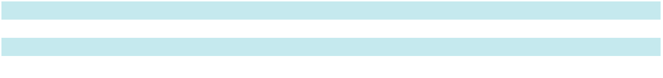

Receivables

Receivables reflected in the financial statements represent the net amount expected to be collected. An allowance for credit losses is established based on expected losses. Expected losses are estimated by reviewing individual accounts, considering aging, financial condition of the debtor, recent payment history, current and forecasted economic conditions and other relevant factors. Upon billing, aging of receivables is monitored until collection. An account is considered current when it is within agreed upon payment terms. An account is written off when it is determined that the asset is no longer collectible.

 |  |  | February 28, |  |  | March 1,
(In thousands) |  |  | 2026 |  |  | 2025
Trade accounts | $ |  | 111,679 | $ |  | 117,533
Construction contracts |  |  | 88,445 |  |  | 70,724
Total receivables |  |  | 200,124 |  |  | 188,257
Less: allowance for credit losses |  |  | 1,608 |  |  | 2,667
Receivables, net | $ |  | 198,516 | $ |  | 185,590
The following table summarizes the activity in the allowance for credit losses:
(In thousands) |  |  | 2026 |  |  | 2025
Beginning balance | $ |  | 2,667 | $ |  | 3,383
Credits against costs and expenses |  |  | (225) |  |  | (1,376)
Deductions from allowance, net of recoveries |  |  | (872) |  |  | (122)
Allowance for credit losses from acquisitions |  |  | — |  |  | 853
Other adjustments |  |  | 38 |  |  | (71)
Ending balance | $ |  | 1,608 | $ |  | 2,667
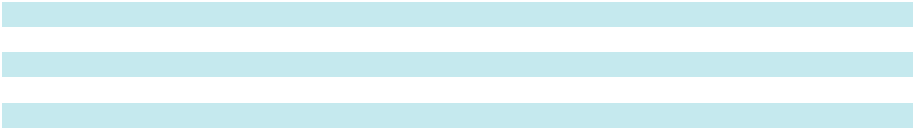
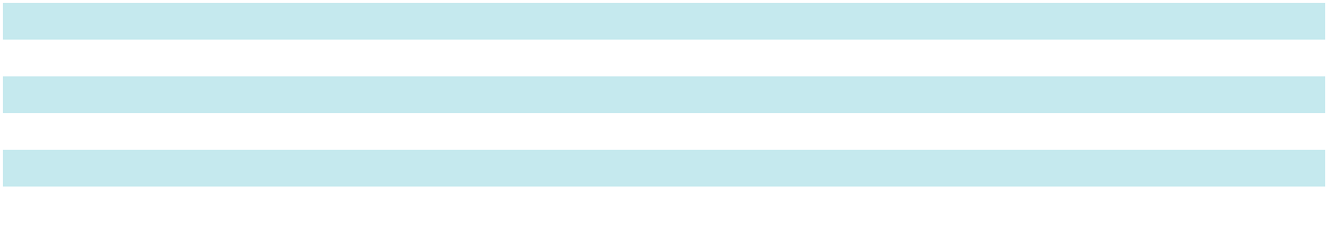

Contract assets and liabilities

Contract assets consist of retainage, costs and earnings in excess of billings and other unbilled amounts typically generated when revenue recognized exceeds the amount billed to the customer. Retainage on construction contracts represents amounts withheld by our customers on long-term projects until the project reaches a level of completion where amounts are released to us from the customer. Contract liabilities consist of billings in excess of costs and earnings and other unearned revenue on contracts.

The time period between when performance obligations are complete and when payment is due is not significant. In certain of our businesses that recognize revenue over time, progress billings follow an agreed-upon schedule of values.

(In thousands) |  | February 28, 2026 |  |  |  | March 1, 2025
Contract assets | $ |  | 59,512 | $ |  | 71,842
Contract liabilities |  |  | 60,903 |  |  | 35,193

Changes in contract assets and liabilities were mainly due to timing of project activity in our businesses that operate under long-term contracts.

47

Table of Contents

Other contract-related disclosures

(In thousands) |  |  | 2026 |  |  | 2025
Revenue recognized related to contract liabilities from prior year-end | $ |  | 29,144 | $ |  | 30,785
Revenue recognized related to prior satisfaction of performance obligations |  |  | 9,705 |  |  | 16,202

Some of our contracts have an expected duration of longer than a year, with performance obligations extending over that time frame. The transaction price associated with performance obligations that were not yet satisfied as of February 28, 2026 will be recognized as revenue in the following estimated time periods:

(In thousands) |  |  |  |  |  | 2026
Within one year |  |  |  | $ |  | 415,455
More than one but less than two years |  |  |  |  |  | 235,738
Beyond two years |  |  |  |  |  | 46,005
Total |  |  |  | $ |  | 697,198
3. Supplemental Balance Sheet Information
Inventories
(In thousands) |  | February 28, 2026 |  |  |  | March 1, 2025
Raw materials | $ |  | 43,441 | $ |  | 36,804
Work-in-process |  |  | 18,089 |  |  | 15,554
Finished goods |  |  | 36,529 |  |  | 39,947
Total inventories, net | $ |  | 98,059 | $ |  | 92,305
Other current assets
(In thousands) |  | February 28, 2026 |  |  |  | March 1, 2025
Short term investments | $ |  | 6,139 | $ |  | 4,798
Prepaid assets |  |  | 15,975 |  |  | 17,155
Refundable income taxes |  |  | 10,797 |  |  | 10,406
Other |  |  | 10,912 |  |  | 18,560
Total other current assets | $ |  | 43,823 | $ |  | 50,919
Other current liabilities
(In thousands) |  | February 28, 2026 |  |  |  | March 1, 2025
Arbitration award payable | $ |  | — | $ |  | 20,182
Accrued self-insurance reserves |  |  | 11,235 |  |  | 18,240
Warranties and backcharges |  |  | 11,938 |  |  | 17,557
Deferred benefit from New Markets Tax Credit transactions |  |  | — |  |  | 9,250
Income and other taxes |  |  | 6,206 |  |  | 5,813
Other |  |  | 16,700 |  |  | 16,617
Total other current liabilities | $ |  | 46,079 | $ |  | 87,659
Other non-current liabilities
(In thousands) |  | February 28, 2026 |  |  |  | March 1, 2025
Deferred warranty revenue | $ |  | 9,856 | $ |  | 10,154
Deferred compensation plan |  |  | 8,266 |  |  | 5,590
Retirement plan obligations |  |  | 4,524 |  |  | 4,640
Deferred tax liabilities |  |  | 17,020 |  |  | 1,256
Other |  |  | 7,461 |  |  | 13,261
Total other non-current liabilities | $ |  | 47,127 | $ |  | 34,901
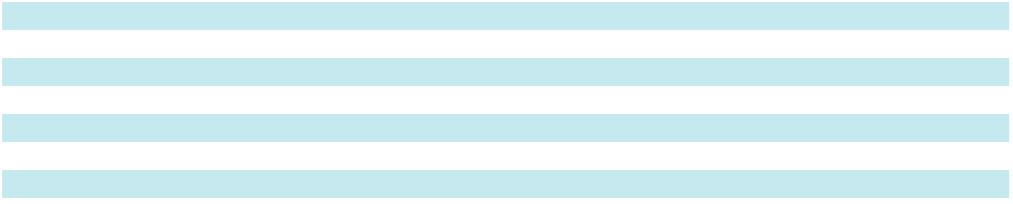

48

Table of Contents

- Financial Instruments Marketable Securities

Through our wholly-owned insurance subsidiary, Prism Assurance, Ltd. (Prism), we hold the following available-for-sale marketable securities, made up of municipal and corporate bonds:

 |  |  | Amortized Cost |  |  | Gross Unrealized |  |  | Gross Unrealized |  |  | Estimated Fair
(In thousands) |  |  | Amortized Cost |  |  | Gains |  |  | Losses |  |  | Value
February 28, 2026 | $ |  | 14,989 | $ |  | 23 | $ |  | 94 | $ |  | 14,918
March 1, 2025 |  |  | 10,148 |  |  | 33 |  |  | 222 |  |  | 9,959

Prism insures a portion of our general liability, workers' compensation and automobile liability risks using reinsurance agreements to meet statutory requirements. The reinsurance carrier requires Prism to maintain fixed-maturity investments, for the purpose of providing collateral for Prism's obligations under the reinsurance agreements.

The amortized cost and estimated fair values of our municipal and corporate bonds at February 28, 2026, by contractual maturity, are shown below. Expected maturities may differ from contractual maturities, as borrowers may have the right to call or prepay obligations with or without penalty. Investments that are due within one year are included in other current assets while those due after one year are included as other non-current assets. Gross realized gains and losses were insignificant for all periods presented.

 |  |  | Amortized Cost |  |  | Estimated Fair
(In thousands) |  |  | Amortized Cost |  |  | Value
Due within one year | $ |  | 6,202 | $ |  | 6,139
Due after one year through five years |  |  | 8,787 |  |  | 8,779
Total | $ |  | 14,989 | $ |  | 14,918

Derivative instruments

We may use interest rate swaps, currency put options, forward purchase contracts, or other instruments to manage risks generally associated with foreign exchange rate, interest rate and commodity price fluctuations. The information that follows explains the various types of derivatives and financial instruments used, how such instruments are accounted for, and how such instruments impact our financial position and performance.

In fiscal 2025, we entered into an interest rate swap with a notional value of $75.0 million with an expiration date of January 5, 2027, to hedge a portion of our exposure to variability in cash flows from interest payments on our floating-rate revolving credit facility.

In fiscal 2026, we entered into an interest rate swap with a notional value of $50.0 million with an expiration date of August 5, 2027, to hedge a portion of our exposure to variability in cash flows from interest payments on our floating-rate revolving credit facility. In fiscal 2026, an interest rate swap with a notional value $30.0 million expired in accordance with the associated agreement.

In fiscal 2026, we entered into multiple aluminum commodity swap contracts with an aggregate notional value of $27.7 million to hedge a portion of our exposure to variability in cash flows associated with forecasted aluminum purchases. These swap contracts mature over the next twelve months, with final settlements occurring by March 2027.

The mark-to-market adjustments on these derivative instruments are recorded within our Consolidated Balance Sheets within other current assets and other current liabilities. Gains or losses associated with these instruments are recorded as a component of accumulated other comprehensive gain or loss until which time the hedged transaction is settled and gains or losses are recorded in net earnings.

Fair value measurements

Financial assets and liabilities are classified in the fair value hierarchy based on the lowest level input that is significant to the fair value measurement: Level 1 (unadjusted quoted prices in active markets for identical assets or liabilities); Level 2

49

Table of Contents

(observable market inputs, other than quoted prices included in Level 1); and Level 3 (unobservable inputs that cannot be corroborated by observable market data). We do not have any Level 3 assets or liabilities.

Financial assets and liabilities measured at fair value on a recurring basis were:

 |  |  | Quoted Prices in |  | Other Observable
 |  |  | Active Markets |  |  |  |  |  | Total Fair Value
(In thousands) |  |  | (Level 1) |  |  | Inputs (Level 2) |  |  | Total Fair Value
February 28, 2026
Assets:
Money market funds | $ |  | 31,662 | $ |  | — | $ |  | 31,662
Municipal bonds |  |  | — |  |  | 14,918 |  |  | 14,918
Aluminum hedging contracts |  |  | — |  |  | 401 |  |  | 401
Liabilities:
Interest rate swap contracts |  |  | — |  |  | 701 |  |  | 701
March 1, 2025
Assets:
Money market funds | $ |  | 20,758 | $ |  | — | $ |  | 20,758
Municipal bonds |  |  | — |  |  | 9,959 |  |  | 9,959
Foreign currency option contract |  |  | — |  |  | 29 |  |  | 29
Interest rate swap contracts |  |  | — |  |  | 539 |  |  | 539
Liabilities:
Interest rate swap contracts |  |  | — |  |  | 540 |  |  | 540
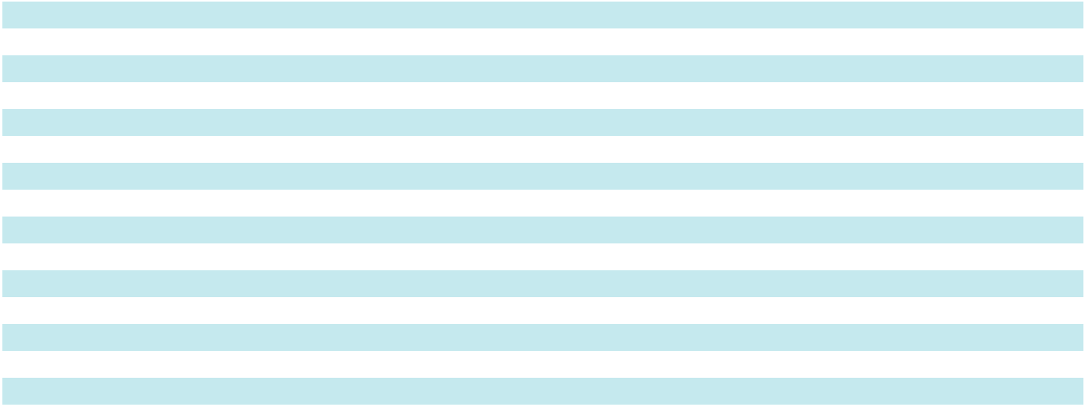

Money market funds

Fair value of money market funds was determined based on quoted prices for identical assets in active markets. These assets are included within cash and cash equivalents on our Consolidated Balance Sheets.

Municipal bonds

Municipal bonds were measured at fair value based on market prices from recent trades of similar securities and are classified within our Consolidated Balance Sheets as other current or other non-current assets based on maturity date.

Derivative instruments

The interest rate swaps are measured at fair value using other observable market inputs, based off benchmark interest rates. Forward foreign exchange and forward purchase aluminum contracts are measured at fair value using other observable market inputs, such as quotations on forward foreign exchange points, foreign currency exchange rates and forward purchase aluminum prices. Derivative positions are primarily valued using standard calculations and models that use as their basis readily observable market parameters. Industry standard data providers are our primary source for forward and spot rate information for interest and currency rates and aluminum prices.

Nonrecurring fair value measurements

We measure certain long-lived assets — including goodwill, intangible assets, property and equipment, and right-of-use lease assets — at fair value on a nonrecurring basis when indicators of impairment are present. These assets, initially recorded at fair value upon acquisition or purchase, are evaluated periodically, and if impairment indicators exist, we compare their carrying values to their estimated fair values and recognize an impairment charge for any excess carrying value. See Note 1 for further information on impairment of long-lived assets.

50

Table of Contents

5. Property, Plant and Equipment

(In thousands) |  | February 28, 2026 |  |  |  | March 1, 2025
Land | $ |  | 3,501 | $ |  | 3,460
Buildings and improvements |  |  | 206,315 |  |  | 195,205
Machinery and equipment |  |  | 446,700 |  |  | 428,015
Computer and office equipment and furniture |  |  | 55,117 |  |  | 61,926
Construction in progress |  |  | 26,179 |  |  | 49,013
Total property, plant and equipment |  |  | 737,812 |  |  | 737,619
Less: accumulated depreciation |  |  | 482,780 |  |  | 469,480
Net property, plant and equipment | $ |  | 255,032 | $ |  | 268,139
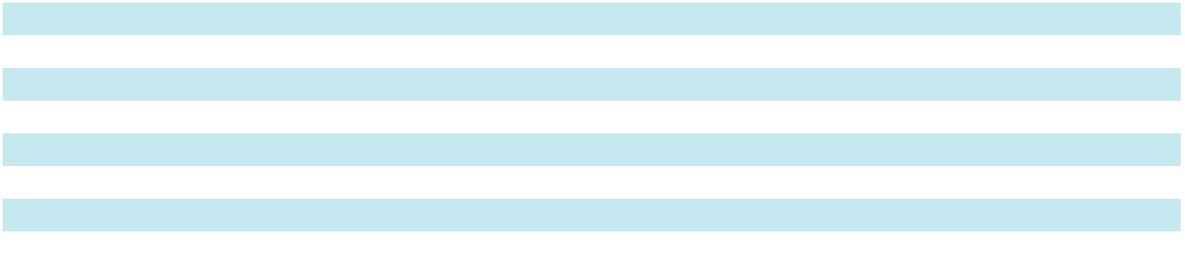

Depreciation expense was $39.4 million, $35.7 million, and $37.6 million in fiscal 2026, 2025, and 2024, respectively.

- Goodwill and Other Intangible Assets Goodwill

The carrying amount of goodwill attributable to each reportable segment was:

 |  | Architectural |  |  | Architectural |  |  | Architectural |  |  | Performance |  |  |  | Total
(In thousands) |  |  | Metals |  |  | Services |  |  | Glass |  |  | Surfaces |  |  | Total
Balance at March 2, 2024 | $ |  | 90,186 | $ |  | 3,038 | $ |  | 25,401 | $ |  | 10,557 | $ |  | 129,182
Foreign currency translation |  |  | (852) |  |  | (117) |  |  | (264) |  |  | — |  |  | (1,233)
Goodwill acquired |  |  | — |  |  | — |  |  | — |  |  | 107,826 |  |  | 107,826
Balance at March 1, 2025 |  |  | 89,334 |  |  | 2,921 |  |  | 25,137 |  |  | 118,383 |  |  | 235,775
Foreign currency translation |  |  | 754 |  |  | 103 |  |  | 112 |  |  | — |  |  | 969
Balance at February 28, 2026 | $ |  | 90,088 | $ |  | 3,024 | $ |  | 25,249 | $ |  | 118,383 | $ |  | 236,744

Intangible assets

In fiscal 2025, $79.7 million of intangible assets were acquired as part of the UW Solutions acquisition. The gross carrying amount of our intangible assets and related accumulated amortization was:

(In thousands)

February 28, 2026

Definite-lived intangible assets:

Customer relationships

Other intangibles

Total

Indefinite-lived intangible assets:

 | Gross |  | Accumulated |  |  | Impairment |  |  |  | Foreign
 | Carrying |  |  |  |  |  |  |  |  | Currency |  |  | Net
 | Amount |  | Amortization |  |  |  | Expense |  | Translation |  |  |  | Net
$ | 131,746 | $ |  | (64,698) | $ |  | (4,994) | $ |  | 2,138 | $ |  | 64,192
 | 65,807 |  |  | (36,286) |  |  | (2,589) |  |  | 940 |  |  | 27,872
 | 197,553 |  |  | (100,984) |  |  | (7,583) |  |  | 3,078 |  |  | 92,064
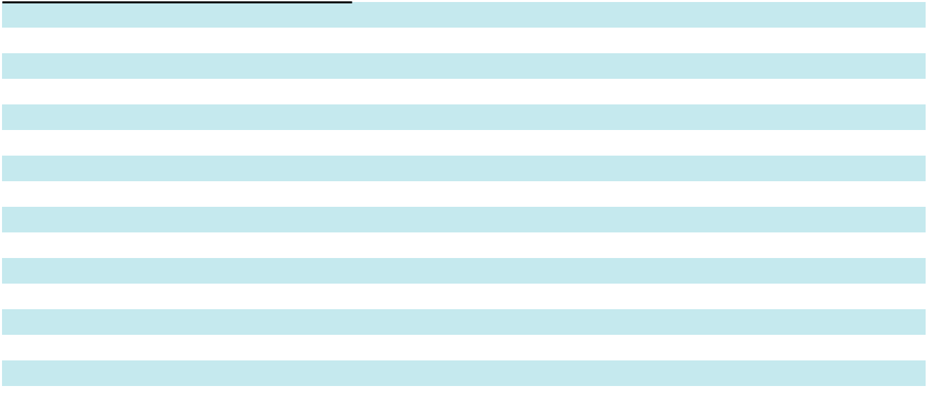

Trademarks |  | 18,996 |  |  |  |  |  | — |  |  | 201 |  |  | 19,197
Total intangible assets | $ | 216,549 | $ |  | (100,984) | $ |  | (7,583) | $ |  | 3,279 | $ |  | 111,261
March 1, 2025
Definite-lived intangible assets:
Customer relationships | $ | 134,402 | $ |  | (56,193) | $ |  | — | $ |  | (2,655) | $ |  | 75,554
Other intangibles |  | 66,832 |  |  | (31,768) |  |  | — |  |  | (1,197) |  |  | 33,867
Total |  | 201,234 |  |  | (87,961) |  |  | — |  |  | (3,852) |  |  | 109,421
Indefinite-lived intangible assets:
Trademarks |  | 26,865 |  |  | — |  |  | (7,634) |  |  | (235) |  |  | 18,996
Total intangible assets | $ | 228,099 | $ |  | (87,961) | $ |  | (7,634) | $ |  | (4,087) | $ |  | 128,417

Amortization expense on definite-lived intangible assets was $10.6 million, $8.9 million and $4.9 million in fiscal 2026, 2025 and 2024, respectively. All amortization expense is included within selling, general and administrative expenses. Estimated future amortization expense for definite-lived intangible assets is:

51

Table of Contents

(In thousands) |  |  | 2027 |  |  | 2028 |  |  | 2029 |  |  | 2030 |  |  | 2031
Estimated amortization expense | $ |  | 6,755 | $ |  | 6,461 | $ |  | 5,590 | $ |  | 5,552 | $ |  | 5,552

- Debt

We are party to a Credit Agreement (the Credit Agreement) with Bank of America, N.A., as administrative agent, and other lenders. The Credit Agreement provides for an unsecured senior credit facility in an aggregate principal amount of up to $700.0 million, in which commitments were made through a $450.0 million, five-year revolving credit facility and a committed $250.0 million delayed draw term loan facility. Borrowings under the revolving credit facility can be in Canadian dollars (CAD) limited to $25.0 million USD. The term loan facility may be utilized in up to two draw downs, which are available to be made within one year after the closing date. The senior credit facility has a term of five years with a maturity date of July 19, 2029.

As a result of the execution of the Credit Agreement, in the second quarter of fiscal 2025, we recognized a loss on extinguishment of debt within interest expense of $0.5 million for the write-off of unamortized financing fees related to the previously existing revolving credit facility. Additionally, we capitalized $3.0 million of lender fees and $0.8 million of third-party fees incurred in connection with the Credit Agreement, which were recorded as other non-current assets and will be amortized over the term of the credit facility as interest expense.

The Credit Agreement contains two maintenance financial covenants that require our Consolidated Leverage Ratio (as defined in the Credit Agreement) to be less than 3.50 and our Consolidated Interest Coverage Ratio (as defined in the Credit Agreement) to exceed 3.00. At February 28, 2026, we were in compliance with all covenants as defined under the terms of the Credit Agreement.

The Credit Agreement also contains an acquisition "holiday." In the event we make an acquisition for which the purchase price is greater than $75.0 million, we can elect to increase the maximum Consolidated Leverage Ratio (as defined in the Credit Agreement) to 4.00 for a period of four consecutive fiscal quarters, commencing with the fiscal quarter in which a qualifying acquisition occurs. No more than two acquisition holidays can occur during the term of the Credit Agreement, and at least two fiscal quarters must separate qualifying acquisitions.

Borrowings under the Credit Agreement bear floating interest at either the Base Rate or Term Secured Overnight Financing Rate (SOFR), or, for CAD borrowings, Canadian Overnight Repo Rate Average (CORRA), plus a margin based on the Consolidated Leverage Ratio (as defined in the Credit Agreement). For Base Rate borrowings, the margin ranges from 0.25% to 0.75%. For Term SOFR and CORRA borrowings, the margin ranges from 1.25% to 1.75%, with an incremental Term SOFR and CORRA adjustment of 0.10% and 0.29547%.

The Credit Agreement also contains an "accordion" provision. Under this provision, we can request that the senior credit facility be increased unlimited additional amounts. Any lender may elect or decline to participate in the requested increase at their sole discretion.

On November 4, 2024, as part of the acquisition of UW Solutions, and for working capital and general corporate purposes, we executed a drawdown against the delayed draw term loan facility for $250.0 million. Outstanding borrowings under the term loan facility were $212.3 million as of February 28, 2026. Outstanding borrowings under the current revolving credit facility were $20.0 million as of February 28, 2026.

At February 28, 2026, we had a total of $2.6 million of ongoing letters of credit related to the senior credit facility, construction contracts and insurance collateral that expire in fiscal year 2027 and reduce borrowing capacity under the revolving credit facility. As of February 28, 2026, the amount available for revolving borrowings was $427.4 million.

The fair value of our senior credit facility approximated carrying value at February 28, 2026, and would be classified as Level 2 within the fair value hierarchy described in Note 4, due to the variable interest rate on these instruments.

52

Table of Contents

Debt maturities and other selected information follows:

(In thousands) |  |  | 2027 |  |  | 2028 |  |  | 2029 |  |  | 2030 |  |  | 2031 |  | Thereafter |  |  |  | Total
Maturities |  | $ | — $ |  |  | — $ |  |  | — $ |  |  | 232,279 | $ |  | — | $ |  | — | $ |  | 232,279
(In thousands, except percentages) |  |  |  |  |  |  |  |  |  |  |  |  |  |  |  |  |  | 2026 |  |  | 2025
Average daily borrowings during the year |  |  |  |  |  |  |  |  |  |  |  |  |  |  |  | $ |  | 278,213 | $ |  | 134,565
Weighted average interest rate during the year |  |  |  |  |  |  |  |  |  |  |  |  |  |  |  |  |  | 5.93 % |  |  | 6.28 %
(In thousands) |  |  |  |  |  |  |  |  |  |  |  |  |  |  | 2026 |  |  | 2025 |  |  | 2024
Interest on debt |  |  |  |  |  |  |  |  |  |  |  |  | $ |  | 16,428 | $ |  | 8,803 | $ |  | 8,704
Interest rate swap gain |  |  |  |  |  |  |  |  |  |  |  |  |  |  | (645) |  |  | (822) |  |  | (893)
Other interest expense |  |  |  |  |  |  |  |  |  |  |  |  |  |  | 668 |  |  | 815 |  |  | 178
Interest income |  |  |  |  |  |  |  |  |  |  |  |  |  |  | (2,475) |  |  | (2,637) |  |  | (1,320)
Interest expense, net |  |  |  |  |  |  |  |  |  |  |  |  | $ |  | 13,976 | $ |  | 6,159 | $ |  | 6,669
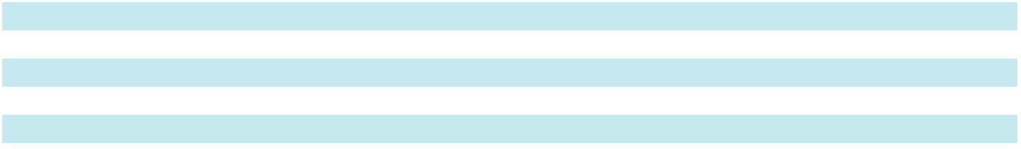

Interest payments under the credit facilities were $16.7 million in fiscal 2026, $8.1 million in fiscal 2025 and $9.3 million in fiscal 2024. The weighted average interest rates on borrowings outstanding, inclusive of the impact of our interest rate swap as of February 28, 2026 and March 01, 2025 were 4.44% and 4.32%, respectively.

53

Table of Contents

- Leases

We have operating leases for certain buildings and equipment used in our operations. We determine if an arrangement contains a lease at inception. Under ASU 2016-20, Leases, we have elected the package of practical expedients permitted under the transition guidance in adopting ASC 842, which, among other things, allowed us to carry forward our historical lease classification. Operating lease assets and liabilities are recognized at the lease commencement date based on the present value of lease payments over the lease term. Lease expense is recognized on a straight-line basis over the lease term. Our leases have remaining lease terms of one to sixteen years, some of which include renewal options that can extend the lease for up to an additional ten years, at our sole discretion.

In determining lease asset value, we consider fixed or variable payment terms, prepayments, incentives, and options to extend, terminate or purchase. Renewal, termination or purchase options affect the lease term used for determining lease asset value only if the option is reasonably certain to be exercised. We use a discount rate for each lease based upon an estimated incremental borrowing rate over a similar term. We have elected the practical expedient to account for lease and non-lease components (e.g., common-area maintenance costs) as a single lease component. Our lease agreements do not contain any material residual value guarantees or material restrictive covenants.

The components of lease expense were as follows:

(In thousands) |  |  | 2026 |  |  | 2025
Operating lease cost | $ |  | 17,067 | $ |  | 14,587
Short-term lease cost |  |  | 1,268 |  |  | 688
Variable lease cost |  |  | 5,955 |  |  | 3,984
Sublease income |  |  | (1,799) |  |  | (1,533)
Total lease cost | $ |  | 22,491 | $ |  | 17,726
Other supplemental information related to leases are as follows:
(In thousands) |  |  | 2026 |  |  | 2025
Cash paid for amounts included in the measurement of operating lease liabilities | $ |  | 18,136 | $ |  | 16,467
Lease assets obtained in exchange for new operating lease liabilities | $ |  | 3,940 | $ |  | 21,810
Weighted-average remaining lease term - operating leases |  |  | 5.6 |  |  | 5.7
Weighted-average discount rate - operating leases |  |  | 4.7 % |  |  | 4.5 %
Future maturities of lease liabilities are as follows:
(In thousands) |  |  |  |  |  | 2026
Fiscal 2027 |  |  |  | $ |  | 15,823
Fiscal 2028 |  |  |  |  |  | 13,191
Fiscal 2029 |  |  |  |  |  | 8,831
Fiscal 2030 |  |  |  |  |  | 6,027
Fiscal 2031 |  |  |  |  |  | 4,833
Thereafter |  |  |  |  |  | 12,094
Total lease payments |  |  |  |  |  | 60,799
Less: Amounts representing interest |  |  |  |  |  | 6,695
Present value of lease liabilities |  |  |  | $ |  | 54,104

54

Table of Contents

- Employee Benefit Plans 401(k) Retirement Plan

We sponsor a single 401(k) retirement plan covering substantially all full-time, non-union employees, as well as union employees at two of our manufacturing facilities. Under the plan, employees are allowed to contribute up to 60% of eligible earnings to the plan, up to statutory limits. The Company matches 100% of the first two percent contributed and 50% of the next four percent contributed on eligible compensation that non-union employees contribute. We contribute to the union plans based on the contractual terms. In total, our matching contributions were $8.8 million in fiscal 2026, $9.1 million in fiscal 2025 and $9.6 million in fiscal 2024.

Deferred Compensation Plan

We maintain a plan that allows participants to defer compensation. The deferred compensation liability was $8.3 million and $5.6 million at February 28, 2026 and March 1, 2025, respectively. We have investments in corporate-owned life insurance policies (COLI) of $10.3 million and money market funds (classified as cash equivalents) of $0.3 million with the intention of utilizing them as long-term funding sources for this plan. The COLI assets are recorded at net cash surrender values and are included in other non-current assets on the Consolidated Balance Sheets.

Plans under Collective Bargaining Agreements

We contribute to a number of multi-employer union retirement plans, which provide retirement benefits to the majority of our union-represented employees; none of the plans are considered significant. However, the risks of participating in these multi-employer plans are different from single-employer plans in the following aspects:

- Assets contributed to these plans by one employer may be used to provide benefits to employees of other participating employers

- If a participating employer stops contributing to the plan, the unfunded obligations of the plan may be borne by the remaining participating employers

- If we choose to stop participating in some of these plans, we may be required to pay those plans an amount based on the underfunded status of the plan, referred to as a withdrawal liability

Under the Pension Protection Act, multi-employer pension plans are categorized into zones (green, yellow, red, and deep red). Among other factors, plans in the red zone are generally less than 65% funded, plans in the yellow zone are between 65% and 80% funded, and plans in the green zone are at least 80% funded. The most recent Pension Protection Act zone status available for fiscals 2026 and 2025 relates to the plan years ending December 31, 2025 and December 31, 2024, respectively.

55

Table of Contents

Our participation in these plans is outlined in the following table.

 |  |  |  | Pension
 |  |  |  | Protection Act |  |  |  | Contributions
 |  |  |  | Zone Status |  |  |  | (In thousands)
 |  | EIN/ |  |  |  |  |  |  |  |  |  |  |  |  |  |  |  |  |  |  | Expiration
 |  |  |  |  |  |  |  |  |  |  |  |  |  |  | FIP/RP Status |  |  |  |  |  | Date of
 |  | Pension |  |  |  |  |  |  |  |  |  |  |  |  | FIP/RP Status |  | Minimum |  | Surcharge |  | Collective
Pension Fund |  | Plan |  | 2026 | 2025 |  | 2026 |  |  |  | 2025 | 2024 |  |  | Pending/ |  | Minimum |  | Surcharge |  | Bargaining
Pension Fund |  | Number |  | 2026 |  |  |  |  |  |  | 2025 |  |  |  | Implemented⁽²⁾ |  | Contribution |  | Imposed |  | Agreement⁽¹⁾
Iron Workers Local
Union No. 5 and Iron
Workers Employers
Association Employees | 521075473 |  |  | Green |  | Green | $ 1,034 |  | $ |  | 722 | $ 1,015 |  |  | No |  | No |  | No | 5/31/2029
Pension Trust Fund |  |  |  | Green |  |  |  |  |  |  |  |  |  |  | No |  | No |  | No
International Painters
and Allied Trades | 526073909 |  |  | Red |  | Red |  | — |  |  | 730 | 971 |  |  | Implemented |  | No |  | No |  | Various
Industry Pension Fund |  |  |  | Red |  | Red |  | — |  |  | 730 |  |  |  | Implemented |  | No |  | No |  | Various
Ironworkers Local 580 | 136178514 |  |  | Green |  | Green | 1,099 |  |  |  | 2,121 | 883 |  |  | Implemented |  | No |  | Yes | 6/30/2023
Pension Fund |  |  |  | Green |  | Green |  |  |  |  | 2,121 |  |  |  | Implemented |  | No |  | Yes
Western Glaziers
Retirement Plan | 916123685 |  |  | Green |  | Green | 304 |  |  |  | 365 | 423 |  |  | No |  | No |  | No | 6/30/2022
(Washington) |  |  |  | Green |  | Green |  |  |  |  | 365 |  |  |  | No |  | No |  | No
Iron Workers Mid- | 366488227 |  |  | Green |  | Green | 96 |  |  |  | 320 | 237 |  |  | No |  | No |  | No | 5/31/2027
America Pension Fund |  |  |  | Green |  | Green |  |  |  |  | 320 |  |  |  | No |  | No |  | No
Other funds |  |  |  |  |  |  |  | 1,220 |  |  | 814 |  | 1,077
Total contributions |  |  |  |  |  |  | $ 3,753 |  | $ |  | 5,072 | $ 4,606


- Plans include contributions required by collective bargaining agreements which have expired, but contain provisions automatically renewing their terms in the absence of a subsequent negotiated agreement.

- FIP is defined as Funding Improvement Plan; RP is defined as Rehabilitation Plan

The Company was listed in the plans' Form 5500s as providing more than 5% of the total contributions for the following plans and plan years:

Pension Fund |  | Year Contributions To Plan Exceeded More
Pension Fund |  | Than 5 Percent Of Total Contributions
Iron Workers Local Union No. 5 and Iron Workers Employers Association Employees Pension Trust Fund |  | 2026, 2025 and 2024
Western Glaziers Retirement Fund (Oregon and Southwest Washington) |  | 2026 and 2025
Ironworkers Local 580 Pension Fund | 2026

Amounts contributed in fiscal 2026, 2025, and 2024 to defined contribution multi-employer plans were $2.8 million, $3.6 million and $2.2 million, respectively.

Obligations and Funded Status of Defined-Benefit Pension Plans

We sponsor the Tubelite Inc. Hourly Employees' Pension Plan (Tubelite Plan), a defined-benefit pension plan that was frozen to new entrants in fiscal 2004, with no additional benefits accruing to plan participants after such time. We also sponsor an unfunded Supplemental Executive Retirement Plan (SERP), a defined-benefit pension plan that was frozen to new entrants in fiscal 2009, with no additional benefits accruing to plan participants after such time.

56

Table of Contents

The following tables present reconciliations of the benefit obligation and the funded status of these plans. The Tubelite Plan uses a measurement date as of the calendar month-end closest to our fiscal year-end, while the SERP uses a measurement date aligned with our fiscal year-end.

(In thousands) |  | February 28, 2026 |  |  |  | March 1, 2025
Change in projected benefit obligation
Benefit obligation beginning of period | $ |  | 8,592 | $ |  | 8,897
Interest cost |  |  | 417 |  |  | 437
Actuarial loss (gain) |  |  | 108 |  |  | 39
Benefits paid |  |  | (769) |  |  | (781)
Benefit obligation at measurement date |  |  | 8,348 |  |  | 8,592
Change in plan assets
Fair value of plan assets beginning of period | $ |  | 3,582 | $ |  | 3,793
Actual return on plan assets |  |  | 122 |  |  | 124
Company contributions |  |  | 516 |  |  | 446
Benefits paid |  |  | (769) |  |  | (781)
Fair value of plan assets at measurement date |  |  | 3,451 |  |  | 3,582
Underfunded status | $ |  | (4,897) | $ |  | (5,010)
The funded status was recognized on the Consolidated Balance Sheets as follows:
(In thousands) |  | February 28, 2026 |  |  |  | March 1, 2025
Other non-current assets | $ |  | 73 | $ |  | 76
Current liabilities |  |  | (446) |  |  | (446)
Other non-current liabilities |  |  | (4,524) |  |  | (4,640)
Total | $ |  | (4,897) | $ |  | (5,010)
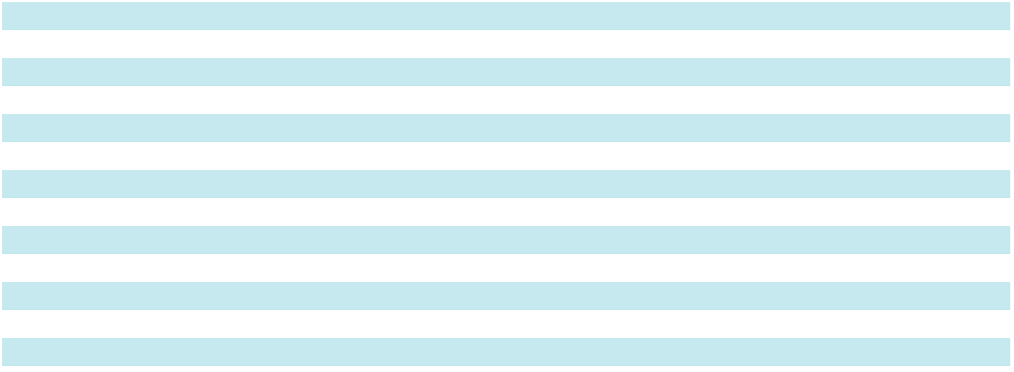

The following was included in accumulated other comprehensive loss and has not yet been recognized as a component of net periodic benefit cost:

(In thousands) |  |  |  |  | 2026 |  |  |  | 2025
Net actuarial loss |  |  |  | $ |  | 2,700 | $ |  | 2,748
Components of the defined-benefit pension plans' net periodic benefit cost:
(In thousands) |  | 2026 |  |  | 2025 |  |  |  | 2024
Interest cost | $ |  | 417 | $ |  | 437 | $ |  | 497
Expected return on assets |  |  | (94) |  |  | (115) |  |  | (120)
Amortization of unrecognized net loss |  |  | 62 |  |  | 66 |  |  | 62
Net periodic benefit cost | $ |  | 385 | $ |  | 388 | $ |  | 439

Total net periodic pension benefit cost is expected to be approximately $0.4 million in fiscal 2027. The estimated net actuarial gain for the defined-benefit pension plans that will be amortized from accumulated other comprehensive loss into net periodic benefit cost for fiscal 2027 is $0.1 million, net of tax expense.

57

Table of Contents

Additional Information

Assumptions

Benefit Obligation Weighted-Average Assumptions |  | 2026 |  |  | 2025 |  | 2024
Discount rate |  |  | 5.00 % | 5.10 % |  | 5.15 %
Net Periodic Benefit Expense Weighted-Average Assumptions |  | 2026 |  |  | 2025 |  | 2024
Discount rate |  |  | 5.10 % | 5.15 % |  | 5.10 %
Expected long-term rate of return on assets |  |  | 4.60 % | 4.60 % |  | 4.50 %

Discount rate. The discount rate reflects the current rate at which the defined-benefit plans' pension liabilities could be effectively settled at the end of the year based on the measurement date. The discount rate was determined by matching the expected benefit payments to payments from the Principal Discount Yield Curve.

Expected return on assets. The expected long-term rate of return on assets is based on historical long-term rates of return achieved by the plan investments, the plan's investment strategy, and current and projected market conditions. The assets of the Tubelite Plan are invested in various duration fixed income funds. The investments are carried at fair value based on prices from recent trades of similar securities, which would be classified as Level 2 in the fair value hierarchy presented in Note 4. We do not maintain assets intended for the future use of the SERP.

Contributions

Company contributions to the plans for fiscal 2026 were $0.5 million and fiscal 2025 were $0.4 million, which equaled or exceeded the minimum funding requirements.

Estimated Future Benefit Payments

The following benefit payments, which reflect expected future service, are expected to be paid by the plans:

(In thousands) |  |  | 2027 |  |  | 2028 |  |  | 2029 |  |  | 2030 |  |  | 2031 |  | 2032-2036
Estimated future benefit payments | $ |  | 826 | $ |  | 774 | $ |  | 762 | $ |  | 748 | $ |  | 724 | $ |  | 3,309

- Commitments and Contingent Liabilities Bond commitments

In the ordinary course of business, predominantly in the Architectural Services Segments, we are required to provide surety or performance bonds that commit payments to our customers for any non-performance against our contracts. At February 28, 2026, $1.3 billion of these types of bonds were outstanding, of which $267.5 million is in our backlog. These bonds have expiration dates that align with completion of these contracts. We have never been required to make payments under surety or performance bonds with respect to our existing businesses.

Warranty and project-related contingencies

We reserve estimated exposures on known claims, as well as on a portion of anticipated claims, for product warranty and rework costs, based on historical product liability claims as a ratio of sales. Claim costs are deducted from the accrual when paid. Factors that could have an impact on the warranty accrual in any given period include changes in manufacturing quality, changes in product mix, and any significant changes in sales volume.

(In thousands) |  |  | 2026 |  |  | 2025
Balance at beginning of period | $ |  | 18,461 | $ |  | 21,362
Additional provision |  |  | 3,993 |  |  | 7,336
Claims paid |  |  | (9,551) |  |  | (10,237)
Balance at end of period | $ |  | 12,903 | $ |  | 18,461

Additionally, we are subject to project management and installation-related contingencies as a result of our fixed-price material supply and installation service contracts, primarily in our Architectural Services Segment and certain parts of our Architectural Metals Segment. We manage the risk of these exposures through contract negotiations, proactive project management and insurance coverages.

Letters of credit

At February 28, 2026, we had $2.6 million of ongoing letters of credit as discussed in Note 7.

58

Table of Contents

Purchase obligations

Purchase obligations for raw material commitments and capital expenditures totaled $15.1 million as of February 28, 2026.

New Markets Tax Credit (NMTC) transactions

During fiscal 2026, we settled our final two NMTC transactions, which resulted in recognizing benefits of $6.7 million in other (income) expense, net.

When these transactions were initiated, the proceeds received from investors were included within other current liabilities in our Consolidated Balance Sheets. The NMTC arrangements were subject to 100 percent tax credit recapture for a period of seven years from the date of transaction. Upon the termination, proceeds were recognized in earnings in exchange for the transfer of tax credits. The direct and incremental costs incurred in structuring this arrangement were deferred and were included in other current assets in our Consolidated Balance Sheets. These costs were recognized in conjunction with the recognition of the related proceeds as settled. During the construction phase or for working capital purposes, we were required to hold cash dedicated to fund the project, which was classified as restricted cash in our Consolidated Balance Sheet. As a result of the structure of these transactions, a variable-interest entity was created. As the other investors in these programs did not have a material interest in the entity's underlying economics, we included 100% of the results of the variable-interest entity in our consolidated financial statements.

Litigation

The Company is a party to various legal proceedings incidental to its normal operating activities. In particular, like others in the construction supply and services industry, the Company is routinely involved in various disputes and claims arising out of construction projects, sometimes involving significant monetary damages or product replacement. We have in the past and are currently subject to product liability and warranty claims, including certain legal claims related to a commercial sealant product formerly incorporated into our products.

In December 2022, the claimant in an arbitration of one such claim was awarded $20 million by an arbitration panel. The claimant then sought to confirm this award in Los Angeles Superior Court in March 2023. In response, the Company moved to vacate the award. Later in March 2023, the Superior Court confirmed the award, which the Company appealed in June 2023. The appeal was argued before the California Court of Appeals, Second Appellate District, Division Seven, on March 7, 2025. The California Court of Appeals confirmed the judgment of the Superior Court on March 25, 2025. The Company paid the final arbitration award, including accrued post-judgment interest, in the amount of $24.7 million, on April 7, 2025. As a result of the judgment, in the fourth quarter of fiscal 2025, we recorded expense of $9.4 million, which represented the impact of the award amount net of existing reserves and estimated insurance proceeds of $11.0 million.

The Company is also subject to litigation arising out of areas such as employment practices, workers compensation and general liability matters. Although it is very difficult to accurately predict the outcome of any such proceedings, facts currently available indicate that no matters will result in losses that would have a material adverse effect on the results of operations, cash flows or financial condition of the Company.

11. Supplier Finance Program Obligations

The Company has a supplier financing arrangement that enables select suppliers, at their sole discretion, to sell our receivables (i.e., our payment obligations to the suppliers) on a non-recourse basis in order to be paid earlier than our payment terms provide. These suppliers’ voluntary inclusion of invoices in the supplier financing arrangement has no bearing on our payment terms, the amounts we pay, or our liquidity. We have no economic interest in the supplier’s decision to participate in the supplier financing program, and we do not provide any guarantees in connection with it. The balances owed are reflected in accounts payable on the Consolidated Balance Sheets and are reflected in net cash provided by operating activities in our Consolidated Statements of Cash Flows when settled.

The following table summarizes the obligation activity for the years ended February 28, 2026 and March 1, 2025 and outstanding balance as of February 28, 2026 and March 1, 2025 that we have confirmed as valid to the administrators of our program:

(In thousands) |  |  | 2026 |  |  | 2025
Balance at beginning of period | $ |  | 6,846 | $ |  | 6,527
Obligations added to the program |  |  | 51,511 |  |  | 47,226
Obligations settled |  |  | (50,500) |  |  | (46,907)
Balance at end of period | $ |  | 7,857 | $ |  | 6,846

59

Table of Contents

12. Shareholders' Equity

We paid dividends totaling $22.2 million ($1.05 per share) in fiscal 2026, $21.7 million ($1.01 per share) in fiscal 2025 and $21.1 million ($0.97 per share) in fiscal 2024.

Share Repurchases

During fiscal 2004, the Board of Directors authorized a share repurchase program, with subsequent increases in authorization. We repurchased 388,582 shares under the program during fiscal 2026, for a total cost of $15.0 million. We repurchased 786,690 shares under the program, for a total cost of $45.4 million, in fiscal 2025, and repurchased 279,916 shares under the program, for a total cost of $11.8 million, in fiscal 2024. We have repurchased a total of 12,451,789 shares, at a total cost of $453.5 million, since the inception of this program. We have remaining authority to repurchase 1,798,211 shares under this program, which has no expiration date. We may elect to repurchase additional shares of common stock under our authorization, subject to limitations contained in our debt agreements and based upon our assessment of a number of factors, including share price, trading volume and general market conditions, working capital requirements, general business conditions, financial conditions, any applicable contractual limitations, and other factors, including alternative investment opportunities. We may finance share repurchases with available cash, additional debt or other sources of financing.

In addition to the shares repurchased under this repurchase plan, during fiscal 2026, 2025 and 2024, the Company also withheld $1.9 million, $6.1 million and $2.5 million, respectively, of Company stock from employees in order to satisfy stock-for-stock option exercises or tax obligations related to stock-based compensation, pursuant to terms of Board and shareholder-approved compensation plans.

Accumulated Other Comprehensive Loss

The following summarizes the accumulated other comprehensive loss, net of tax, at February 28, 2026 and March 1, 2025:

(In thousands) |  |  | 2026 |  |  | 2025
Net unrealized loss on marketable securities | $ |  | (57) | $ |  | (149)
Net unrealized gain on derivative instruments |  |  | 121 |  |  | —
Pension liability adjustments |  |  | (1,996) |  |  | (2,106)
Foreign currency translation adjustments |  |  | (28,870) |  |  | (33,037)
Total accumulated other comprehensive loss | $ |  | (30,802) | $ |  | (35,292)

13. Share-Based Compensation

We have a 2019 Stock Incentive Plan and a 2019 Non-Employee Director Stock Plan (the Plans) that provide for the issuance of 1,150,000 and 300,000 shares, respectively, for various forms of stock-based compensation to employees and non-employee directors. Awards under these Plans may be in the form of incentive stock options (to employees only), non-statutory options, stock-settled stock appreciation rights (SARs), or nonvested share awards and units, all of which are granted at a price or with an exercise price equal to the fair market value of the Company’s stock at the date of award.

On October 31, 2025, the Company announced the departure of its Chief Executive Officer. In connection with a separation agreement, the Board of Directors approved the accelerated vesting of certain outstanding unvested restricted stock awards and performance share unit awards previously granted. As a result of this modification, the Company recognized incremental stock-based compensation expense of $2.1 million during the third quarter of fiscal 2026, representing the fair value of the awards that would have otherwise vested over the remaining service periods. This amount is included in SG&A expenses on the Consolidated Results of Operations.

We recorded share-based compensation expense, in which we account for any forfeitures as they occur, as follows:

(In thousands) |  |  | 2026 |  |  | 2025 |  |  | 2024
Restricted stock awards and restricted stock units | $ |  | 8,546 | $ |  | 8,040 | $ |  | 6,753
Performance share units |  |  | (300) |  |  | 2,685 |  |  | 2,714
Stock options |  |  | — |  |  | — |  |  | 254
Share-based compensation expense | $ |  | 8,246 | $ |  | 10,725 | $ |  | 9,721

At February 28, 2026, there was $12.2 million of total unrecognized compensation cost related to nonvested share and nonvested share unit awards, which is expected to be recognized over a weighted average period of approximately 1.7 years. The total fair value of shares vested during fiscal 2026 was $12.8 million.

60

Table of Contents

The table below sets forth the number of stock-based compensation awards granted during the twelve months ended

February 28, 2026, along with the weighted average grant date fair value:

Awards |  | Number of Awards |  |  | Weighted Average
Awards |  | Number of Awards |  | Grant Date Fair Value
Restricted stock awards and restricted stock units ⁽¹⁾ | 359,490 |  | $ |  | 39.91
Performance share units ⁽²⁾ | 53,542 |  |  |  | 45.44

- Represent service condition awards which generally vest over a two- or three-year period.

- Represent performance condition awards with the grant equal to the target number of performance shares based on the share price at grant date. These grants allow for the right to receive a variable number of shares, between 0% and 200% of target, dependent on being employed at the end of the performance period and achieving defined performance goals for average adjusted return on invested capital and cumulative adjusted earnings per share.

Service Condition Awards

Nonvested share awards and units generally vest over a two, three or four-year period. The following table summarizes nonvested restricted stock awards and restricted stock units activity for fiscal 2026:

 | Number of Shares |  |  | Weighted Average
 | and Units |  | Grant Date Fair Value
Awards outstanding at March 1, 2025 | 348,219 | $ |  | 48.53
Granted | 359,490 |  |  | 39.91
Vested | (197,250) |  |  | 46.90
Forfeited and cancelled | (80,222) |  |  | 52.13
Awards outstanding at February 28, 2026 | 430,237 | $ |  | 41.44

Performance Condition Awards

In fiscal 2022, the Compensation Committee of the Board of Directors implemented an executive compensation program for certain key employees. In each of the first quarters of fiscal 2026, fiscal 2025 and fiscal 2024, we issued performance shares in the form of nonvested share unit awards, which give the recipient the right to receive shares earned at the end of the respective three-fiscal-year performance period. The number of share units issued at grant is equal to the target number of performance shares and allows for the right to receive a variable number of shares, ranging from 0% to 200% of target, dependent on achieving defined performance goals and being employed at the end of the performance period.

The following table summarizes nonvested performance share units granted and outstanding for which plans are at 0% to 200% of target:

 | Number of Shares |  |  | Weighted Average
 | and Units at Target |  | Grant Date Fair Value
Awards outstanding at March 1, 2025 | 101,120 | $ |  | 51.13
Granted ⁽¹⁾ | 81,466 |  |  | 45.50
Vested ⁽¹⁾ | (72,715) |  |  | 47.48
Forfeited and cancelled | (71,327) |  |  | 51.21
Awards outstanding at February 28, 2026 | 38,544 | $ |  | 48.07

- Includes 27,924 shares for performance goals component of the fiscal 2023-2025 performance period.

Stock Options

There were no outstanding options after fiscal 2024 and the aggregate intrinsic value of securities exercised (the amount by which the stock price on the date of exercise exceeded the stock price of the award on the date of grant) was $1.8 million.

61

Table of Contents

14. Income Taxes

Earnings before income taxes consisted of the following:

(In thousands) |  |  | 2026 |  |  | 2025 |  |  | 2024
United States | $ |  | 83,038 | $ |  | 111,029 | $ |  | 133,185
International |  |  | (5,582) |  |  | 1,545 |  |  | (3,932)
Earnings before income taxes |  | $ | 77,456 |  | $ | 112,574 |  | $ | 129,253
The components of income tax expense (benefit) for each of the last three fiscal years are as follows:
(In thousands) |  |  | 2026 |  |  | 2025 |  |  | 2024
Current
Federal | $ |  | 5,966 | $ |  | 19,979 | $ |  | 32,900
State and local |  |  | 752 |  |  | 3,546 |  |  | 6,172
International |  |  | 1,550 |  |  | (586) |  |  | 286
Total current |  |  | 8,268 |  |  | 22,939 |  |  | 39,358
Deferred
Federal |  |  | 13,611 |  |  | 3,190 |  |  | (8,361)
State and local |  |  | 3,224 |  |  | 691 |  |  | (1,387)
International |  |  | (1,352) |  |  | (45) |  |  | —
Total deferred |  |  | 15,483 |  |  | 3,836 |  |  | (9,748)
Total non-current tax expense |  |  | (426) |  |  | 747 |  |  | 30
Total income tax expense | $ |  | 23,325 | $ |  | 27,522 | $ |  | 29,640
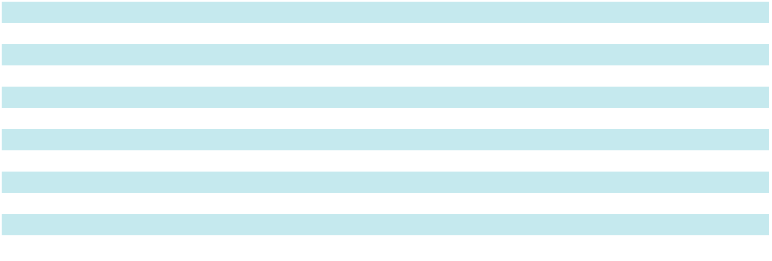

Income tax payments, net of refunds, were $4.1 million, $29.6 million and $33.0 million in fiscal 2026, 2025 and 2024, respectively.

 |  | 2026
Federal | $ | 2,000
State and local
New York |  | 352
Texas |  | 349
New York City |  | 279
Other state and local |  | 848
International
Brazil |  | 318
Other international |  | —
Total | $ | 4,146
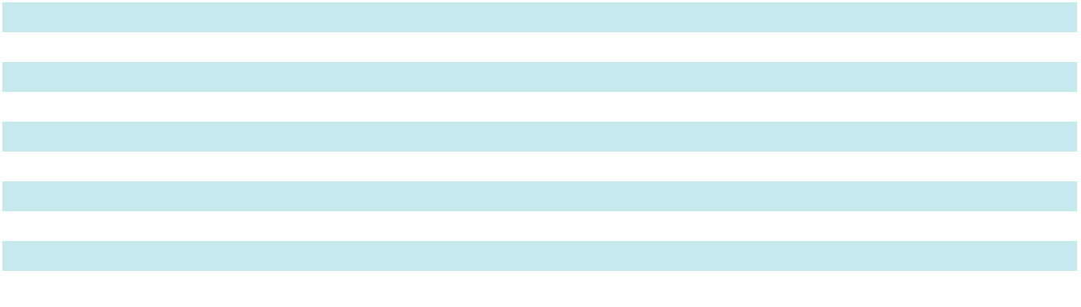

62

Table of Contents

In accordance with our prospective adoption of ASU 2023-09, the following presents a reconciliation of the U.S. federal statutory income tax rate to Apogee's worldwide effective income tax rate for fiscal year ended February 28, 2026:

 |  |  | 2026
(In thousands) |  |  | Amount |  |  | Percent
Federal statutory income tax rate |  | $ | 16,266 |  |  | 21.0 | %
State and local income taxes, net of federal tax benefit ⁽¹⁾ |  |  | 3,005 |  |  | 3.9
Foreign tax effects (Canada):
Cancellation of debt income |  |  | 1,135 |  |  | 1.5
Other |  |  | 235 |  |  | 0.3
Effect of cross border tax laws |  |  | (598) |  |  | (0.8)
Tax credits |  |  | (427) |  |  | (0.6)
Changes in valuation allowance |  |  | 350 |  |  | 0.5
Nontaxable or non-deductible items |  |  | 885 |  |  | 1.1
Changes in unrecognized tax benefits |  |  | (427) |  |  | (0.6)
Other adjustments:
Return to provision |  |  | 2,140 |  |  | 2.8
Other |  |  | 761 |  |  | 1.0
Consolidated effective tax rate |  | $ | 23,325 |  |  | 30.1 | %
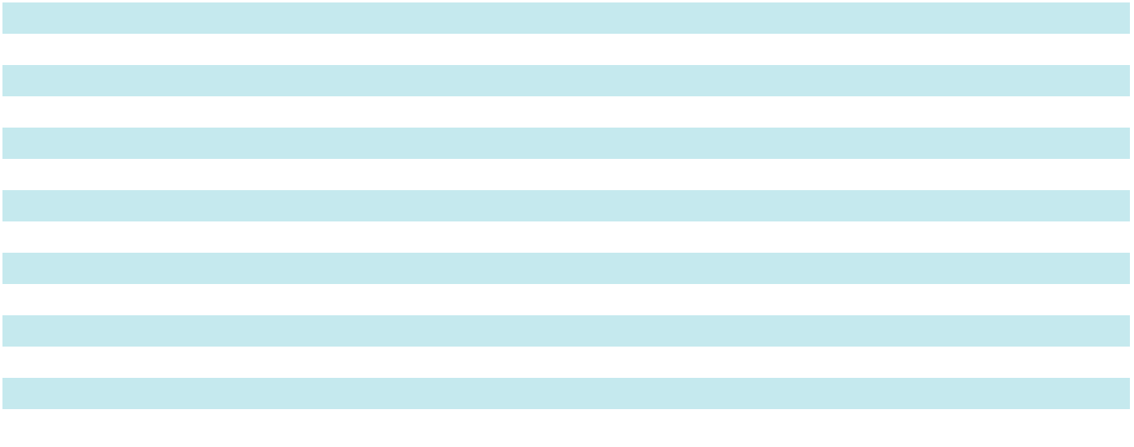

- State and local taxes in Illinois, New York, and New York City made up the majority (greater than 50 percent) of the tax effect in this category.

For the fiscal years ended March 1, 2025, and March 2, 2024, a reconciliation of the federal statutory income tax rate to

Apogee's worldwide effective income tax rate is provided below:

 | 2025 |  |  | 2024
Federal statutory income tax rate |  | 21.0 % | 21.0 %
State and local income taxes, net of federal tax benefit |  | 2.9 | 2.4
Foreign tax rate differential |  | (0.8) | (0.2)
Valuation allowance |  | (0.3) | 1.0
Deduction for foreign derived intangible income |  | (0.4) | (0.3)
Research & development tax credit |  | (1.5) | (1.3)
§162(m) Executive Compensation Limitation |  | 3.4 | 0.8
Tax benefit of share based awards |  | (1.0) | (0.6)
Other, net |  | 1.1 |  | 0.1
Consolidated effective income tax rate |  | 24.4 % | 22.9 %

The consolidated effective tax rate for fiscal 2026 increased 5.7 percentage points from fiscal 2025, primarily due to an increase in tax expense on discrete items in fiscal 2026. The consolidated effective tax rate for fiscal 2025 increased 1.5 percentage points from fiscal 2024, primarily due to an increase in taxes for nondeductible executive compensation. On July 4, 2025, the One Big Beautiful Bill Act (OBBBA) was signed into law in the United States, introducing a wide array of tax reform measures. These include extensions and modifications to certain provisions originally enacted under the Tax Cuts and Jobs Act. OBBBA did not have a material effect on the Company’s effective tax rate for fiscal year 2026.

Deferred tax assets and deferred tax liabilities at February 28, 2026 and March 1, 2025 were:

(In thousands) |  |  | 2026 |  |  | 2025
Deferred tax assets
Accrued expenses | $ |  | 4,316 | $ |  | 3,743
Deferred compensation |  |  | 5,629 |  |  | 9,794
Section 174 capitalized costs |  |  | — |  |  | 15,675
Operating lease liabilities |  |  | 11,356 |  |  | 14,898
Net operating losses and tax credits |  |  | 6,470 |  |  | 11,679
Other |  |  | 12,712 |  |  | 10,443
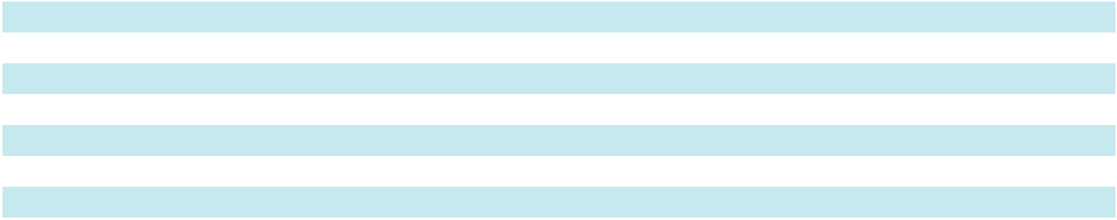

63

Table of Contents

(In thousands) |  |  | 2026 |  |  | 2025
Total deferred tax assets |  |  | 40,483 |  |  | 66,232
Less: valuation allowance |  |  | (9,115) |  |  | (9,582)
Deferred tax assets, net of valuation allowance |  |  | 31,368 |  |  | 56,650
Deferred tax liabilities
Depreciation |  |  | 25,033 |  |  | 22,401
Operating lease, right-of-use assets |  |  | 10,289 |  |  | 13,605
Other |  |  | 10,487 |  |  | 13,405
Total deferred tax liabilities |  |  | 45,809 |  |  | 49,411
Net deferred tax (liabilities) assets | $ |  | (14,441) | $ |  | 7,239

The Company has state and foreign net operating loss carryforwards with a tax effect of $6.4 million. A valuation allowance of $3.6 million has been established for these net operating loss carryforwards due to the uncertainty of the use of the tax benefits in future periods.

Management assesses the available positive and negative evidence to estimate whether sufficient future taxable income will be generated to permit use of the existing Deferred Tax Assets (DTAs). This has resulted in valuation allowances being recorded against DTAs in prior years in Brazil, Canada and various states.

The Company files income tax returns in the U.S. (federal and certain states), Canada, Brazil and other international jurisdictions and is generally subject to limited audit activity. The Internal Revenue Service is in the process of conducting a U.S. federal examination for fiscal year 2023.

The Company considers the earnings of its non-U.S. subsidiaries to be indefinitely invested outside of the United States on the basis of estimates that future domestic cash generation will be sufficient to meet future domestic cash needs and specific plans for reinvestment of those subsidiary earnings. Should the Company decide to repatriate the foreign earnings, it would need to adjust the income tax provision in the period it was determined that the earnings will no longer be indefinitely invested outside the U.S.

If we were to prevail on all unrecognized tax benefits recorded, $3.4 million, $3.8 million and $3.3 million for fiscal 2026, 2025 and 2024, respectively, would benefit the effective tax rate. Also included in the balance of unrecognized tax benefits for fiscal 2026, 2025 and 2024 are $0.7 million, $2.2 million, and $1.8 million, respectively, of tax benefits that, if recognized, would result in decreases to deferred taxes.

Penalties and interest related to unrecognized tax benefits are recorded in income tax expense. For fiscal 2026, 2025 and 2024, we accrued penalties and interest related to unrecognized tax benefits of $0.8 million, $1.0 million, and $0.6 million, respectively.

The following table provides a reconciliation of the total amounts of gross unrecognized tax benefits:

(In thousands) |  |  | 2026 |  |  | 2025 |  |  | 2024
Gross unrecognized tax benefits at beginning of year | $ |  | 5,967 | $ |  | 5,053 | $ |  | 5,312
Gross increases in tax positions for prior years |  |  | 4 |  |  | 347 |  |  | 91
Gross decreases in tax positions for prior years |  |  | (260) |  |  | (11) |  |  | (65)
Gross increases based on tax positions related to the current year |  |  | 212 |  |  | 886 |  |  | 579
Settlements |  |  | — |  |  | — |  |  | (354)
Statute of limitations expiration |  |  | (1,844) |  |  | (308) |  |  | (510)
Gross unrecognized tax benefits at end of year | $ |  | 4,079 | $ |  | 5,967 | $ |  | 5,053

64

Table of Contents

15. Earnings per Share

Basic earnings per share is computed by dividing net earnings by the weighted average number of common shares outstanding. Diluted earnings per share is computed by dividing net earnings by the weighted average number of common shares outstanding, including the dilutive effects of stock options, SARs and nonvested shares. The following table presents a reconciliation of the share amounts used in the computation of basic and diluted earnings per share:

(In thousands) | 2026 |  | 2025 |  | 2024
Basic earnings per share - weighted average common shares outstanding |  | 21,295 |  | 21,726 |  | 21,871
Weighted average effect of nonvested share grants and assumed exercise of stock options | 222 |  | 165 |  | 220
Diluted earnings per share - weighted average common shares and potential common shares
outstanding | 21,517 |  | 21,891 |  | 22,091
Stock awards excluded from the calculation of earnings per share because the award price was
greater than the average market price of the common shares | 177 |  | 23 |  | 31
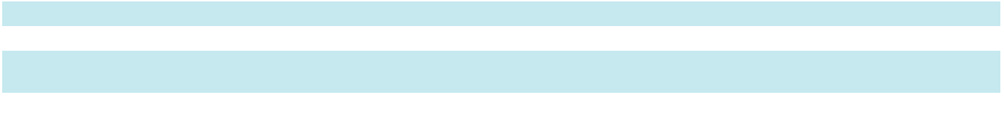

16. Business Segment Data

We have four operating segments which are also reportable segments. Each of our four segments have distinct economic characteristics, including products and services provided, production processes and varying ranges in performance and results:

- The Architectural Metals Segment designs, engineers, fabricates and finishes aluminum window, curtainwall, storefront and entrance systems used primarily in non-residential construction.

- The Architectural Services Segment integrates technical services, project management, and field installation services to design, engineer, fabricate, and install architectural curtainwall and other façade-related systems primarily in non-residential construction.

- The Architectural Glass Segment cuts, treats, coats and fabricates high-performance glass used in custom window and wall systems primarily for non-residential buildings.

- The Performance Surfaces Segment develops and manufactures high-performance coated materials for a variety of applications, including wall decor, museums, graphic design, digital displays, architectural interiors, and industrial flooring.

The Company’s CEO is the chief operating decision maker (CODM). The CODM utilizes segment net sales and adjusted EBITDA to assess segment performance and make decisions about the allocation of operating and capital resources by analyzing recent results, trends, and variances of each segment in relation to forecasts and historical performance.

Net sales, adjusted cost of sales, adjusted SG&A, adjusted other income (expense), depreciation and amortization and the resulting adjusted EBITDA for each of the Company’s four reportable segments are presented below. Segment net sales is defined as net sales of the segment including sales related to intersegment transactions. We present intersegment net sales eliminations separately to exclude these sales from our consolidated total. Segment adjusted EBITDA includes intersegment sales transactions and excludes certain corporate costs that are not allocated at a segment level. We report these unallocated corporate costs in Corporate and Other.

65

Table of Contents

 |  | Architectural |  |  | Architectural |  |  | Architectural |  |  | Performance |  |  |  | Total
(In thousands) |  |  | Metals |  |  | Services |  |  | Glass |  |  | Surfaces |  |  | Total
52-Weeks Ended February 28, 2026
Net sales to external customers | $ |  | 503,750 | $ |  | 439,232 | $ |  | 263,785 | $ |  | 197,966 | $ |  | 1,404,733
Intersegment net sales |  |  | 278 |  |  | — |  |  | 19,874 |  |  | — |  |  | 20,152
Total segment net sales |  |  | 504,028 |  |  | 439,232 |  |  | 283,659 |  |  | 197,966 |  |  | 1,424,885
Adjusted cost of sales ⁽¹⁾ |  |  | (371,416) |  |  | (370,329) |  |  | (208,876) |  |  | (134,066) |  |  | (1,084,687)
Adjusted SG&A ⁽²⁾ |  |  | (93,316) |  |  | (41,640) |  |  | (42,435) |  |  | (37,410) |  |  | (214,801)
Adjusted other expense, net ⁽³⁾ |  |  | — |  |  | — |  |  | (91) |  |  | — |  |  | (91)
Adjusted depreciation and amortization |  |  | 14,813 |  |  | 3,593 |  |  | 13,442 |  |  | 15,153 |  |  | 47,001
Adjusted EBITDA | $ |  | 54,109 | $ |  | 30,856 | $ |  | 45,699 | $ |  | 41,643 | $ |  | 172,307
52-Weeks Ended March 1, 2025
Net sales to external customers | $ |  | 524,617 | $ |  | 419,861 | $ |  | 294,385 | $ |  | 122,131 | $ |  | 1,360,994
Intersegment net sales |  |  | 92 |  |  | — |  |  | 27,812 |  |  | — |  |  | 27,904
Total segment net sales |  |  | 524,709 |  |  | 419,861 |  |  | 322,197 |  |  | 122,131 |  |  | 1,388,898
Adjusted cost of sales ⁽¹⁾ |  |  | (373,902) |  |  | (344,702) |  |  | (220,636) |  |  | (76,487) |  |  | (1,015,727)
Adjusted SG&A ⁽²⁾ |  |  | (96,687) |  |  | (45,604) |  |  | (42,287) |  |  | (21,504) |  |  | (206,082)
Adjusted other income, net ⁽³⁾ |  |  | — |  |  | — |  |  | 115 |  |  | — |  |  | 115
Adjusted depreciation and amortization |  |  | 16,471 |  |  | 3,978 |  |  | 12,274 |  |  | 6,746 |  |  | 39,469
Adjusted EBITDA | $ |  | 70,591 | $ |  | 33,533 | $ |  | 71,663 | $ |  | 30,886 | $ |  | 206,673
53-Weeks Ended March 2, 2024
Net sales to external customers | $ |  | 598,249 | $ |  | 377,442 | $ |  | 342,028 | $ |  | 99,223 | $ |  | 1,416,942
Intersegment net sales |  |  | 3,487 |  |  | 980 |  |  | 36,421 |  |  | — |  |  | 40,888
Total segment net sales |  |  | 601,736 |  |  | 378,422 |  |  | 378,449 |  |  | 99,223 |  |  | 1,457,830
Adjusted cost of sales ⁽¹⁾ |  |  | (425,424) |  |  | (323,761) |  |  | (267,469) |  |  | (60,636) |  |  | (1,077,290)
Adjusted SG&A ⁽²⁾ |  |  | (105,509) |  |  | (40,295) |  |  | (42,934) |  |  | (14,354) |  |  | (203,092)
Adjusted other income (expense), net ⁽³⁾ |  |  | — |  |  | — |  |  | (2,263) |  |  | — |  |  | (2,263)
Adjusted depreciation and amortization |  |  | 19,226 |  |  | 4,010 |  |  | 11,955 |  |  | 3,040 |  |  | 38,231
Adjusted EBITDA | $ |  | 90,029 | $ |  | 18,376 | $ |  | 77,738 | $ |  | 27,273 | $ |  | 213,416


- Adjusted cost of sales excludes $15.0 million of adjustments related to acquisition and restructuring expense for the year ended February 28, 2026, $4.2 million of adjustments related to acquisition and restructuring expense for the year ended March 1, 2025, and $5.5 million of adjustments related to restructuring expense for the year ended March 2, 2024. See the reconciliation presented below for further detail.

- Adjusted SG&A expenses excludes $8.8 million of adjustments related to acquisition and restructuring for the year ended February 28, 2026, $3.8 million of adjustments related to acquisition, restructuring and impairment expense for the year ended March 1, 2025, and $3.0 million of adjustments related to restructuring expense for the year ended March 2, 2024. See the reconciliation presented below for further detail.

- Adjusted Other (income) expense, net excludes $6.7 million and $4.7 million of NMTC benefit recorded for the years ended February 28, 2026, and March 2, 2024, respectively.

66

Table of Contents

The following table presents the reconciliation of adjusted EBITDA to net earnings, the nearest measurement under U.S.

GAAP:

(In thousands) |  |  | February 28, 2026 |  |  | March 1, 2025 |  |  | March 2, 2024
Segment adjusted EBITDA | $ |  | 172,307 | $ |  | 206,674 | $ |  | 213,416
Corporate and Other expenses |  |  | (13,827) |  |  | (27,635) |  |  | (32,097)
Segment acquisition-related costs ⁽¹⁾ |  |  | (1,831) |  |  | (4,529) |  |  | —
Segment restructuring costs ⁽²⁾ |  |  | (21,959) |  |  | (3,535) |  |  | (8,496)
Impairment |  |  | — |  |  | (7,634) |  |  | —
Depreciation and amortization |  |  | (49,998) |  |  | (44,608) |  |  | (41,588)
Other income, net ⁽³⁾ |  |  | 6,740 |  |  | — |  |  | 4,687
Interest expense, net |  |  | (13,976) |  |  | (6,159) |  |  | (6,669)
Income tax expense |  |  | (23,325) |  |  | (27,522) |  |  | (29,640)
Net earnings | $ |  | 54,131 | $ |  | 85,052 | $ |  | 99,613

- Acquisition-related costs include one-time expenses incurred to integrate the UW Solutions acquisition.

- Segment restructuring costs related to Project Fortify. Included in the years ended February 28, 2026, and March 2, 2024 are non-cash amounts related to impairment of intangible assets. See Note 1 for additional information.

- Other income, net includes $6.7 million and $4.7 million of NMTC benefit recorded for the years ended February 28, 2026, and March 2, 2024, respectively.

The following table presents the capital expenditures, depreciation and amortization and identifiable assets by reportable segments and the reconciliation to amounts reported for GAAP:

 |  | Architectural |  |  | Architectural |  |  | Architectural |  |  | Performance |  |  |  | Corporate |  |  | Total
(In thousands) |  |  | Metals |  |  | Services |  |  | Glass |  |  | Surfaces |  |  | and Other |  |  | Total
Fiscal 2026
Capital expenditures | $ |  | 6,710 | $ |  | 2,594 | $ |  | 7,016 | $ |  | 7,960 | $ |  | 3,028 | $ |  | 27,308
Depreciation and amortization |  |  | 14,813 |  |  | 3,593 |  |  | 13,442 |  |  | 15,153 |  |  | 2,997 |  |  | 49,998
Identifiable assets |  |  | 325,562 |  |  | 178,938 |  |  | 202,087 |  |  | 337,076 |  |  | 78,682 |  |  | 1,122,345
Fiscal 2025
Capital expenditures | $ |  | 3,333 | $ |  | 7,522 | $ |  | 13,782 | $ |  | 9,479 | $ |  | 1,477 | $ |  | 35,593
Depreciation and amortization |  |  | 16,471 |  |  | 3,978 |  |  | 12,274 |  |  | 9,085 |  |  | 2,800 |  |  | 44,608
Identifiable assets |  |  | 343,553 |  |  | 179,311 |  |  | 213,067 |  |  | 345,034 |  |  | 94,304 |  |  | 1,175,269
Fiscal 2024
Capital expenditures | $ |  | 4,733 | $ |  | 3,166 | $ |  | 12,142 | $ |  | 16,896 | $ |  | 6,243 | $ |  | 43,180
Depreciation and amortization |  |  | 19,226 |  |  | 4,011 |  |  | 11,955 |  |  | 3,040 |  |  | 3,356 |  |  | 41,588
Identifiable assets |  |  | 363,512 |  |  | 131,651 |  |  | 208,651 |  |  | 83,731 |  |  | 96,519 |  |  | 884,064
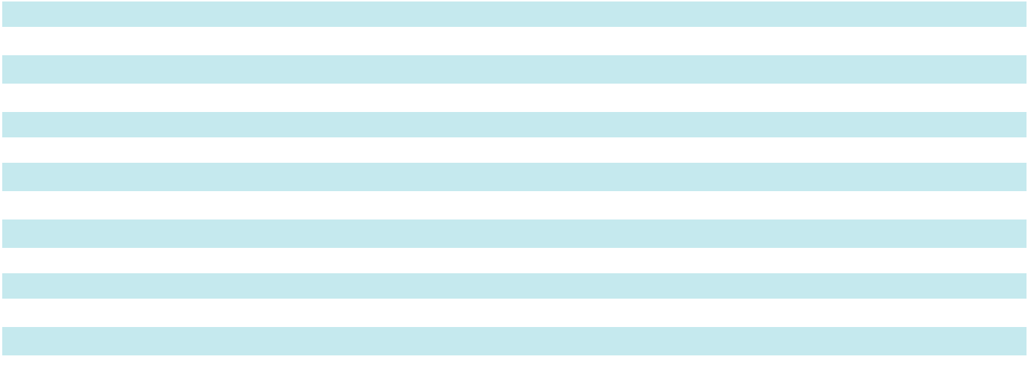

The following tables present net sales, based on the location in which the sale originated, and long-lived assets, representing property, plant and equipment, net of related depreciation, by geographic region.

(In thousands) |  |  | February 28, 2026 |  |  | March 1, 2025 |  |  | March 2, 2024
Net Sales
United States | $ |  | 1,337,409 | $ |  | 1,258,887 | $ |  | 1,295,436
Canada |  |  | 51,301 |  |  | 85,417 |  |  | 101,055
Brazil |  |  | 16,023 |  |  | 16,690 |  |  | 20,451
Total | $ |  | 1,404,733 | $ |  | 1,360,994 | $ |  | 1,416,942

67

Table of Contents

(In thousands) |  |  | February 28, 2026 |  |  | March 1, 2025 |  |  | March 2, 2024
Long-Lived Assets
United States | $ |  | 252,659 | $ |  | 261,457 | $ |  | 235,398
Canada |  |  | 748 |  |  | 4,984 |  |  | 6,345
Brazil |  |  | 1,625 |  |  | 1,698 |  |  | 2,473
Total | $ |  | 255,032 | $ |  | 268,139 | $ |  | 244,216

Our export net sales from U.S. operations were $51.0 million, $54.1 million and $47.6 million in fiscal 2026, 2025 and 2024, respectively, representing approximately 4%, 4% and 3% of consolidated net sales in each of these fiscal years, respectively. Due to the varying combinations and integration of individual window, storefront and curtainwall systems, it is impractical to report product revenues generated by class of product beyond the segment revenues currently reported.

17. Acquisitions

On November 4, 2024, we completed the acquisition of UW Solutions for $240.9 million in cash. UW Solutions is a U.S. based, vertically integrated manufacturer of high-performance coated substrates with a portfolio of well-known brands, including ResinDEK®, ChromaLuxe®, RDC Coatings™, and Unisub®, each known as a leader in its specified applications. The UW Solutions business activity is included in our Performance Surfaces Segment.

The total purchase consideration was $232.2 million in cash, net of a favorable net working capital adjustment of $0.9 million and cash acquired of $8.7 million. The acquisition was funded with cash on hand and borrowings under our existing credit agreement. During fiscal 2025, we incurred pre-tax acquisition-related expenses of $10.3 million associated with the UW Solutions acquisition. We incurred $1.5 million for inventory step-up expense and $0.2 million of transaction costs, which were included in costs of sales, as well as $4.2 million of transaction costs, $2.1 million of integration costs, and $2.3 million of amortization of acquired backlog, which were included in SG&A within our consolidated results of operations. During fiscal 2026, we incurred total pre-tax acquisition-related expenses of $2.1 million associated with the acquisition, of which $0.4 million and $1.7 million are included in cost of sales and SG&A, respectively, within our Consolidated Results of Operations.

We accounted for the acquisition as a purchase of a business and recorded the excess of the purchase price over the estimated fair value of the assets acquired and liabilities assumed as goodwill of $107.8 million. The goodwill recognized is attributable primarily to expected synergies by integrating UW Solutions into our Performance Surfaces Segment and by creating a scalable growth platform in the specialty coatings and materials market. The goodwill is expected to be amortized and deductible for income tax purposes. We have determined the appropriate fair values of the acquired intangible assets and completed our analysis of the economic lives of the assets acquired. We assigned $21.0 million to a tradename asset and are amortizing it over a 15-year expected life. We assigned $2.3 million to a contract backlog asset and amortized it over a life of 4 months. We assigned $47.4 million to a customer relationship asset and are amortizing a portion over a 10-year expected life and the remainder over a 15-year expected life, based on historical customer attrition rates. We assigned $7.8 million to a developed technology asset and are amortizing over a 7.5-year expected life.

68

Table of Contents

The following table presents the estimated fair values of assets acquired and liabilities assumed at the acquisition date:

(In thousands)
Assets:
Cash and cash equivalents | $ | 8,703
Receivables, net |  | 12,427
Inventories, net |  | 17,903
Other current assets |  | 1,122
Property, plant and equipment |  | 26,563
Operating lease right-of-use assets |  | 14,189
Goodwill |  | 107,826
Intangible assets, net |  | 79,679
Other non-current assets |  | 166
Total Assets | $ | 268,578
Liabilities:
Accounts payable |  | 5,126
Accrued compensation and benefits |  | 6,900
Operating lease liabilities |  | 1,259
Other current liabilities |  | 1,490
Non-current operating lease liabilities |  | 12,930
Total Liabilities | $ | 27,705
Net assets recorded | $ | 240,873
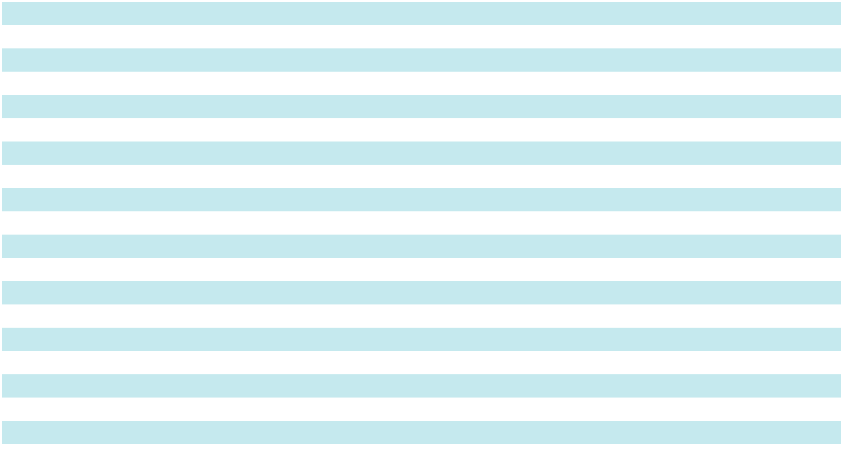

The impact of the acquisition of UW Solutions on our consolidated results of operations for fiscal 2026 was $100.4 million of net sales and $3.7 million of net loss, respectively. The impact of the acquisition of UW Solutions on our consolidated results of operations for fiscal 2025 was $32.0 million of net sales and $7.4 million of net loss, respectively.

The following supplemental unaudited pro forma information presents our financial results as if the acquisition of UW Solutions had occurred on February 26, 2023. This supplemental pro forma information has been prepared for comparative purposes and would not necessarily indicate what may have occurred if the acquisition had been completed on February 26, 2023, and this information is not intended to be indicative of future results.

(in thousands, except earnings per share data)

(Unaudited)
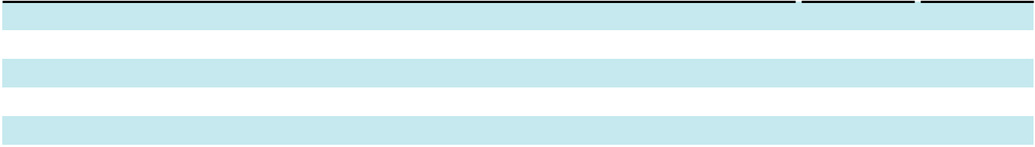

Net sales

Net earnings

Earnings per share:

2025 2024

- 1,423,635 $ 1,513,734

90,97883,256

Basic | $ | 4.19 | $ | 3.81
Diluted | $ | 4.16 | $ | 3.77

Nonrecurring charges of $4.4 million of transaction costs, $2.1 million of integration costs, $2.3 million of amortization of acquired backlog, and $1.5 million of inventory step-up expense incurred in fiscal 2025 are reflected as if those charges were incurred in the first and second quarters of the fiscal 2024 supplemental pro forma earnings.

These amounts have been calculated after applying our accounting policies and adjusting the results of UW Solutions to reflect the effect of definite-lived intangible assets recognized as part of the business combination on amortization expense as if the acquisition had occurred on February 26, 2023.

18. Restructuring

During the fourth quarter of fiscal 2024, we announced strategic actions to streamline our business operations, enable a more efficient cost model, and better position the Company for profitable growth (referred to as “Project Fortify”). Project Fortify primarily impacted the Architectural Metals Segment and included:

- Eliminating certain lower-margin product and service offerings, enabling consolidation into a single operating entity.

- Transferring production operations from the Company’s facility in Walker, Michigan, to the Company’s facilities in Monett, Missouri and Wausau, Wisconsin.

69

Table of Contents

- Simplifying the segment’s brand portfolio and commercial model to improve flexibility, better leverage the Company’s capabilities, and enhance customer service.

Additionally, the Company implemented actions to optimize processes and streamline resources in its Architectural Services Segment and Corporate and Other. The Company completed Project Fortify during the fourth quarter of fiscal 2025 and incurred a total of $16.7 million of restructuring charges, of which $4.3 million was recognized in fiscal 2025 and $12.4 million in fiscal 2024. The fiscal 2025 charges consisted of $2.5 million recorded in cost of sales and $1.8 million recorded within SG&A, while the fiscal 2024 charges consisted of $5.5 million recorded in cost of sales and $6.9 million recorded within SG&A.

On April 23, 2025, we announced a second phase of Project Fortify to drive further cost efficiencies, primarily in the Architectural Metals and Architectural Services Segments. Phase 2 focused on further optimizing our operating footprint and aligning resources to enable a more effective operating model.

During fiscal 2026, we incurred $27.4 million of pre-tax costs associated with Phase 2, of which $14.6 million is included in cost of sales and $12.8 million is included within SG&A. Restructuring expenses for fiscal 2026 and fiscal 2024 include non-cash impairment charges described in Note 1.

 |  | Architectural |  |  | Architectural |  |  | Architectural |  |  | Corporate & |  |  |  | Total
(In thousands) |  |  | Metals |  |  | Services |  |  | Glass |  |  | Other |  |  | Total
February 28, 2026
Termination benefits | $ |  | 3,617 | $ |  | 5,779 | $ |  | — | $ |  | 1,365 | $ |  | 10,761
Contract termination costs |  |  | 2,042 |  |  | 3,782 |  |  | — |  |  | — |  |  | 5,824
Other restructuring charges |  |  | 913 |  |  | 5,825 |  |  | — |  |  | 4,120 |  |  | 10,858
Total restructuring charges | $ |  | 6,572 | $ |  | 15,386 | $ |  | — | $ |  | 5,485 | $ |  | 27,443
March 1, 2025
Termination benefits |  |  | 928 |  |  | (640) |  |  | — |  |  | 788 |  |  | 1,076
Contract termination costs |  |  | — |  |  | — |  |  | — |  |  | — |  |  | —
Other restructuring charges |  |  | 3,096 |  |  | 151 |  |  | — |  |  | — |  |  | 3,247
Total restructuring charges | $ |  | 4,024 | $ |  | (489) | $ |  | — | $ |  | 788 | $ |  | 4,323
March 2, 2024
Termination benefits |  |  | 3,348 |  |  | 2,475 |  |  | — |  |  | 56 |  |  | 5,879
Contract termination costs | $ |  | 1,568 | $ |  | 49 | $ |  | — | $ |  | — | $ |  | 1,617
Other restructuring charges |  | $ | 1,054 |  | $ | 2 |  | $ | — |  | $ | 3,851 |  | $ | 4,907
Total restructuring charges | $ |  | 5,970 | $ |  | 2,526 | $ |  | — | $ |  | 3,907 | $ |  | 12,403
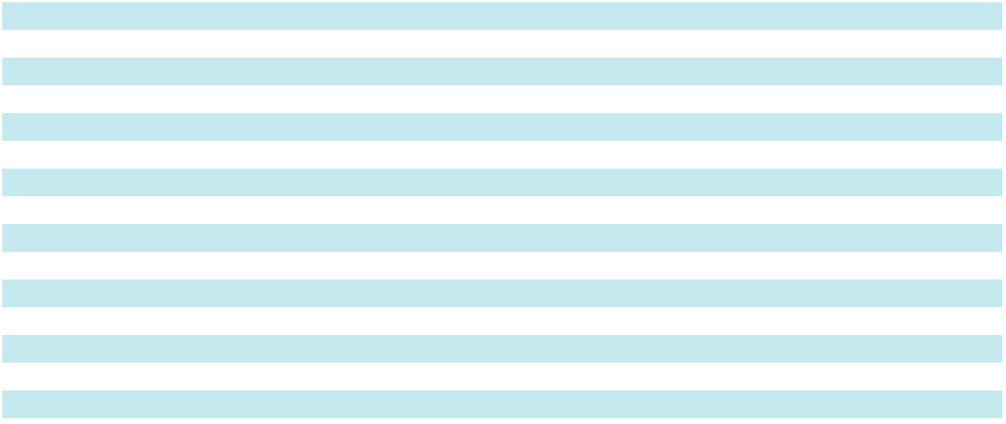

The following table summarizes our restructuring related accrual balances included within accrued payroll and related benefits and other current liabilities on the Consolidated Balance Sheets. All remaining accrual balances are expected to be paid within fiscal 2027.

 |  | Architectural |  |  | Architectural |  |  | Architectural |  |  |  | Corporate |  |  | Total
(In thousands) |  |  | Metals |  |  | Services |  |  | Glass |  |  | and Other |  |  | Total
Balance at March 2, 2024 | $ |  | 2,814 | $ |  | 2,067 | $ |  | — | $ |  | 56 | $ |  | 4,937
Restructuring expense |  |  | 1,931 |  |  | (812) |  |  | — |  |  | 778 |  |  | 1,897
Payments |  |  | (4,256) |  |  | (605) |  |  | — |  |  | (323) |  |  | (5,184)
Other adjustments |  |  | 797 |  |  | — |  |  | — |  |  | — |  |  | 797
Balance at March 1, 2025 | $ |  | 1,286 | $ |  | 650 | $ |  | — | $ |  | 511 | $ |  | 2,447
Restructuring expense |  |  | 4,920 |  |  | 5,111 |  |  | — |  |  | 1,369 |  |  | 11,400
Payments |  |  | (2,686) |  |  | (3,450) |  |  | — |  |  | (798) |  |  | (6,934)
Other adjustments |  |  | 61 |  |  | — |  |  | — |  |  | — |  |  | 61
Balance at February 28, 2026 | $ |  | 3,581 | $ |  | 2,311 | $ |  | — | $ |  | 1,082 | $ |  | 6,974

The amounts presented in the table above do not include items charged directly to expense as incurred, as those items are not reflected in accrued payroll and related benefits and other current liabilities on the Consolidated Balance Sheets.

70

Table of Contents

ITEM 9. CHANGES IN AND DISAGREEMENTS WITH ACCOUNTANTS ON ACCOUNTING AND FINANCIAL DISCLOSURE

None.

71

Table of Contents

ITEM 9A. CONTROLS AND PROCEDURES

Evaluation of Disclosure Controls and Procedures. As of the end of the period covered by this report (the Evaluation Date), we carried out an evaluation, under the supervision and with the participation of management, including the Chief Executive Officer and the Chief Financial Officer, of the effectiveness of the design and operation of our disclosure controls and procedures (as defined in Rules 13a-15(e) or 15d-15(e) of the Exchange Act). Based upon that evaluation, the Chief Executive Officer and Chief Financial Officer concluded that, as of the Evaluation Date, our disclosure controls and procedures were effective to ensure that information required to be disclosed by the Company in the reports that it files or submits under the Exchange Act is (i) recorded, processed, summarized and reported within the time periods specified in applicable rules and forms, and (ii) accumulated and communicated to our management, including our Chief Executive Officer and Chief Financial Officer, to allow timely decisions regarding required disclosure.

Management's Annual Report on Internal Control Over Financial Reporting. The report of management required under this Item 9A is contained on page 32 in Item 8 of this Annual Report on Form 10-K under the caption “Management's Annual Report on Internal Control Over Financial Reporting.”

Attestation Report of Independent Registered Public Accounting Firm. The attestation report required under this Item 9A is contained on page 33 in Item 8 of this Annual Report on Form 10-K under the caption “Report of Independent Registered Public Accounting Firm.”

Changes in Internal Control over Financial Reporting. There have not been any changes in our internal control over financial reporting (as such term is defined in Rules 13a-15(f) and 15d-15(f) under the Exchange Act) during the most recent fiscal quarter covered by this report that would have materially affected, or are reasonably likely to materially affect, the Company's internal control over financial reporting.

ITEM 9B. OTHER INFORMATION

Insider Adoption or Termination of Trading Arrangements

During the fiscal quarter ended February 28, 2026, none of our directors or officers (as defined in Rule 16a-1(f) of the Exchange Act) adopted or terminated any "Rule 10b5-1 trading arrangement" or any "non-Rule 10b5-1 trading arrangement", as each term is defined in Item 408(c) of Regulation S-K.

ITEM 9C. DISCLOSURES REGARDING FOREIGN JURISDICTIONS THAT PREVENT INSPECTIONS Not applicable.

72

Table of Contents

PART III

ITEM 10. DIRECTORS, EXECUTIVE OFFICERS, CODE OF ETHICS AND CORPORATE GOVERNANCE

We have adopted a Code of Business Ethics and Conduct that applies to all of our employees, including our principal executive officer, president, principal financial officer and principal accounting officer, and Board of Directors. The Code of Business Ethics and Conduct is published on the “Investors-Governance” section of our website at www.apog.com. Any amendments to the Code of Business Ethics and Conduct and waivers of the Code of Business Ethics and Conduct for our Chief Executive Officer and Chief Financial Officer will be published on our website.

The other information required by this item, other than the information set forth in Part I above under the heading “Information About Our Executive Officers,” is set forth under the headings “Proposal 1: Election of Directors,” “Frequently Asked Questions - How Can I Recommend or Nominate a Director Candidate?”, “Corporate Governance - Board Meetings and 2026 Annual Meeting of Shareholders,” and “Corporate Governance - Board Committee Responsibilities, Meetings and Membership” in the Proxy Statement for the Company's Annual Meeting of Shareholders to be held on June 24, 2026, which will be filed with the Securities and Exchange Commission within 120 days after our fiscal year-end (our 2026 Proxy Statement). This information is incorporated herein by reference.

We have an insider trading policy governing the purchase, sale and other dispositions of the Company's securities that applies to all personnel of the Company and its subsidiaries, including directors, officers, employees and other covered persons. The Company believes that its insider trading policy is reasonably designed to promote compliance with insider trading laws, rules and regulations, as well as applicable listing standards. A copy of the Company’s insider trading policy is filed as Exhibit 19.1 to this report.

ITEM 11. EXECUTIVE AND DIRECTOR COMPENSATION

The information required by this item is set forth under the headings “Executive Compensation,” "CEO Pay Ratio Disclosure" and “Non-Employee Director Compensation" in our 2026 Proxy Statement. This information is incorporated herein by reference.

ITEM 12. SECURITY OWNERSHIP OF CERTAIN BENEFICIAL OWNERS AND MANAGEMENT AND RELATED STOCKHOLDER MATTERS

The following table summarizes, with respect to our equity compensation plans, the number of shares of our common stock to be issued upon exercise of outstanding options, warrants and other rights to acquire shares, the weighted-average exercise price of these outstanding options, warrants and rights, and the number of shares remaining available for future issuance under our equity compensation plans as of February 28, 2026, the last day of fiscal 2026.

 |  |  |  |  |  | Number of Securities
 |  |  |  |  |  | Remaining Available for
 |  | Number of Securities to |  | Weighted-Average |  | Future Issuance under
 |  |  |  |  |  | Equity Compensation
 |  | be Issued Upon Exercise |  | Exercise Price of |  | Plans (Excluding
Plan Category |  | of Outstanding Options, |  | Outstanding Options, |  | Securities Reflected in
Plan Category |  | Warrants and Rights |  | Warrants and Rights |  | the First Column)
Equity compensation plans | 230,273 ⁽¹⁾ ⁽²⁾ |  |  | N/A ⁽³⁾ |  | 534,566 ⁽⁴⁾
approved by security holders
Equity compensation plans not |  | None |  | None |  | None
approved by security holders
Total | 230,273 |  |  | N/A |  | 534,566


Includes 75,783 shares underlying performance share unit awards granted under our 2019 Stock Incentive Plan, assuming maximum performance; 133,967 restricted stock unit awards granted under our 2019 Stock Incentive Plan, 2009 Non-Employee Director Stock Plan, and 2019 Non-Employee

- Director Stock Plan, and 20,523 phantom shares under our Deferred Compensation Plan for Non-Employee Directors. Dividends accrue on the outstanding performance share units during the three-year performance periods but will be paid only on shares earned at the end of each performance cycle. Certain outstanding restricted stock units have dividend rights attached, but none of the restricted stock units are transferable.

At the beginning of fiscal years 2024, 2025 and 2026, performance share units were awarded to plan participants which will vest based on our Company’s performance over each three-year performance period. The performance share units represent the right to receive shares of our common
- stock at the end of each three-year performance period. Pursuant to SEC rules and the reporting requirements for this table, we have included in this column 75,783 shares underlying the outstanding performance share units at maximum performance, assuming our Company performed at the maximum level during the applicable performance periods. Only 38,544 shares underly the performance awards at target level performance.

- In calculating the weighted-average exercise price of outstanding options, warrants and rights, we have not included in this column shares of restricted stock that are issued and outstanding, performance share units or restricted stock units.

Pursuant to SEC Rules and the reporting requirements for this table, of these shares, 3,822 are available for issuance under our Legacy Partnership
- Plan; 390,862 are available for grant under our 2019 Stock Incentive Plan; 125,142 are available for grant under our 2019 Non-Employee Director Stock Plan; and 14,740 are available for grant under our Deferred Compensation Plan for Non-Employee Directors.

73

Table of Contents

ITEM 13. CERTAIN RELATIONSHIPS AND RELATED TRANSACTIONS, AND DIRECTOR INDEPENDENCE

The information required by this item is set forth under the headings “Corporate Governance - Director Independence” and "Corporate Governance - Certain Relationships and Related Transactions" in our 2026 Proxy Statement. This information is incorporated herein by reference.

ITEM 14. PRINCIPAL ACCOUNTANT FEES AND SERVICES

Information about aggregate fees billed to us by our principal accountant, Deloitte & Touche LLP (PCAOB ID No. 34) is presented under the headings “Audit Committee Report" and "Fees Paid to Independent Registered Public Accounting Firm - Audit Fees, Audit-Related Fees, Tax Fees and All Other Fees” and “Policy on Audit Committee Pre-Approval of Audit and Permissible Non-Audit Services” in our 2026 Proxy Statement. This information is incorporated herein by reference.

74

Table of Contents

PART IV

ITEM 15. EXHIBITS AND FINANCIAL STATEMENT SCHEDULES

- List of documents filed as a part of this report:

  - Financial Statements - The consolidated financial statements listed below are set forth in Item 8 of Part II of this report.

Consolidated Balance Sheets as of February 28, 2026 and March 1, 2025

Consolidated Results of Operations for the Years Ended February 28, 2026, March 1, 2025 and March 2, 2024

Consolidated Statements of Comprehensive Earnings for the Years Ended February 28, 2026, March 1, 2025 and March 2, 2024

Consolidated Statements of Cash Flows for the Years Ended February 28, 2026, March 1, 2025 and March 2, 2024

Consolidated Statements of Shareholders' Equity for the Years Ended February 28, 2026, March 1, 2025 and March 2, 2024

Notes to Consolidated Financial Statements

  - Financial Statement Schedules - All schedules for which provision is made in the applicable accounting regulations of the Securities and Exchange Commission have been omitted because they are not applicable or the required information is shown in the financial statements or notes thereto.

  - Exhibits - Exhibits marked with an asterisk (*) identify each management contract or compensatory plan or arrangement. Exhibits marked with a pound sign (#) are filed herewith. The remainder of the exhibits have heretofore been filed with the Securities and Exchange Commission and are incorporated herein by reference.
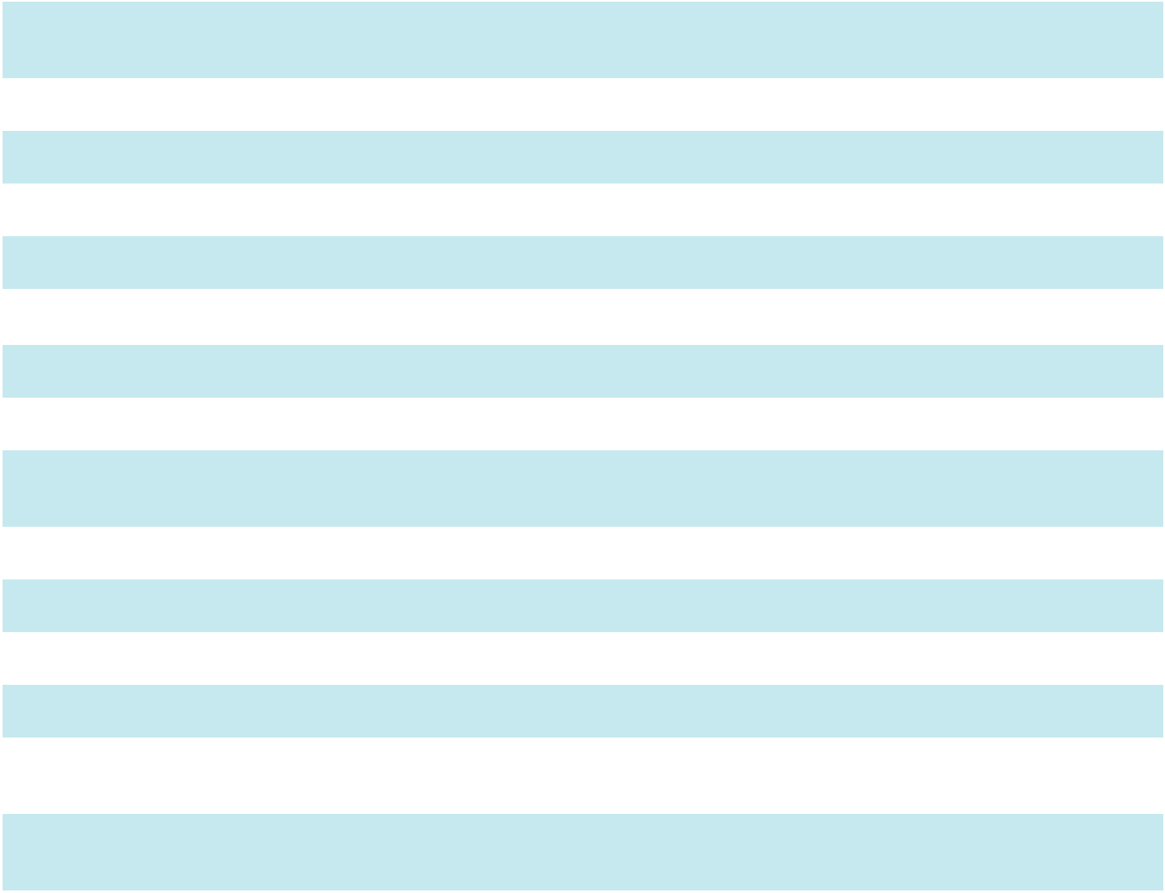

2.1 Membership Interest Purchase Agreement, dated as of September 23, 2024, by and among UW Holdings, LLC, UW Interco, LLC and Apogee Enterprises, Inc.* Incorporated by reference to Exhibit 2.1 to the Registrant’s Current Report on Form 8-K filed on September 25, 2024.

3.1 Restated Articles of Incorporation. Incorporated by reference to Exhibit 3.1 to Registrant's Annual Report on Form
10-K for the year-ended February 28, 2004.

3.2 Articles of Amendment to Restated Articles of Incorporation. Incorporated by reference to Exhibit 3.1 to Registrant's Current Report on Form 8-K filed on January 16, 2020.

3.3 Amended and Restated Bylaws of Apogee Enterprises, Inc. Incorporated by reference to Exhibit 3.3 to the Registrant’s Quarterly Report on Form 10-Q filed on July 1, 2021.
4.1 Specimen certificate for shares of common stock of Apogee Enterprises, Inc. Incorporated by reference to Exhibit

4.1 to Registrant's Quarterly Report on Form 10-Q filed on July 1, 2021.

4.2 Description of Securities. Incorporated by reference to Exhibit 4.2 to Registrant's Annual Report on Form 10-K for the year ended February 29, 2020.
10.1* Apogee Enterprises, Inc. Deferred Compensation Plan for Non-Employee Directors (2014 Restatement).
Incorporated by reference to Exhibit 4.4 to Registrant's Registration Statement on Form S-8 filed on July 24, 2014.

10.2* Apogee Enterprises, Inc. 2021 Deferred Compensation Plan for Non-Employee Directors. Incorporated by reference to Exhibit 4.5 to Apogee’s Registration Statement on Form S-8 filed on October 13, 2021.
10.3* Apogee Enterprises, Inc. 2000 Employee Stock Purchase Plan (Amended and Restated Effective as of April 21,
2021). Incorporated by reference to Exhibit 10.4 to Apogee’s Annual Report on Form 10-K filed on April 22,

2021.

10.4* Apogee Enterprises, Inc. Non-Employee Director Charitable Matching Contribution Program. Incorporated by reference to Exhibit 10.25 to Registrant's Annual Report on Form 10-K for the year-ended February 26, 2005.

10.5* Apogee Enterprises, Inc. Deferred Incentive Compensation Plan (2005 Restatement). Incorporated by reference to Exhibit 10.3 to Registrant's Current Report on Form 8-K filed on October 17, 2006.

10.6* Apogee Enterprises, Inc. 2009 Stock Incentive Plan, as amended and restated (2011). Incorporated by reference to Exhibit 10.1 to Registrant's Current Report on Form 8-K filed on June 28, 2011.
10.7* Apogee Enterprises, Inc. 2009 Non-Employee Director Stock Incentive Plan, as amended and restated (2014).

Incorporated by reference to Exhibit 4.4 to Registrant's Registration Statement on Form S-8 filed on July 24, 2014.

10.8* Form of Restricted Stock Agreement under the Apogee Enterprises, Inc. 2009 Non-Employee Director Stock Incentive Plan. Incorporated by reference to Exhibit 10.3 to Registrant's Current Report on Form 8-K filed on June 30, 2009.

10.9* Restricted Stock Deferral Program under the Apogee Enterprises, Inc. 2009 Non-Employee Director Stock Incentive Plan, as Amended and Restated (2014) (2015 Statement). Incorporated by reference to Exhibit 10.1 to Registrant's Current Report on Form 8-K filed on June 30, 2015.

75

Table of Contents

10.10* Form of Deferred Restricted Stock Unit Agreement under the Apogee Enterprises, Inc. 2009 Non-Employee Director Stock Incentive Plan, as Amended and Restated (2014) (2015 Statement). Incorporated by reference to Exhibit 10.2 to Registrant's Current Report on Form 8-K filed on June 30, 2015.

10.11* Form of Restricted Stock Agreement under the Apogee Enterprises, Inc. 2009 Stock Incentive Plan for awards made on or after April 26, 2011. Incorporated by reference to Exhibit 10.3 to Registrant's Current Report on Form 8-K filed on May 2, 2011.

10.12* Apogee Enterprises, Inc. 2011 Deferred Compensation Plan, effective January 1, 2011. Incorporated by reference to Exhibit 10.1 to Registrant's Current Report on Form 8-K filed on October 12, 2010.

10.13* First Amendment to the Apogee Enterprises, Inc. 2011 Deferred Compensation Plan. Incorporated by reference to Exhibit 10.3 to the Registrant's Current Report on Form 8-K filed July 1, 2014.

10.14* Second Amendment to the Apogee Enterprises, Inc. 2011 Deferred Compensation Plan. Incorporated herein by reference to Exhibit 10.2 to Registrant’s Current Report on Form 8-K filed on June 29, 2016.

10.15* Third Amendment to the Apogee Enterprises, Inc. 2011 Deferred Compensation Plan, dated October 5, 2017. Incorporated by reference to Exhibit 10.1 to the Registrant's Current Report on Form 8-K filed on October 10, 2017.

10.16* Fourth Amendment to the Apogee Enterprises, Inc. 2011 Deferred Compensation Plan, dated June 28, 2018.
Incorporated by reference to Exhibit 10.2 to Registrant's Current Report on Form 8-K filed on July 3, 2018.

10.17* Fifth Amendment to the Apogee Enterprises, Inc. Deferred Incentive Compensation Plan (2005 Restatement), dated June 26, 2023. Incorporated by reference to Exhibit 10.2 to Registrant's Current Report on Form 8-K filed on June 27, 2023.

10.18* Form of Change-in-Control Severance Agreement. Incorporated herein by reference to Exhibit 10.38 to Registrant's Annual Report on Form 10-K filed on April 30, 2018.

10.19* Apogee Enterprises, Inc. 2019 Non-Employee Director Stock Plan. Incorporated by reference to Exhibit 4.6 to Registrant's Registration Statement on Form S-8 filed on February 12, 2020.

10.20* Apogee Enterprises, Inc. 2019 Stock Incentive Plan. Incorporated by reference to Exhibit 4.5 to Registrant's Registration Statement on Form S-8 filed on February 12, 2020.

10.21* Form of Restricted Stock Agreement under the Apogee Enterprises, Inc. 2019 Stock Plan. Incorporated by reference to Exhibit 10.1 to Registrant’s Current Report on Form 8-K filed on January 16, 2020.

10.22* Form of Stock Option Agreement under the Apogee Enterprises, Inc. 2019 Stock Incentive Plan. Incorporated by reference to Exhibit 10.1 to Registrant's Current Report on Form 8-K filed on July 7, 2020.

10.23* Apogee Enterprises, Inc. 2019 Stock Incentive Plan, as Amended and Restated (2021). Incorporated by reference to Exhibit 4.5 to Apogee’s Registration Statement on Form S-8 filed on June 25, 2021.

10.24* Amended Form of Restricted Stock Agreement under the Apogee Enterprises, Inc. 2019 Stock Incentive Plan, as Amended and Restated (2021). Incorporated by reference to Exhibit 10.2 to Registrant's Current Report on Form 8-K filed on May 7, 2024.

10.25* Amended Form of Restricted Stock Unit Agreement under the Apogee Enterprises, Inc. 2019 Stock Incentive Plan, as Amended and Restated (2021). Incorporated by reference to Exhibit 10.3 to Registrant's Current Report on Form 8-K filed on May 7, 2024.

10.26* Executive Equity Deferral Program Under the Apogee Enterprises, Inc. 2019 Stock Incentive Plan dated May 1,
2024. Incorporated by reference to Exhibit 10.7 to Registrant's Current Report on Form 8-K filed on May 7, 2024.

10.27* Apogee Enterprises, Inc. 2019 Non-Employee Director Stock Plan, as Amended and Restated (2024). Incorporated by reference to Exhibit 4.5 to Apogee's Registration Statement on Form S-8 filed on June 20, 2024.
10.28* Form of Restricted Stock Agreement under the Apogee Enterprises, Inc. 2019 Non-Employee Director Stock Plan.

Incorporated by reference to Exhibit 10.2 to Registrant’s Current Report on Form 8-K filed on January 16, 2020.

10.29* Form of Deferred Restricted Stock Unit Agreement under the Apogee Enterprises, Inc. 2019 Non-Employee Director Stock Incentive Plan. Incorporated by reference to Exhibit 10.3 to Registrant’s Current Report on Form 8-K filed on January 16, 2020.

10.30* Restricted Stock Deferral Program Under the Apogee Enterprises, Inc. 2019 Non-Employee Director Stock Incentive Plan. Incorporated by reference to Exhibit 10.1 to Registrant's Current Report on Form 8-K filed on April 29, 2020.

10.31* Form of Restricted Stock Unit Agreement under the Apogee Enterprises, Inc. 2019 Non-Employee Director Stock Plan. Incorporated by reference to Exhibit 10.2 to Registrant's Current Report on Form 8-K filed on April 29, 2020.

10.32* Form of CEO Evaluation-Based Incentive Agreement. Incorporated by reference to Exhibit 10.2 to Registrant’s Current Report on Form 8-K filed on April 30, 2019.

10.33* Form of Annual Cash Incentive Award Agreement. Incorporated by reference to Exhibit 10.2 to Registrant's Current Report on Form 8-K filed on July 7, 2020.
10.34* Employment Agreement between Apogee Enterprises, Inc. and Ty R. Silberhorn, dated December 15, 2020.

Incorporated by reference to Exhibit 10.1 to Registrant’s Current Report on Form 8-K filed on December 21, 2020.

10.35* Form of Restricted Stock Award Agreement entered into by Apogee Enterprises, Inc. and Ty R. Silberhorn on January 4, 2021. Incorporated by reference to Exhibit 10.2 to Registrant’s Current Report on Form 8-K filed on December 21, 2020.

76

Table of Contents

10.36* | Form of Restricted Stock Agreement. Incorporated by reference to Exhibit 10.1 to Registrant's Current Report on
 | Form 8-K filed on April 26, 2021.
10.37*
10.37* | Form of Performance Award Agreement. Incorporated by reference to Exhibit 10.2 to Registrant's Current Report
 | on Form 8-K filed on April 26, 2021.
10.38* | Form of Executive Short-Term Incentive Plan Memorandum. Incorporated by reference to Exhibit 10.3 to
 | Registrant's Current Report on Form 8-K filed on April 26, 2021.
10.39* | Executive Short-Term Incentive Plan Terms and Conditions. Incorporated by reference to Exhibit 10.4 to
 | Registrant's Current Report on Form 8-K filed on April 26, 2021.
10.40* | Offer Letter dated March 2, 2023 between Apogee Enterprises, Inc. and Matthew J. Osberg. Incorporated by
 | reference to Exhibit 10.1 to Registrant's Current Report on Form 8-K filed on March 8, 2023.
10.41 | Separation Agreement dated October 30, 2025 between Apogee Enterprises, Inc. and Ty Silberhorn. Incorporated
 | by reference to Exhibit 10.1 to Registrant's Current Report on Form 8-K filed on November 5, 2025.
10.42
10.42 | Offer Letter effective October 31, 2025 between Apogee Enterprises, Inc. and Don Nolan. Incorporated by
 | reference to Exhibit 10.2 to Registrant's Current Report on Form 8-K filed on November 5, 2025.
10.43 | Offer Letter Agreement between Apogee Enterprises, Inc. and Mark Richard Augdahl. Incorporated by reference to
 | Exhibit 10.1 to Registrant's Current Report on Form 8-K filed on January 22, 2026.
10.44 | Form of Restricted Stock Agreement. Incorporated by reference to Exhibit 10.2 to Registrant's Current Report on
 | Form 8-K filed on January 22, 2026.
10.45
10.45 | Form of Deferred Stock Unit Agreement, under the Apogee Enterprises, Inc. 2019 Stock Incentive Plan, as
 | amended and restated from time to time.
10.46
10.46 | Form of Executive Restricted Stock/Performance Share Deferral Election Form, under the Apogee Enterprises, Inc.
 | 2019 Stock Incentive Plan, as amended and restated from time to time.
10.47
10.47 | Credit Agreement dated July 19, 2024 between Apogee Enterprises, Inc., certain material domestic subsidiaries of
 | the Company as guarantors, Bank of America, N.A., as administrative agent, swingline lender and L/C issuer and
 | the syndicate of lenders which are party thereto from time to time. Incorporated by reference to Exhibit 10.1 to the
 | Registrant’s Current Report on Form 8-K filed on July 25, 2024.


19.1#

21#

23#

31.1#

31.2#

32.1#

Apogee Enterprises, Inc. Insider Trading Policy.

Subsidiaries of the Registrant.

Consent of Deloitte & Touche LLP.

Certification of Chief Executive Officer pursuant to rule 13a-14(a) under the Securities Exchange Act of 1934.

Certification of Chief Financial Officer pursuant to rule 13a-14(a) under the Securities Exchange Act of 1934.

Certification of Chief Executive Officer pursuant to 18 U.S.C. Section 1350, as adopted pursuant to Section 906 of the Sarbanes-Oxley Act of 2002.

32.2# Certification of Chief Financial Officer pursuant to 18 U.S.C. Section 1350, as adopted pursuant to Section 906 of the Sarbanes-Oxley Act of 2002.

97.1 Incentive Compensation Recovery Policy. Incorporated by reference to Exhibit 97.1 to the Registrant’s Current Report on Form 10-K filed on April 26, 2024.

- The following materials from Apogee Enterprises, Inc.'s Annual Report on Form 10-K for the year ended February 28, 2026 are furnished herewith, formatted in iXBRL (Inline Extensible Business Reporting Language): (i) the Consolidated Balance Sheets as of February 28, 2026 and March 1, 2025, (ii) the Consolidated Results of Operations for the three years ended February 28, 2026, March 1, 2025 and March 2, 2024, (iii) the Consolidated Statements of Comprehensive Earnings for the three years February 28, 2026, March 1, 2025 and March 2, 2024,

  - the Consolidated Statements of Cash Flows for the three years ended February 28, 2026, March 1, 2025 and March 2, 2024, (v) the Consolidated Statements of Shareholders' Equity for the three years ended February 28, 2026, March 1, 2025 and March 2, 2024 and (vi) the Notes to Consolidated Financial Statements.

104 Cover Page Interactive Data File (formatted as Inline XBRL and contained in Exhibit 101).

ITEM 16. FORM 10-K SUMMARY

None.

77

Table of Contents

SIGNATURES

Pursuant to the requirements of Section 13 or 15(d) of the Securities Exchange Act of 1934, the registrant has duly caused this report to be signed on its behalf by the undersigned, thereunto duly authorized, on April 24, 2026.

APOGEE ENTERPRISES, INC.

/s/ Donald A. Nolan

Donald A. Nolan

Executive Chair, President and Chief Executive Officer

Pursuant to the requirements of the Securities Exchange Act of 1934, this report has been signed below by the following persons on behalf of the registrant and in the capacities indicated on April 23, 2026.

Signature |  | Title |  | Signature |  | Title
 |  | Executive Chair and |  |  |  | Executive Vice
/s/ Donald A. Nolan |  | Chief Executive |  | /s/ Mark R. Augdahl |  | President and Chief
/s/ Donald A. Nolan |  | Officer |  | /s/ Mark R. Augdahl |  | Financial Officer
Donald A. Nolan |  | (Principal Executive |  | Mark R. Augdahl |  | (Principal
 |  | Officer) |  |  |  | Financial and
 |  |  |  |  |  | Accounting Officer)
/s/ Elizabeth M. Lilly |  |  |  | /s/ Christina M. Alvord
Elizabeth M. Lilly |  | Director |  | Christina M. Alvord |  | Director

/s/ Herbert K. Parker |  | /s/ Mark A. Pompa
Herbert K. Parker | Director | Mark A. Pompa | Lead Independent
 |  |  | Director

/s/ Lloyd E. Johnson |  | /s/ Patricia K. Wagner
Lloyd E. Johnson | Director | Patricia K. Wagner | Director

78

CORPORATE INFORMATION

BOARD OF DIRECTORS

Donald A. Nolan, 65

Executive Chair
Apogee Enterprises, Inc.

Former President and Chief Executive Officer

Kennametal Inc.

Christina M. Alvord, 59 ^{1, 3}
Retired President, Southern & Gulf Coast,

and Central Divisions

Vulcan Materials Company

Lloyd E. Johnson, 72 ^{1, 2}
Retired Global Managing Director, Finance and
Internal Audit
Accenture Corporation

Elizabeth M. Lilly, 63 ^{1, 2}
Chief Investment Officer and Executive Vice President The Pohlad Companies

Herbert K. Parker, 68 ^{2,3}
Retired Executive Vice President-Operation Excellence

Harman International Industries, Inc.

Mark A. Pompa, 61 ^{1, 2}
Lead Director

Retired Executive Vice President and Chief Financial

Officer

EMCOR Group, Inc.

Patricia K. Wagner, 63 ^{2, 3}
Retired Group President of U.S. Utilities
Sempra Energy

- Audit Committee

- Compensation Committee

- Nominating and Corporate Governance Committee

CORPORATE OFFICERS

Donald A. Nolan, 65

Chief Executive Officer

Mark R. Augdahl, 60

Executive Vice President and Chief Financial Officer

Bryan A. Welp, 50

Vice President, General Counsel, and

Secretary

Troy R. Johnson, 52 President, Architectural Metals

Matthew Christian, 44 President, Architectural Services

Brent C. Jewell, 52 President, Architectural Glass

Veena Lakkundi, 57

President, Performance Surfaces

APOGEE SEGMENTS

Architectural Metals Segment

Minneapolis, MN

Architectural Services Segment

Minneapolis, MN

Architectural Glass Segment

Owatonna, MN

Performance Surfaces Segment

McCook, IL

INVESTOR INFORMATION

TRANSFER AGENT AND REGISTRAR

To sign up for direct deposit of dividends service, or for inquiries regarding stock certificates, such as address or name changes, lost certificates or lost dividends, contact Computershare Investor Services, Apogee's transfer agent and registrar.

Computershare Investor Services address:

P.O. Box 43078

Providence, RI 02940-3078

Computershare Investor Services website:

www.computershare.com

Computershare Investor Services telephone numbers:
U.S. Residents: (800) 736-3001

Canada or the U.S. Virgin Islands: (800) 736-3001

Outside the U.S.: (781) 575-3100

COMMON STOCK

Apogee Enterprises, Inc., common stock is traded on the Nasdaq Stock Market LLC under the symbol APOG.


INVESTOR INQUIRIES

Additional information, such as Forms 10-K, 10-Q and proxy statements as filed with the Securities and Exchange Commission, and news releases, may be obtained through one of the following:

Internet: www.apog.com
Email: ir@apog.com

Telephone: (952) 346-3502

Toll Free: (877) 752-3432

Mail: Apogee Enterprises, Inc.
Attn: Investor Relations
4400 West 78th Street, Suite 520
Minneapolis, MN 55435

