UNITED STATES
SECURITIES AND EXCHANGE COMMISSION
Washington, D.C. 20549

FORM 8-K

CURRENT REPORT
Pursuant to Section 13 or 15(d) of the
Securities Exchange Act of 1934

Date of report (Date of earliest event reported): September 10, 2026

APOGEE ENTERPRISES, INC.
(Exact name of registrant as specified in its charter)

Minnesota |  |  |  |  |  | 0-6365 |  |  |  |  |  | 41-0919654
(State or other jurisdiction of incorporation) |  |  |  |  |  | (Commission File Number) |  |  |  |  |  | (I.R.S. Employer Identification No.)
4400 West 78th Street, Suite 520 |  |  |  |  |  | Minneapolis |  |  |  |  |  | Minnesota |  |  |  |  |  | 55435
(Address of principal executive offices) |  |  |  |  |  |  |  |  |  |  |  |  |  |  |  |  |  | (Zip Code)
Registrant's telephone number, including area code: |  |  |  |  |  |  |  |  | (952) 835-1874
Check the appropriate box below if the Form 8-K filing is intended to simultaneously satisfy the filing obligation of the registrant under any of the following provisions:
☐ |  |  | Written communications pursuant to Rule 425 under the Securities Act (17 CFR 230.425)
☐ |  |  | Soliciting material pursuant to Rule 14a-12 under the Exchange Act (17 CFR 240.14a-12)
☐ |  |  | Pre-commencement communications pursuant to Rule 14d-2(b) under the Exchange Act (17 CFR 240.14d-2(b))
☐ |  |  | Pre-commencement communications pursuant to Rule 13e-4(c) under the Exchange Act (17 CFR 240.13e-4(c))
Securities registered pursuant to Section 12(b) of the Exchange Act:
Title of each class |  |  | Trading Symbol(s) |  |  | Name of each exchange on which registered
Common Stock, $0.33 1/3 Par Value |  |  | APOG |  |  | The Nasdaq Stock Market
Indicate by check mark whether the registrant is an emerging growth company as defined in Rule 405 of the Securities Act of 1933 (Section 230.405 of this chapter) or Rule 12b-2 of the Securities Exchange Act of 1934 (Section 240.12b-2 of this chapter).
☐ Emerging growth company
If an emerging growth company, indicate by check mark if the registrant has elected not to use the extended transition period for complying with any new or revised financial accounting standards provided pursuant to Section 13(a) of the Exchange Act. ☐

Item 5.02 |  |  | Departure of Directors or Certain Officers; Election of Directors; Appointment of Certain Officers; Compensatory Arrangement of Certain Officers
(b)
On September 10, 2026, Patricia K. Wagner informed the Board of Directors (the “Board”) of Apogee Enterprises, Inc. (the “Company”) that she intends to retire from the Board effective October 2, 2026. Ms. Wagner’s retirement is not as a result of a disagreement with the Company relating to the Company’s current or past operations, policies or practices.
(d)
On August 5, 2026, the Board elected Messrs. Joseph B. Hayek and Suresh Krishna as directors of the Company. Effective September 11, 2026, Mr. Hayek was appointed to the Nominating and Corporate Governance Committee and Mr. Krishna was appointed to the Compensation Committee.
On September 11, 2026, the Board elected Julie K. Streich, age 55, to serve as a Class I director with a term expiring at the Company’s 2029 Annual Meeting of Shareholders and until her successor is duly elected and qualified. The Board also determined that Ms. Streich is independent under the applicable listing standards of The Nasdaq Stock Market LLC and the Company’s director independence standards. The Board also appointed Ms. Streich to the Audit Committee of the Board effective as of September 11, 2026. With the election of Ms. Streich, the Board increased its size from eight to nine directors.
Ms. Streich served as Chief Financial Officer of Barnes Group Inc. from 2021 until her retirement in March 2026 and served as Interim Chief Executive Officer from March 2022 to July 2022. Prior to joining Barnes Group, she served as Senior Vice President, Finance Operations for Centrica Plc from March 2019 to July 2020 and as Vice President, Global Planning and Analytics from 2017 to 2019.
Earlier in her career, Ms. Streich held several leadership positions with Direct Energy, a U.S.-based subsidiary of Centrica, including Chief Financial Officer of Direct Energy Home from 2016 to 2017, Vice President, Corporate Finance from 2013 to 2016, and Chief Financial Officer, DE Residential from 2012 to 2013. Ms. Streich served on the Board of Directors of Phoenix Energy Technologies from April 2014 to November 2015. Since 2023, she has served on the Board of Directors of Schneider National, Inc., where she currently serves as Chair of the Audit Committee.
Ms. Streich earned a Bachelor of Arts degree in Economics and Spanish from Ripon College and an MBA in International Business from the University of Texas at San Antonio.
There are no arrangements or understandings between Ms. Streich and any other person pursuant to which Ms. Streich was elected as a director of the Company. There are no transactions involving Ms. Streich that would require disclosure under Item 404(a) of Regulation S-K. Ms. Streich does not have any family relationship with any director or executive officer of the Company or any person nominated or chosen by the Company to become a director or executive officer.
As a non-employee director, Ms. Streich will participate in the Company’s non-employee director compensation arrangements in effect during her service. Ms. Streich will receive, on a pro-rated basis for fiscal year 2027, the current annual cash retainer of $75,000 for services as a director. In connection with her election to the Board, Ms. Streich received a time-based restricted stock award of 2,530 shares of the Company’s common stock. The restricted stock award will vest in three equal annual installments on the first three anniversaries of the grant date, subject to the director’s continued service through each vesting date. The closing price of the Company’s common stock on The Nasdaq Stock Market on September 11, 2026 was $37.88. Ms. Streich will also be eligible to participate in the Company’s Deferred Compensation Plan for Non-Employee Directors and Charitable Matching Contributions Program for Non-Employee Directors, each as described under the heading “Non-Employee Director Compensation” in the Company’s proxy statement delivered in connection with the 2026 Annual Meeting of Shareholders as filed with the Securities and Exchange Commission on May 12, 2026.

Item 7.01 |  |  | Regulation FD Disclosure
A copy of the press release announcing the election of Ms. Streich to the Board is furnished as Exhibit 99.1 to this Current Report on Form 8-K and is incorporated herein by reference.

Item 9.01 |  |  | Financial Statements and Exhibits.
99.1 |  |  | Press Release issued by Apogee Enterprises, Inc. dated September 14, 2026**
104 |  |  | Cover Page interactive Data file (embedded within the Inline XBRL document).

** |  |  | Furnished herewith

SIGNATURE
Pursuant to the requirements of the Securities Exchange Act of 1934, the registrant has duly caused the report to be signed on its behalf by the undersigned hereunto duly authorized.
 |  |  |  |  |  | APOGEE ENTERPRISES, INC.
 |  |  |  |  |  | By: |  |  | /s/Bryan A. Welp
Bryan A. Welp
Vice President, General Counsel and Secretary
Date: |  |  | September 14, 2026

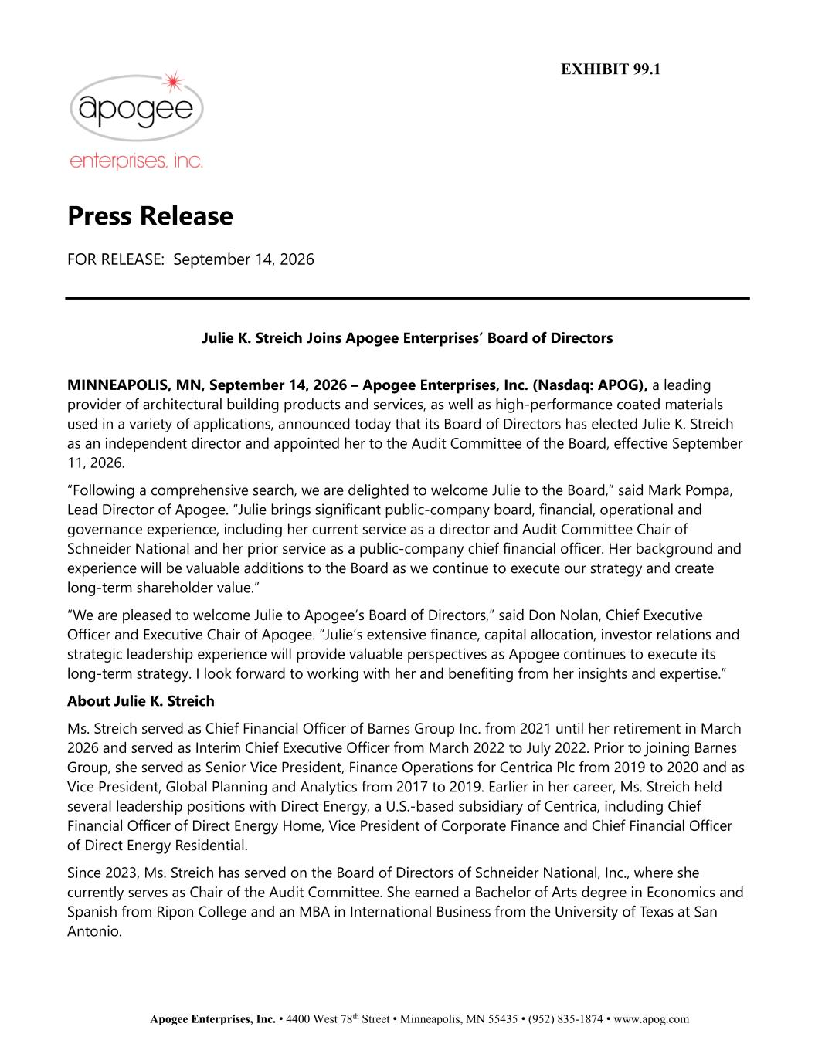

Apogee Enterprises, Inc. • 4400 West 78th Street • Minneapolis, MN 55435 • (952) 835-1874 • www.apog.com Press Release FOR RELEASE: September 14, 2026 Julie K. Streich Joins Apogee Enterprises’ Board of Directors MINNEAPOLIS, MN, September 14, 2026 – Apogee Enterprises, Inc. (Nasdaq: APOG), a leading provider of architectural building products and services, as well as high-performance coated materials used in a variety of applications, announced today that its Board of Directors has elected Julie K. Streich as an independent director and appointed her to the Audit Committee of the Board, effective September 11, 2026. “Following a comprehensive search, we are delighted to welcome Julie to the Board,” said Mark Pompa, Lead Director of Apogee. “Julie brings significant public-company board, financial, operational and governance experience, including her current service as a director and Audit Committee Chair of Schneider National and her prior service as a public-company chief financial officer. Her background and experience will be valuable additions to the Board as we continue to execute our strategy and create long-term shareholder value.” “We are pleased to welcome Julie to Apogee’s Board of Directors,” said Don Nolan, Chief Executive Officer and Executive Chair of Apogee. “Julie’s extensive finance, capital allocation, investor relations and strategic leadership experience will provide valuable perspectives as Apogee continues to execute its long-term strategy. I look forward to working with her and benefiting from her insights and expertise.” About Julie K. Streich Ms. Streich served as Chief Financial Officer of Barnes Group Inc. from 2021 until her retirement in March 2026 and served as Interim Chief Executive Officer from March 2022 to July 2022. Prior to joining Barnes Group, she served as Senior Vice President, Finance Operations for Centrica Plc from 2019 to 2020 and as Vice President, Global Planning and Analytics from 2017 to 2019. Earlier in her career, Ms. Streich held several leadership positions with Direct Energy, a U.S.-based subsidiary of Centrica, including Chief Financial Officer of Direct Energy Home, Vice President of Corporate Finance and Chief Financial Officer of Direct Energy Residential. Since 2023, Ms. Streich has served on the Board of Directors of Schneider National, Inc., where she currently serves as Chair of the Audit Committee. She earned a Bachelor of Arts degree in Economics and Spanish from Ripon College and an MBA in International Business from the University of Texas at San Antonio. EXHIBIT 99.1

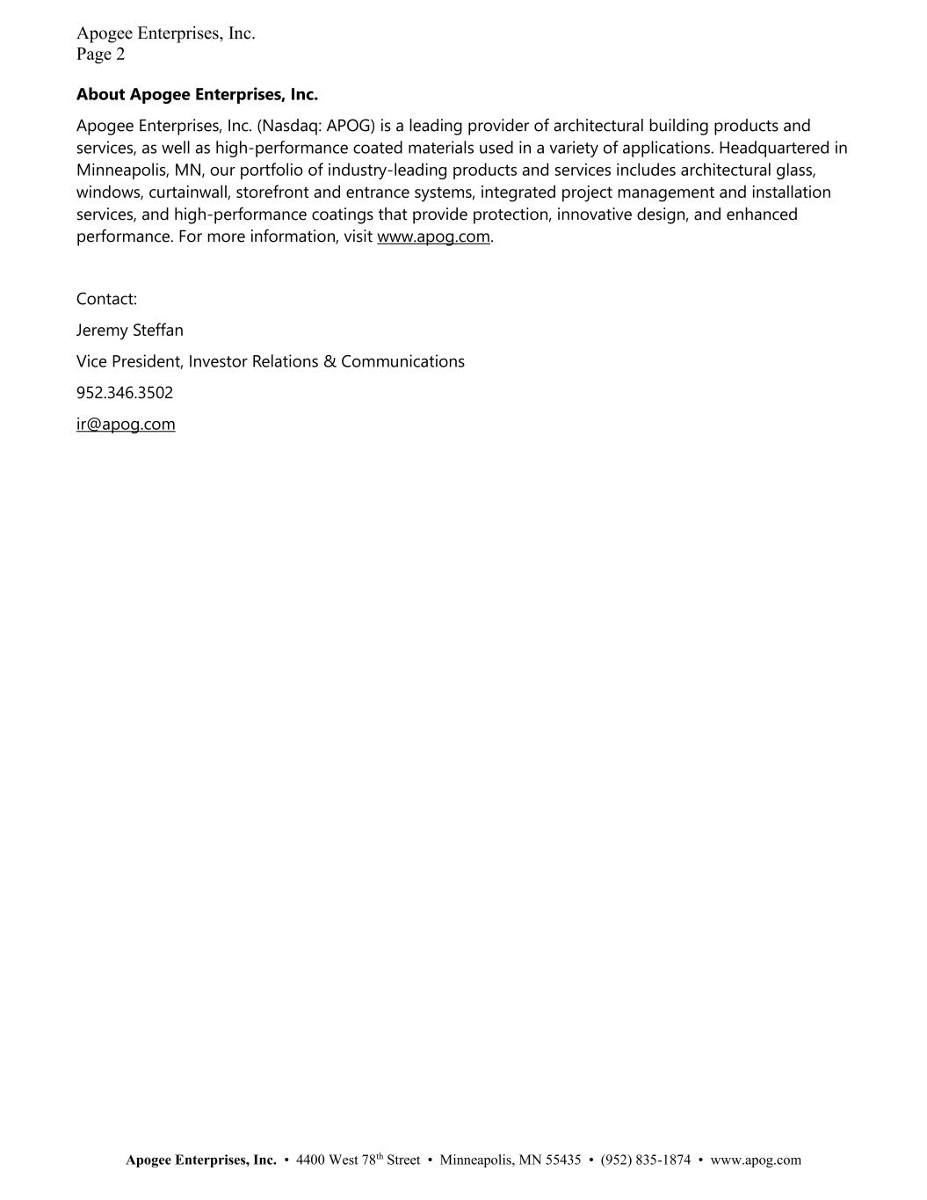
Apogee Enterprises, Inc. Page 2 Apogee Enterprises, Inc. • 4400 West 78th Street • Minneapolis, MN 55435 • (952) 835-1874 • www.apog.com About Apogee Enterprises, Inc. Apogee Enterprises, Inc. (Nasdaq: APOG) is a leading provider of architectural building products and services, as well as high-performance coated materials used in a variety of applications. Headquartered in Minneapolis, MN, our portfolio of industry-leading products and services includes architectural glass, windows, curtainwall, storefront and entrance systems, integrated project management and installation services, and high-performance coatings that provide protection, innovative design, and enhanced performance. For more information, visit www.apog.com. Contact: Jeremy Steffan Vice President, Investor Relations & Communications 952.346.3502 ir@apog.com

